The general strategy for my store was to provide as much flexibility as possible. To accomplish this I contained all the store info in a single XML file (StoreInfo.xml) as well as containing all of the flower information in one XML file (Flowers.xml) as well. This keeps the upkeep low when there needs to be an update applied to either of these XML sources. You are left with only two files to edit and are not left with many files to attend to when making a simple change. This approach seemed natural for me to attempt and it worked out well separating the data into a store file and a flowers file.

Part 1 - Schemas

When creating the schemas for this project I noticed that it took a few shots to get it exactly how I wanted it. I had realized that making all of my elements contain the flower info was not ideal and would provide me difficulty when it would come time to pull out the information that I would want to use. So, after creating my 1st set of schemas I realized that I needed to add an element to signify what type of flower that would be called. This element came in very useful down the line when creating the style sheets for my store pages. This also made it easy to sort the information by element type and then you would have all the associated information that went with the flower type (Stock ID, Quantity, Description, Name, and Price). The final schema layout looks like the following:

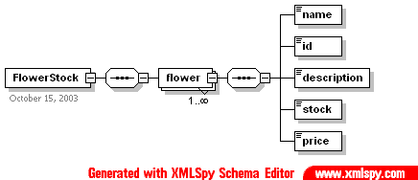

Having such a shallow tree that contains all of my information was very beneficial when creating the style sheets for the different types of flowers. This helped with having shorter path names to content. Also, the naming of the elements and the attributes was key in creating easy to follow structure and flow in the documents. I made element and attribute names as close as possible to what they were actually containing. So in the case in the above schema the following fields would contain the following information:

- FlowerStock (Root)
  - Contains all things that are flowers in this store.
- flowers (1st branch from root)
  - Contains all the flowers that are found in this store.
- type (Attribute of flowers)
  - Tells the elements what type of flower they are. (ex. rose)
- name (Element of flowers)
  - What is the name of the flower?
- id (Element of flowers)
  - What is the flower ID number?
- description (Element of flowers)
  - What is the product description of the flower?
- stock (Element of flowers)
  - How many do we have in stock?
- price (element of flowers)
  - What are we going to charge to sell this flower?

With a simple breakdown like the above it was intuitive to get the meaning of what each field means just be looking at the name. Even though our sample data is very small and only have a few describing factors for each type of flower, this structure provides a simple, yet effective way to understand what each flower is and what it’s describing factors are.

As for the store information, it is very similar to the above and the flower information. I tried to keep things simple again and only use attributes where I felt that they were needed and to try to keep the element count as low as possible. I contained all the store info in a shallow tree format again (not as shallow as the flowers in some cases). This, again, helped me keep track of my information without having to dig through deep trees of information just to find one bit of information. Also, when extracting the data is helps keep the code clean by only having to change one part of a path instead of a whole path that might lead down an entirely different part of the information tree. Grouping relevant information was something else that I tired to accomplish when creating this schema. I wanted to keep the store hours close to each other and not scatter them around the layout. This provides a more intuitive approach to finding data and makes the structure easier to read and to follow when looking at the data upon a quick glance. My schema for the store information is as follows:

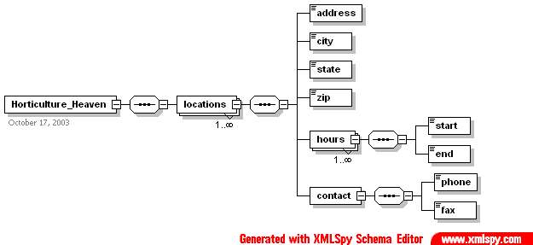

Like I stated above this tree is not as shallow as the flower’s but, nonetheless it is very shallow. This schema took some revisions to figure out exactly how I wanted my data to be stored. I left this schema open for expandability by allowing the locations element be repeated as many times as necessary. From there the tree branches out into the information that is relevant to the stores. Below I will describe what each element and attribute is exactly used for.

- Horticulture_Heaven (Root)
  - This is the root of the store info and is also the name of my store/company.
- locations (Element)
  - The base for all the locations in this store/company. Multiple instances of this element can be created.
- address (element)
  - Contains the basic street address info. (ex. 123 Main St.)
- city (element)
  - The city in which the store is located (ex. Seattle)
- state (element)
  - The state in which the store is located (ex. WA)
- zip (element)
  - The zip code for the store
- hours (element)
  - Can have multiple instances for different type of store hours. (ex. Monday)
- start (element of hours)
  - The start/open time. (ex. 9:00am)
- end (element of hours)
  - The end/close time. (ex. 7:00pm)
- contact (element)
  - The base for where the contact info is stored.
- phone (element of contact)
  - The phone number of the store. (ex. 555-555-555)
- fax (element of contact)
  - The fax number of the store. (ex. 555-555-555)

Again, simple names were used to make sure that the layout was easy to follow and easy to understand at a simple glance. Using names like fax and phone helps anyone get a quick and basic understanding of what the field is depicting. This also will enable other users to be able to take my schema and understand what is desired of them to use it for. An example of this is how we needed to take our store information and apply it to the Washington State Plant Registry schema. The fields are easy to follow and offer simple usage for everyone that uses them. This concept is important if you ever need to pass along your data or structure to someone who has never seen your information before.

Part 2 – Linking XML Files

With the way that my project style sheets were laid out it was required of me to pull information from more than one XML source at a time. Doing so was not a difficult task but required the use of the <xsl:variable/> functions and the document() function to point where the information was coming from. The exact line that I used in my various flower style sheets was:

<xsl:variable name="StoreInfo" select="document('StoreInfo.xml')/Horticulture_Heaven"/>

The reason for not leaving the $StoreInfo variable at the root was that I saw no purpose in not including it since I would have to include it every time when I made calls to this variable. I thought that I could reduce the clutter in the code by just adding it to the variable. This was also the only instance where I needed to use a variable to get information from another source. This variable was only used to populate the store information on the left hand side navigation bar.

Part 3 - Ad Hoc & the Future

I left a lot of open expandability features in my design for later additions to the data. I offered the opportunity to add multiple stores and the ability to specify flowers by type via an attribute, for example. Also, with the use of elements and the shallow tree approach it will be easy to add an element and/or attributes to the layout for future and Ad Hoc expandability without having information lingering deep in the data tree. This is one of the main reasons for the very shallow tree structure. It opens up the doors for future expandability.

Part 4 – Site Information

As apart of this project I did not input any data accept the data that was handed down to us. So, things like the descriptions on the main page, the added descriptions on the individual flower pages, and the footer info was all hard coded in HTML. My reasoning behind this is because I felt that each flower page may want a different look and feel as compared to the pages and maybe include specialized content for each of the pages (e.g. specials). Now, this is not the case for the product that I have produced, but, I left this open for expandability if the need were to arise down the line. Thus, I have a lower reused data count than most people do, but I offer more layout flexibility. Now, if the customer demanded that a single layout format was to be used, my plan would change and I would add this information to my information source (XML files) and thus increase my reused information found on the site. But, from my understanding, my customers did not require this and maybe they wish to have more variety on their pages. In either case it is an easy upgrade to make the site more dynamic and to include more reused data. However, due to the fact that some of the text fields and other information areas are hard coded, my reusability is lower, but it the opportunity to expand to an even more XML driven site in the future still is a definite possibility.

