Excellent! – Full Credit

INFO 370 – Autumn 2004 Name(s): Prins, Trotter, Yaptinchay
Lab 1

Exploring and Describing The Shape of Data

Directions: Conduct the following exercises and respond to the following questions by writing your answers in the spaces below. Respond to the items that are underlined. Email a copy of the completed worksheet to the instructor at msaxton@u.washington.edu.

In this assignment, you will begin to examine a dataset collected as part of the PEW Internet and American Life project. One goal of this study was to gather descriptive data about Internet usage by adults in the general public.

You may work individually or pair up with a classmate to complete the following exercises. Variables are listed throughout the worksheet in bold, capital letters. Portions of the project codebook pertaining to these variables have been copied for you on the last page.

1.a. Calculate the following descriptive statistics for the variable AGE and enter them in the table below. Look for the Descriptive Statistics function under the Analyze menu. You can limit the sample to men and women (SEX) by using the Select Cases function under the Data menu.

100% correct
 | N | Mean | Median | Std. Dev. | Youngest  (Min.) | Oldest  (Max.) | Missing Cases
Total | 2322 | 47.07 | 45.00 | 18.485 | 18 | 94 | 0
Men | 1168 | 45.25 | 44.00 | 18.005 | 18 | 92 | 0
Women | 1154 | 48.92 | 47.00 | 18.786 | 18 | 94 | 0

Are men and women in the sample about the same age, or is one group older than the other? Do you think this may have an effect on personal Internet usage habits? Explain.

Women are slightly older then men by roughly 3 years. We conclude this because the standard deviation is roughly the same (~0.7 difference). Std. Dev. Is a measure of movement about the center; look at Mean or Median to compare groups

We do not believe that this may have an effect on internet usage because the difference of three years is not large enough to have a significant impact on behaviors in general, let alone internet habits. OK

1.b. Create a histogram illustrating the age distribution of the total sample. Look for this function under the Graphs menu. Include a line indicating the normal curve. Add a title to your chart. Paste the chart here:
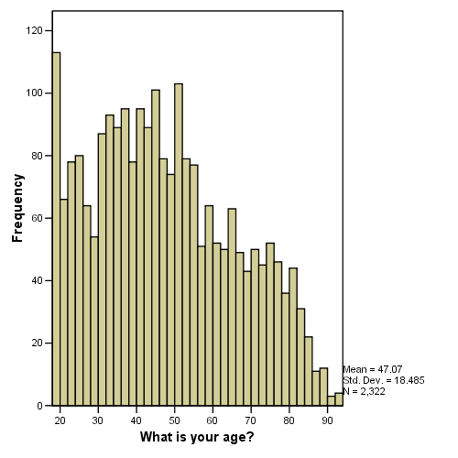
Good

2. Create two bar charts showing income distribution (INC) and last grade level attained (EDUC) of cases in the sample. Paste in both charts below.
Exclude “Don’t Know” from your barcharts – this category does not fit in the ordinal ranking – could just as easily be at the beginning.

Although these are not true histograms because you are working with ordinal variables, the bar charts appear to emulate histograms by showing the distribution of cases in ranked categories. Does the distribution of each variable appear normal or skewed?

For the income variable, the distribution does not appear to be normal. It is slightly skewed to the right. OK

For the education variable, the distribution is normal with the exception for the instance of the “business, technical, and vocational” category. Skewed to the left – more highly educated persons in the sample

If you were to redefine the categories, would this alter the overall shape of the distribution? Explain.

In the instance of the education variable, yes, redefinition of the categories would achieve a normal distribution. Namely, we would not place the “business, technical, and vocational” the as an intermediary step between high school and some college (as it often is not). Good

As for the income variable, the presence of the category, “Unknown/Refused Answer” will prevent a normal distribution and its omission would be beneficial. We could normalize the data for all other data points by reallocating the amount of income per category.

What effect do you think the distribution of these two variables in this sample may have on the findings related to personal Internet usage habits?

The distribution of these two variables could reveal whether either the level of education or amount of income affects internet usage.

The graphs by themselves are [useless] always a good idea to take a look at the shape of each variable by itself before beginning analysis – knowing about skewness or other unusual features helps aid interpretation, unless represented in a different form which includes the “internet user” variable (shown below).
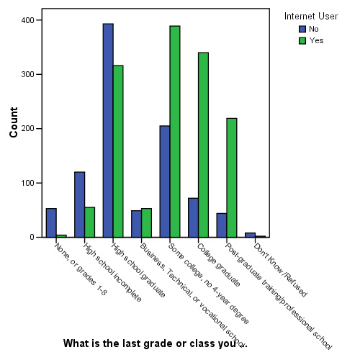
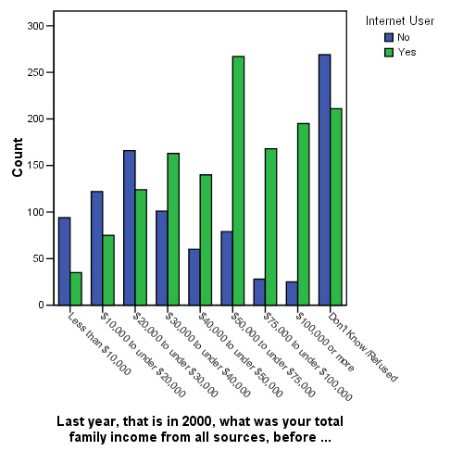
Well Done! – But exclude the “Don’t Know” category

3. Select those cases that are identified as being Internet users (I_USER).
- Calculate the percentage of Men and Women.
- Calculate the mean and std. deviation for age.
- Locate the Median for income and education level.
Enter this information in the table below.

Now select those cases that are not identified as being Internet Users. Obtain the same statistics as for the first group.

 | Internet Users | Internet Non-users
% Men | 52.9% | 45.8%
% Women | 47.1% | 54.2%
Age - Mean | 40.44 | 56.76
Age - Std. Dev. | 14.653 | 19.217
Income - Median | $50,000 to under $75,000 | $30,000 to under $40,000  20,000 to 30,000
Education – Median | Some College, No 4-Year Degree  College graduate | High School Graduate
Exclude “Don’t Know” for Income and Education

Would you say these two groups, users and non-users appear to be the same or different in terms of these social characteristics? Do you think this may have any effect on personal Internet usage habits? Explain.

The two groups, users and non-users appear to be different in terms of these social characteristics. The data shows that internet users tend to have a higher level of education and higher level of income when compared to non-internet users. As such, this could be interpreted that those with higher income or higher education have greater access and opportunity to become an internet-user. Or, conversely, that those with a higher level of income and higher education level are more inclined or have greater interest in being an internet-user. Excellent!
Codes

SEX ENTER RESPONDENT'S SEX:
- Male
- Female

AGE What is your age?

_________ years (97=97 or older)
98 (DO NOT READ) Don’t Know
99 Refused

INC Last year, that is in 2000, what was your total family income from all sources, before taxes. Just stop me when I get to the right category. (READ)

1 Less than $10,000
2 $10,000 to under $20,000
3 $20,000 to under $30,000
4 $30,000 to under $40,000
5 $40,000 to under $50,000
6 $50,000 to under $75,000
7 $75,000 to under $100,000
8 $100,000 or more
9 (DO NOT READ) Don’t Know/Refused

EDUC What is the last grade or class you completed in school?
(DO NOT READ, BUT CAN PROBE FOR CLARITY IF NEEDED).

1 None, or grades 1-8
2 High school incomplete (grades 9-11)
3 High school graduate (grade 12 or GED certificate)
4 Business, Technical, or vocational school AFTER high school
5 Some college, no 4-year degree
6 College graduate (B.S., B.A., or other 4-year degree)
7 Post-graduate training/professional school after college (Master's
degree/Ph.D., Law or Medical school)
9 (DO NOT READ) Don’t Know/Refused

I_USER
0 No
1 Yes

