INFO 440A Fall 2003

Information System Design

Lab Deliverable Document

LAB: Personas

Student 1: Aaron Egaas

Student 2: Ryan Prins
You have been hired by the iSchool student services office to design a Informatics Program Assistance System. The goal of the system is to give students all the program information they need to fully succeed in their courses. Here is the triple

By delivering course and program information to Informatics students we will be able to better prepare our students for their future jobs and degrees because they will be able to focus more on the subject matter of the curriculum and less on the logistics of their degree.

Is this a strategic or tactical design assignment? | Tactical

1- Interview
- Choose a partner. You will both hand in the same deliverable document
- For each question in this interview switch between being the interviewer and being the interviewee. In this way, the results of the interview will be a mix of you and your partner's answers.

Follow these rules when you interview your partner:
- Passionate dispassion: be engaged but not committed to an opinion.
- Remembers it is about them not you
- Probe, dig, and follow-up
- Lead (without a destination)
- Accurately record the facts
- Reiterate and rephrase
- Get evidence

Interview: Who is she?
Job or position | Freelance Web Developer
Age | 22
Sex | M
Birth place | Minneapolis, MN
Education | University of Washington, iSchool Students, Informatics
Hobbies | Video Games, Snowboarding, Movies, Music, Technology, Gadgets

Interview: Attitudes
Beliefs about us | What do they do for me? I have no KNOWLEDGABLE dealings with them so far.
Styles | Action movies, Rock Music, Technology News, Real News, Politics, good design, eye candy
How much they need us | “We need them to manage student affairs so we don’t have to”
How much influence we have | They guide us and provide answers to questions that we have for them. They are there to support us, the students.

Interview: Experience
Systems like ours | Little to none.
What they use now | I am very familiar with what they have.
Computer savvy | Expert level… black belt in computing
Subject matter | I have interacted with the subject material before, which is found in various places online.

Interview: Needs and desires
What are the:  - Necessary features  - Desired features  - Wow features | Necessary: Cool if the Informatics program provided a one stop shop for this information. Easy to use. Simple. Effective and robust. Desired: An easy way to get to my personal file on the N: drive. A standard way that all of the course web pages are done. An easy way to contact people for groups or to manage group projects since group projects is a very large part of the program.  Wow: Personalized portal page.
Use frequency | If it was done well I’d use it a few times a week to get that information. I would use that information that I received whenever I needed it.
Use duration | For however long it takes me to get my information.

2- The Sketch
- Make a pencil sketch of the all the answers laying them out and trying to find the patterns.
- Scan your drawing and paste it in below this sentence

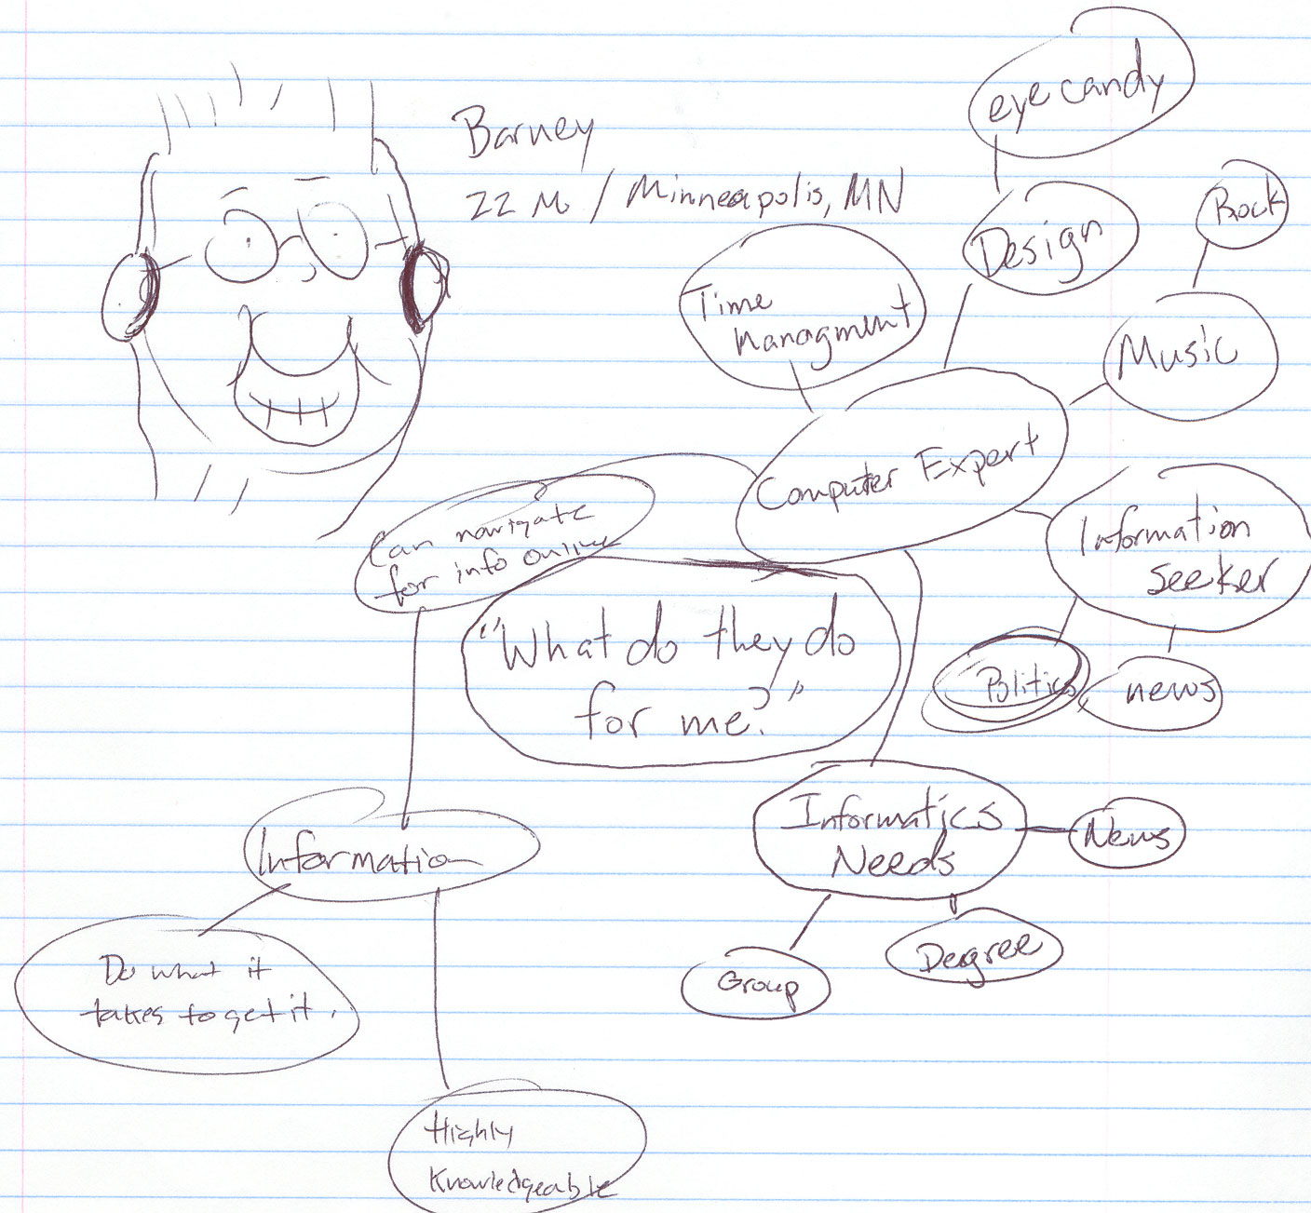

3- Refining the Sketch
Using your sketch as a guide, fill in the following table to fully describe the person you have created.

Who he is (1-2 paragraphs) | Barney is a 22 year old Informatics Major at the University of Washington. He is the ultimate consumer of information, heavily relying on various methods of information retrieval (Google) and extraction (RSS). He is an early technology adopter, whether it comes to gadgets, computers or technology. He maintains relationships with his family in Minnesota through email and instant messaging, he owns Apple products, and appreciates good design and eye candy.  He is a ferocious video game player and extreme sport enthusiast, and his choices in movies and music reflect that. He manages his time and his school while freelance designing web sites for various companies in the city in which he lives.
What he wants (ordered list) | - Quick access to information and then to move on  - Information contained all in one place  - Easy navigation and online help if needed  - Robust search features  - Easy to look at  - Mostly, he wants his information need filled
How it should be delivered (ordered list) | - Concise information presentation  - Contact for more information  - Don’t present it like I’m a moron  - Contact information if I desire or require more information
Strong negatives (bullet list) | - Don’t use FRAMES  - Confusing information presentation  - Poor design of interface  - Lacking search

4- Humanizing the Persona
Add personality, a picture, and a name to the persona to finish it off. Create the final persona below in a layout that is easy to read and attractive.


Barney / 22 / Male / Minneapolis, MN / Informatics Student @ UW

“I know that I can find the information online, but I want a place where I can just log in and find it all in one place.”

Academic Background: Barney is the first one in his family that has attended college. It is a very big deal to him that he does well in school and that he graduates with a degree. Barney currently has a 3.8 GPA for his first three years in college. He was a national merit finalist in high school. When he is not in class he is consumed by his studies. He is a very intellectual person and doesn’t like to be treated as anything less.
He is passionate about information presentation online.

Goals: When Barney graduates he wants to work in the tech industry as a consultant for web presentations. Barney has aspirations to start his own web design company and want to hire some of the best in the industry. He want to eventually have a family that will welcome technology with open arms.

