INFO 440A Fall 2003

Information System Design

Lab Deliverable Document

LAB: Content Modeling

Student Ryan Prins

Introduction
In this lab you will develop a preliminary content model that describes the containers you want your information to come in.

Recall the set-up for the labs so far:

You have been hired by the iSchool student services office to design a Informatics Program Assistance System. The goal of the system is to give students all the program information they need to fully succeed in their courses. Here is the triple

By delivering course and program information to Informatics students we will be able to better prepare our students for their future jobs and degrees because they will be able to focus more on the subject matter of the curriculum and less on the logistics of their degree.

So far, you have:
- Analyzed your user based and have developed a persona that stands in for that user base in your ongoing design.
- Gathered requirements from your users and other stakeholder (your boss).
- Developed a taxonomy that describes the information you want to deliver.

You are now ready to begin to work through the design of the content for your system. To do so you will:

- Define the content domain you intend to capture and deliver.
- Define the content model for the domain including
  - The main content types within the content domain.
  - The main elements within each type.
  - The access structures that you will need to make the content manageable and accessible.

Content Types
Go to the URL: http://www.ischool.washington.edu/programs/informatics/ .Click around until you feel familiar with the content under this URL. Then include at least 8 content types in this table that directly support the triple for your system:

 | Content Type Name | Quantity on the site | How this type supports the triple
1 | FAQ | 8 | It outlines many of the questions that people ask when trying to deiced on whether or not they should be an Informatics major. They have a very relevant question titled “What can you do with a degree in Informatics?” This question will help them ease their mind on what lies ahead of them after the degree is completed.
2 | Student Guide | 7 | This outlines current resources for Informatics majors. These could range from past capstone projects to current achievements.
3 | Degree Requirements | many | This page displays the requirements that are needed to graduate with a degree in informatics. This will help focus the students on what they need to do to graduate. It lists the human, integrative, and technical strand classes in one location for them to see where they are headed in the degree. It also outlines what they need to do with regards to general education requirements.
4 | Required Core Courses | many | This page outlines in plain English what is required of the students in regards to their Informatics classes. There are complete class descriptions on this page.
5 | Course Schedules | 7 | This displays the classes that are being offered for the different iSchool programs and also the projected schedules for the future. This helps the Informatics students because it will help them plan on what classes that they want to take in the future to pursue their degree.
6 | Course Websites | Many | These are the links to all of the iSchool courses that are offered during the current quarter. This makes it easier for students to find their class homepages.
7 | E-Mail ListServs | Many | The list of listservers provides a wealth of information to the students about what is offered on them. It also stresses the importance of being on iAnnounce and iMajors for pertinent information directed to students.
8 | Academic Resources | 8 | Provides a listing of links to various university sites that will help students become comfortable with the policies that the university has. It is mainly focused on grading.

Choose the three content types from the list above that you feel are most important to the triple. For each of the three perform the following tasks

- Find a good example of the type on a web page.
- Take a screen shot of the type and paste it into your favorite image editor.
- Mark up the screen to show the various identifiable elements of the type.

FAQ

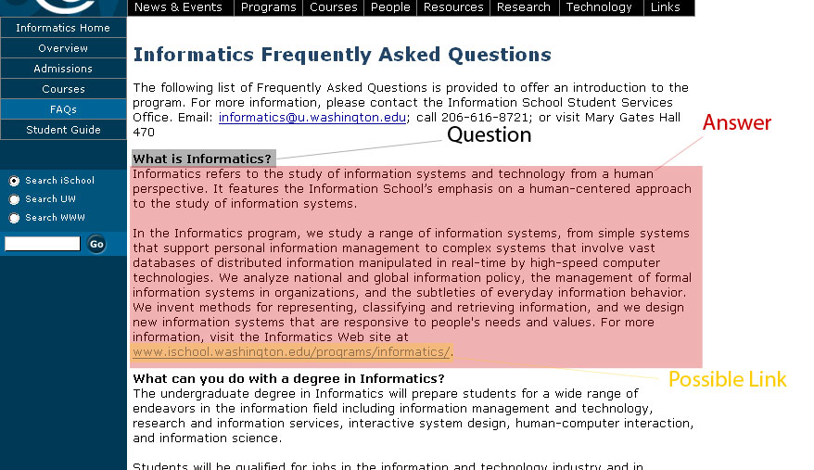

Required Core Courses

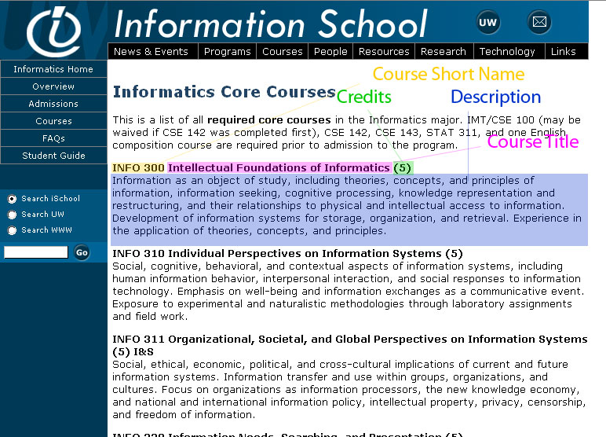

Course Web Sites

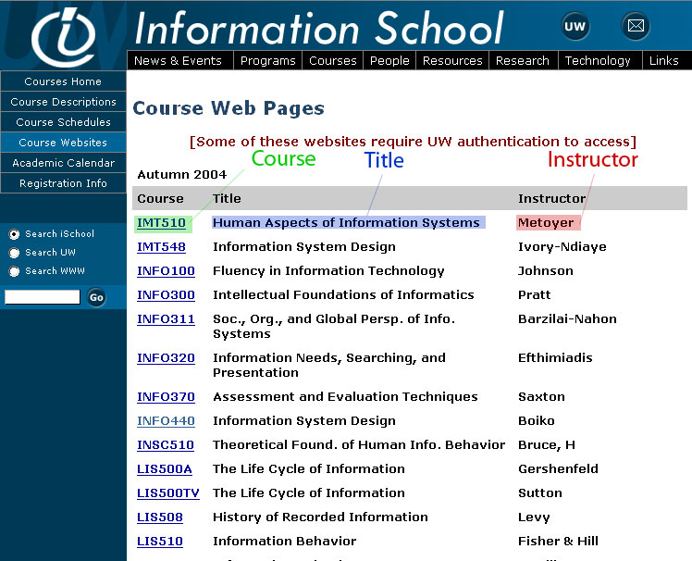

- Either
  - Fill in the table below that shows the profile of the elements
or
  - Create a schema in XML spy that shows the profile of the elements

Type 1: Name: FAQ
Delete the table below and paste in your Spy schema if you decide to do one.

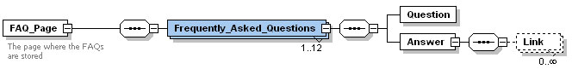

Type 2: Name: Required Core Courses
Delete the table below and paste in your Spy schema if you decide to do one.

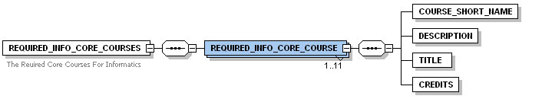

Type 3: Name: Course Web Sites
Delete the table below and paste in your Spy schema if you decide to do one.

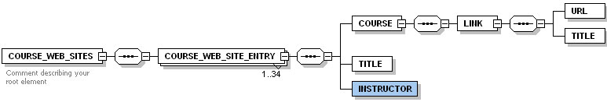

New Type: Name: Complete Course Information
Look again at the triple and decide on a new kind of content type that is not already on the site you studied. Delete the table below and paste in your Spy schema if you decide to do one.

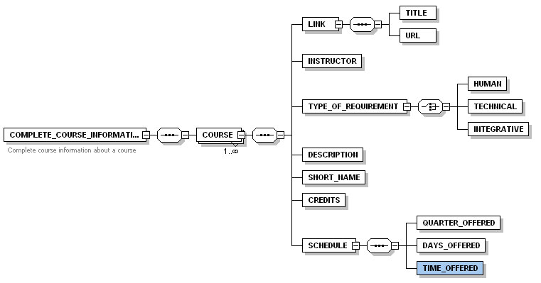

Access Types
Review the site once more and find at least three access structures that appear. Then design a structure of your own that you feel would benefit your persona and support our triple. List all four structures in the following table:

Name | Type | Where is it used? | What content types does it allow you to access? | How does it support the triple?
Side navigation | Navigation | On every page that is on the iSchool website | It varies. On the Informatics page it allows you to click back to the Informatics Home, FAQ, Overview, Admissions, Courses, and Student Guide. | It makes it easy for students to find the information on the page. They don’t want to be searching all over the place for the information and putting it in one place makes it easier for them.
Top navigation | Navigation | On every page that is on the iSchool website | It provides a uniformed navigation that is global to the entire site. It will point you in the right direction for a particular topic. If you cannot find it in the navigation a relative page could be found within the page. | By having a navigation that is global all over the entire site it is common for every user on every page. So, when they need to look for something and it is not in the side navigation they will more than likely find it in the top navigation if they know that it is there.
Site Search | Search | On side navigation of every iSchool page | It allows you to access all types of information that is stored on the iSchool web site. You simply search for it in the provided text box. | This meets the triple by making the information available at the fingertips of the person that is using it. They can search for exactly what they are looking for and they do not need a navigation menu to find it.
Site map | Hierarchy | It is used in one location on the site to display a roadmap of the entire site. | The sitemap would allow you to find all of the content types that are on the web site. | It will make it easy to do a plain text search or also to follow the hierarchy down to a particular topic. While this may not be the most efficient way of doing this, it will lay out all of the content types on one page and then the user could see if there are any relative types that may not have had a correlation made on the page that they are looking to view.

The Content Domain
The content domain statement for the information system we have been working on can be derived directly from the triple:

The course and program information Informatics students need to better prepare for their future jobs and degrees

Supposing that you will collect and distribute only the information of the 4 types you defined above, answer the following questions to define this smaller content domain:

What one or two sentences fully summarize and capture the nature of the content in the types? This is your content domain statement. | We collect information that will answer frequently asked questions about Informatics, provide complete course information, illustrate what courses are required for graduation, and also contain information where course websites can be found.
What few questions clearly put a piece of content within or outside the domain? | Will this information answer a frequently asked question by Informatics students?  Is this information relevant to an Informatics course?  Will this information help a student pick a course needed for graduation?

Discuss what work you would need to accomplish to go from the limited domain you were able to specify in this lab to the content types that support the full domain that we derived form the triple.

I would need to broaden up my domain. This is obvious. To do this I would need to expand to things that also included jobs. This is one item that I neglected to include in my four content types. The inclusion of this information would help me get my content domain closer to fulfilling the requirements of the provided triple. I do not know why I did not include this to begin with during this lab, but I know that it will be something that needs to be added.

