INFO 440A Fall 2003

Information System Design

Lab Deliverable Document

LAB: Activities

Student Ryan Prins

Introduction
In this lab you will develop a preliminary list of the activities that your information system must support.

Recall the set-up for the labs so far:

You have been hired by the iSchool student services office to design a Informatics Program Assistance System. The goal of the system is to give students all the program information they need to fully succeed in their courses. Here is the triple

By delivering course and program information to Informatics students we will be able to better prepare our students for their future jobs and degrees because they will be able to focus more on the subject matter of the curriculum and less on the logistics of their degree.

So far, you have:
- Tried to understand people by
  - Developing a persona
  - Gathering requirements.
- Tried to understand your information by
  - Developed a subject taxonomy.
  - Developing a content model.

In this lab we will begin to understand tasks, that is, what the user has to accomplish with your system. To do so you will:

- Explore the idea of a mental map and compare your mental model to that of another student.
- Define a set of tasks that according to your requirements you need to support.
- Detail some of those tasks to understand more about them.
- Perform a hierarchical task analysis on one task.
- Find some example sites that show of the kind of user experience you feel best suits your system.

Task Brainstorm and Priority

Refer back to your previous 5 labs to find a set of tasks that your system might need to support FOR YOUR PERSONA. Find at least one unique task per lab (4 or 5 would be better) and fill the table below based on what you find:

Lab | Possible tasks
Strategic Design | - Provide course and program information easily  - Informatics students are our most important group  - Better prepare our students for their future jobs
Personas | - One stop shop for information  - Make finding information easy to use  - Simple presentation of information  - Ability to use robust search features  - Quick access to information
Requirements | - Click links to classes  - Show program requirements  - Provide good navigation  - Seamless integration with UW’s Catalyst tools  - Works on any platform
IA | - Find Information about Job resources  - Find Information about Professors  - Display Calendar of events  - Display Course catalog  - List Program technology
Content Modeling | - Provide Side Navigation  - Provide Top Navigation  - Using Site Search  - Provide Site Map

Of the tasks above choose the three that seem most important and fill in the following sections with information about them:

Task 1 Name:__Provide Course and Program Information Easily_

Description | Barney (our persona) want to be able to find course and program information (about Informatics) very easily. He already has a lot to focus on and if finding the information is easier than that would ease his mind a lot.
How often would the persona do it? | We expect him to want to do this about one a quarter. We say this because the requirements are of most importance when registering for the next quarter. However, we do realize that they could check more often if their interest level was high enough to  check frequently.
Does she likely have an existing process? What is it? | He might be doing this by checking DARS via MyUW already. But he has expresses a disklike in having to re-run DARS reports each quarter. This is a major detraction to the DARS service. Other than DARS he often visits the iSchool’s webpage to check the Informatics course requirements and to see what classes are to be offered the next quarter.
How does it support the triple? | Barney and ourselves realize that being in higher education is more than just attending classes and doing homework. It is also managing relationships, having a job, and much more. So, by providing this information easily it is one item that is made more efficient and simple for him to use. This takes the pain out of what can be a stressful situation, finding classes and program requirements.
What metaphors might you use to express this task to the persona? | We think that the metaphor of newspaper headline is a good one to represent this task. The main idea that we want to get across is that finding this information should be as simple as understanding a headline in a newspaper. It should be short, concise, and to the point. Here is an example:

Task 2 Name:_Click Links to Classes

Description | Barney has a lot of URLs to look over for his various classes. He has many of them bookmarked but he is often not at the computer where they are bookmarked. So, he often clicks links that take him to the class homepage.
How often would the persona do it? | This more than likely occurs daily. He is taking classes every day and it is a very common occurrence for professors to put schedules and readings online. So, he could be doing this multiple times a day. It is really hard to get an exact count on the frequency.
Does she likely have an existing process? What is it? | His current process is to bookmark the links or to head to the iSchools “courses” webpage for all of the available courses that have web pages.
How does it support the triple? | By having a link to the classes it is making it easier for Barney to maneuver the web in regards to his classes and it will save him time and frustration. He doesn’t have to remember a URL for each class. Remembering URLs can be troublesome for him to find because there is no set rule on how to make the URL for a course page.
What metaphors might you use to express this task to the persona? | We think that the metaphor of a spider web is one that works will for this task. You want to have one location in which you start and then you want to make it easy to branch out to the other locations from this one starting point. It is not important that you can go from one class page to another directly, just a long as there is one location where you can access all of the class sites. An image of this would look like:  

Task 3 Name:_Using Site Search_

Description | Barney can be impatient sometimes and he want to fine information NOW! So, what does he do? He looks for a search function to find that he is looking for. He thinks that he is a good searcher and can usually find exactly what he is looking for when he uses a site search.
How often would the persona do it? | It is hard to say how much Barney would use the site search. On sites that have good navigation, this could be very little. On ones that lack good navigation, this could rise. However, if he is in a rush and doesn’t want to navigate through an entire site to find his information he will use the site search to find what he is looking for.
Does she likely have an existing process? What is it? | The existing process usually consists of Barney using the existing navigation to initially find what he is looking for. If after a short amount of time he has not found what he is looking for, he will then use the site search to help pinpoint what he is looking for. However, as stated before, if he is in a rush, the navigation is thrown out of the window and he goes right to the site search.
How does it support the triple? | By using site search it makes it easer for Barney to find the information that he needs. If the site has navigation that is not to his liking this could be his only option. So, by using site search he can take the information into his own hands and find what he wants using his own methods. It takes away the stress factor of using a pre-defined navigation scheme.
What metaphors might you use to express this task to the persona? | A metaphor that we feel expresses this concept is that of a dart board. You know that some times you might hit it right one, but at other times you may be off and have to “throw” (search) again. A picture to describe this is like:  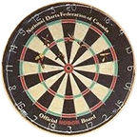

Hierarchical Task Analysis
Let’s suppose one of your tasks is “Select Classes for Next Quarter.” In other words, you feel that it is important for the system to aid students in course selection. Create a diagram (on paper or electronically) that breaks this task down hierarchically. Include the diagram in the space below:

For: Click Links to Classes

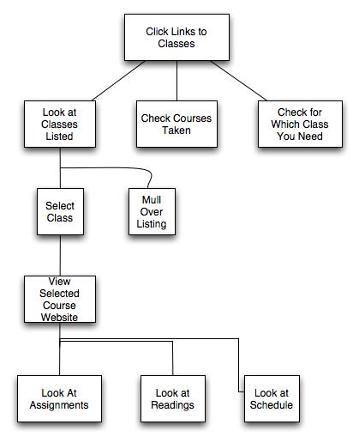

When you have completed your analysis, answer these questions:

How did you know when to stop including details and creating levels in the diagram? | I figured that once I got to the information that was represented on a typical class website that I could stop. That is generally what a student is looking for on the course websites. They want to know: What is coming up? What is due? and Where can I get what I need to do? I could have expanded on the others further, but due to time I only focused on the presentation I used above.
These steps probably would not always be done in the same way by different people, or by the same person from quarter to quarter. What could you do to account for that in your analysis? | You could provide multiple access to the same information. Like I described above Barney could have just clicked a bookmark to get to the homepage of the class he was interested in. So that takes the initial browsing out of the picture. This mainly removes the 1st child layer to the root item. He would have been browsing his bookmarks as opposed to a website that has all of the courses listed.

Mental maps
Find a partner and exchange hierarchical task analyses. Include your partner’s diagram here:

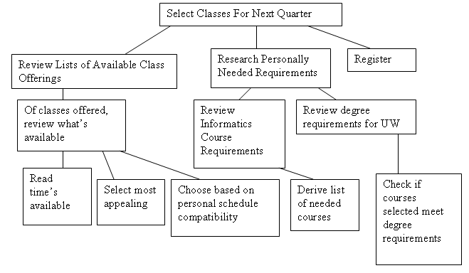

When you are finished, answer these questions:

What are the basic differences between your analysis and that of your partner? | This HTA is much more robust and provides more detail in each level of the hierarchy. There are often more then one link from the parent item to the child elements.
What does exercise have to do with mental models? | For the most part it makes sense to the mental model that I had of the same task. I would have changed “Research Personally Needed Requirements” to “Check Prerequisites”. But, other than that the flow of the HTA is very similar to what I would have done. I might not have made “Register” a child element of the root element. I would have preferred to put it under “Select most appealing”. Other than those two things I would have done a very similar task to get where this HTA lead me.
What do mental models have to do with the design of information systems? | If you have a different process than that one being presented it could be difficult to complete the task that you want to do. So, mental models play a very important part in information system design. You want to match the mental model of your users so that they can find what they are looking for.

User Experience
Cruise the Web and find at least three pages that have elements of the user experience you want your system to have as well. Fill in the sections below for each illustration:

Illustration 1
Paste the illustration below:

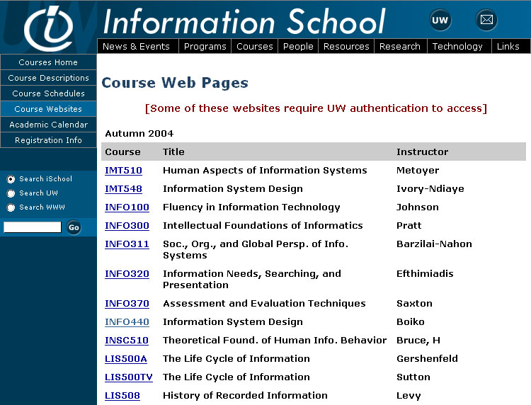

Please answer these questions:

What elements do you want to use from this illustration and why? | I really like the layout of the rows in this example. It states clearly what the coruse name is, the short name (INFO xxx), and who the instructor is. This should be enough information to get the user started with finding their class.
What elements do you not want to use and why? | I don’t like how the classes for different programs are mixed. If they were separated by program (INFO, MLIS, etc..) that would help me out better.

Illustration 2
Paste the illustration below:

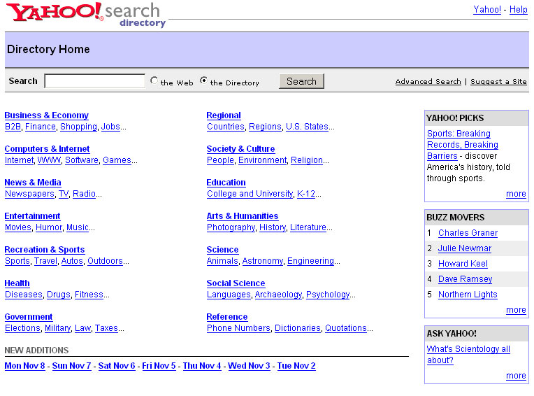

Please answer these questions:

What elements do you want to use from this illustration and why? | I like the categorization of items here. It makes it fairly clear to the user what they can select from. This could be useful for defining program in the iSchool. Each program could have its own category. I also like that the layout and design is simple, it is not so overly complex that you get lost in the design or layout of the site.
What elements do you not want to use and why? | There are a lot of categories listed. I would definitely have less categories. Also, I would not have the right side content that they have in the image above. That is just extra information that is not going to help the student find what they are looking for.

Illustration 3
Paste the illustration below:

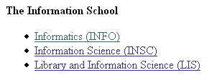

Please answer these questions:

What elements do you want to use from this illustration and why? | This is exactly what I am looking for by splitting up the programs. While all of the programs may not be listed, this is the idea on what I want. I like it because I can tell by just looking at it that each program has a different link. I really like this layout a lot.
What elements do you not want to use and why? | I don’t like the bulleted list, but this is just a style thing. That style worked for the site where I got it from, but it would not work will with the design of this experience. Also don’t know if I would have the short name (e.g. INFO). Some programs may not have this and I don’t want to list a program that doesn’t have one. So, I would more than likely not include the program short name.

