INFO 440A Fall 2003

Information System Design

Lab Deliverable Document

LAB: Interactions

Student Ryan Prins

Introduction
In this lab you will develop a preliminary list of the interactions that your information system must support and will detail one of the interactions.

Recall the set-up for the labs so far:

You have been hired by the iSchool student services office to design a Informatics Program Assistance System. The goal of the system is to give students all the program information they need to fully succeed in their courses. Here is the triple

By delivering course and program information to Informatics students we will be able to better prepare our students for their future jobs and degrees because they will be able to focus more on the subject matter of the curriculum and less on the logistics of their degree.

So far, you have:
- Tried to understand people by
  - Developing a persona
  - Gathering requirements.
- Tried to understand your information by
  - Developed a subject taxonomy.
  - Developing a content model.
- Tried to understand the tasks by
  - Charting the activities users want to accomplish

In this lab we will continue to understand tasks by working through the interactions that the system will support. To do so you will:

- Create a site path diagram that shows the range of interactions that you want to support.
- Pick the most important interaction on your site path and
  - Model it like a user case
  - Model it like a flow chart
  - Discuss how you will make the necessary tradeoffs and include the necessary user aids.

Site map

Refer back to your previous lab on activities. Use the information you generated there as well as what you can come up with today to create a site path diagram for your system. Draw the diagram on paper or in your favorite image program and paste it below.

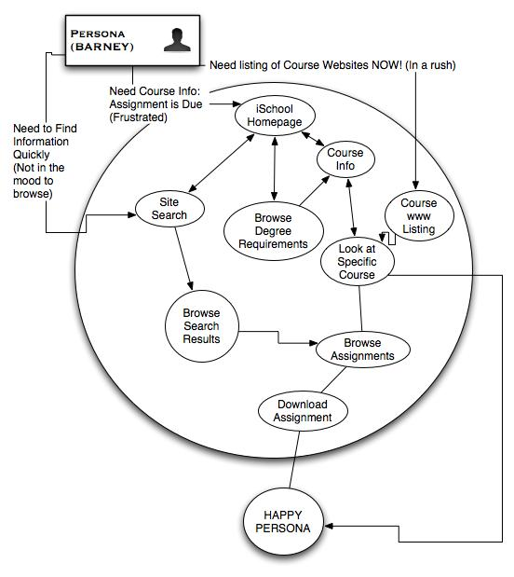

Close-up on an interaction
In this part of the lab, you will use a variety of methods to detail one interaction

Basic use case
Choose one path on your diagram and fill in the following table to describe it’s basic use case:

User entry information need | Need to find class information about a specific class. I have an assignment due and I know that the details of the assignment are listed on the website.
User entry attitude | Flustered! I didn’t know that it was due today!
Interaction
  User Action | System Response
  Open up iSchool Website
  Go to Course Websites Page
   | List all courses with websites
  Select desired course from the list
   | Display course website
  Find assignment information
  Locate the correct assignment
  Download assignment
   | Download file to user for their use

Flow Chart
Use paper or your favorite diagramming tool (Visio, etc.) to create a flowchart of the same interaction that you charted above. Paste the flowchart below:

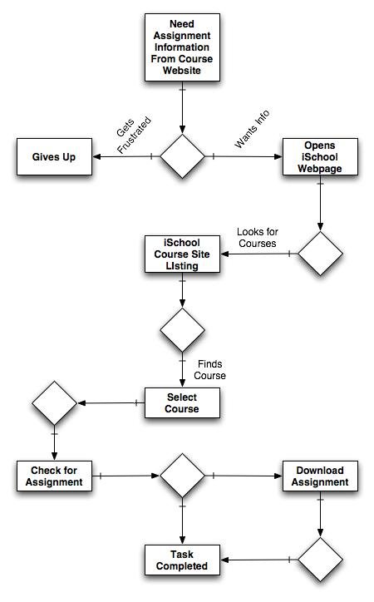

Interaction design essentials

Think hard about the interaction you have been detailing. Without making any sketches of user interface, discuss how you could include these essentials in the interaction that you described above:

Essential question | Your answer
How will you indicate where the user is?  - Current Status  - What comes next  - Where the end of the interaction is  - Undo (how to go back) | To show where the user where they are by having nice large titles on each page. This way it will stand out on where they are within the system. To show them where they could head concise titles will be places on links or on pages that come next in a sequence. At the end of the interaction the user will be presented with a dialogue that will tell them that they have reached the end of the interaction and that they can head back “home”. Also, there will be a back button that not only tells the user that they can go back, but also what they are going back to. This could be done at the bottom of the page, but also in a breadcrumb sort of thing at the top of each page.
How will you indicate want just happened?  - Feedback  - Error recovery | By displaying a confirmation that the actions that they took are producing some sort of output. If they click on a link the title that was on the link should be displayed somewhere on the page that they are being lead to. There also should be a way to recover from an error. If they end up in a page that they do not want to be in, an option to take them back to the previous page should be provided. This way they can undo the actions that they just took. Also, if there is a catastrophic error there should be means provided to inform the owner that there was a major error.
How will you give the user the feeling that she gets to do it her way?  - Accounting for divergent goals  - Leveraging the user’s conceptual model  - Defaults | By giving the user a wide range of choices and also letting them choose their path from multiple angles, they will feel like they are in control of their problem. This will allow for them to control the system on how they want to control it. They might have a different way of approaching a problem than was designed, so giving them an option take it their way will provide them with some confidence. Also, with defaults they will be able to see how we have designed the system and how we think that they should interact with it.

