INFO 440A Fall 2003

Information System Design

Lab Deliverable Document

LAB: Prototypes

Student Ryan Prins

Introduction
In this lab you will develop a prototype of one of the interactions that your information system must support.

Recall the set-up for the labs so far:

You have been hired by the iSchool student services office to design a Informatics Program Assistance System. The goal of the system is to give students all the program information they need to fully succeed in their courses. Here is the triple

By delivering course and program information to Informatics students we will be able to better prepare our students for their future jobs and degrees because they will be able to focus more on the subject matter of the curriculum and less on the logistics of their degree.

So far, you have:
- Tried to understand people by
  - Developing a persona
  - Gathering requirements.
- Tried to understand your information by
  - Developed a subject taxonomy.
  - Developing a content model.
- Tried to understand the tasks by
  - Charting the activities users want to accomplish
  - Stringing those activities into sequences (interactions) that users need to go through to accomplish a goal.

In this lab we will convert an interaction into an interface. To do so, you will need to collect the pertinent information from your previous labs.
- From the IA lab, you will draw in your subject taxonomy
- From your content modeling lab you will draw in the model of a content type.
- From your activities lab you will draw in your metaphors and user experience elements
- From your interactions lab you will draw in an interaction and your design considerations around it.
In other words, this lab forces you to synthesize a lot of information from your previous work. Don’t worry if the information from all these previous labs does not all fit together. Feel free to change what you said in previous labs to make all the pieces fit together. remember, this is play time!!!

Once you have gathered and coordinated the information from your other labs, you will:
- Map the content model to an HTML page layout.
- Map the subject taxonomy to a navigation feature.
- Turn your interaction into an HTML page sequence.
- Enhance the page with the metaphors and user experience elements that you have come up with.

Gathering the information

Refer back to your previous labs. Start with the information you generated there, but end with a set of resources that all tie together as follows. The taxonomy, content type, metaphors and user experience elements that you use must directly support the interaction that you use:
- The metaphors and user experience are ones that enhance the interaction.
- The subject taxonomy and content type must be ones that the interaction is about.

Interaction
Choose/modify an interaction. Answer these two questions:

My Interaction: Need to find course information (Assignment is due)

What requirements does it address? | It meets the requirements of being able to find information in one place at one time. Also, it meets the requirement of getting course information.
What will your persona think of it? Will she understand it? Will it be a wow feature? Will she need it? | Our persona will love it! They like the fact that they can go to one page and get all of their information about their classes (what is due, calendar, etc…). We think that he will be able to understand it because the interaction is not to terribly complex (our user is slightly more advanced than most) and the information is presented in a clean and concise manner. This will not really be a wow feature for our user, but more of a feature that they will be glad to see added to the current iSchool web infrastructure. As for the use… this could be used daily or multiple times a day. This contains much of the information about all of their classes and this would be an interaction that is completed multiple times a day.

Describe it’s use case below

User entry information need | Need to find class information about a specific class. I have an assignment due and I know that the details of the assignment are listed on the website.
User entry attitude | Flustered! I didn’t know that it was due today!
Interaction
  User Action | System Response
  (1) Open up iSchool Website
   | (2) Opens up iSchool Website
  (3) Go to Course Websites Page
   | (4) List all courses with websites
  (4) Select desired course from the list
   | (5) Display course website
  (6) Find assignment information
  (7) Locate the correct assignment
  (8) Click on assignment
   | (9) Prepare file for download
   | (10) Send file to user
  (11) Select location to save file
   | (12) Display status bar for download
  (13) Verify that file is downloaded

Answer the essential interaction design questions for this interaction here:

Essential question | Your answer
How will you indicate where the user is?  - Current Status  - What comes next  - Where the end of the interaction is  - Undo (how to go back) | To show where the user where they are by having nice large titles on each page. This way it will stand out on where they are within the system. To show them where they could head concise titles will be places on links or on pages that come next in a sequence. At the end of the interaction the user will be presented with a dialogue that will tell them that they have reached the end of the interaction and that they can head back “home”. Also, there will be a back button that not only tells the user that they can go back, but also what they are going back to. This could be done at the bottom of the page, but also in a breadcrumb sort of thing at the top of each page.
How will you indicate want just happened?  - Feedback  - Error recovery | By displaying a confirmation that the actions that they took are producing some sort of output. If they click on a link the title that was on the link should be displayed somewhere on the page that they are being lead to. There also should be a way to recover from an error. If they end up in a page that they do not want to be in, an option to take them back to the previous page should be provided. This way they can undo the actions that they just took. Also, if there is a catastrophic error there should be means provided to inform the owner that there was a major error.
How will you give the user the feeling that she gets to do it her way?  - Accounting for divergent goals  - Leveraging the user’s conceptual model  - Defaults | By giving the user a wide range of choices and also letting them choose their path from multiple angles, they will feel like they are in control of their problem. This will allow for them to control the system on how they want to control it. They might have a different way of approaching a problem than was designed, so giving them an option take it their way will provide them with some confidence. Also, with defaults they will be able to see how we have designed the system and how we think that they should interact with it.

Metaphors and user experience elements
Choose/modify the metaphors and user experience elements that support this interaction and list them below:

What metaphors might you use to express this task to the persona? | We think that the metaphor of newspaper headline is a good one to represent this task. The main idea that we want to get across is that finding this information should be as simple as understanding a headline in a newspaper. It should be short, concise, and to the point. Here is an example:

Illustration 1
Paste the illustration below:

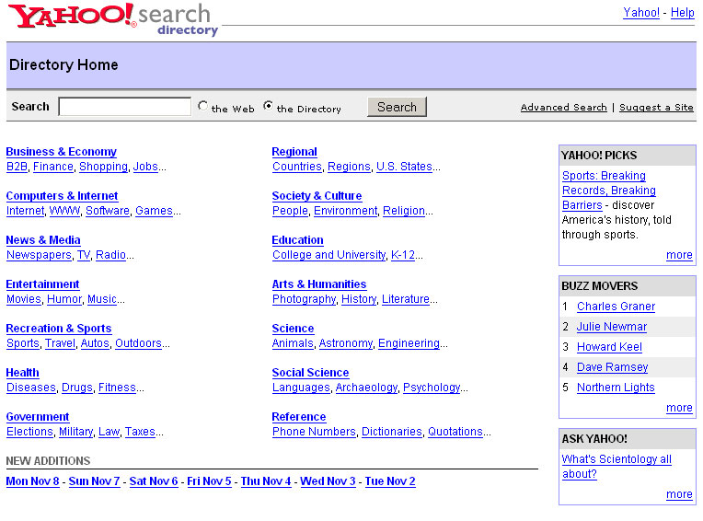

Please answer these questions:

What elements do you want to use from this illustration and why? | I like the categorization of items here. It makes it fairly clear to the user what they can select from. This could be useful for defining program in the iSchool. Each program could have its own category. I also like that the layout and design is simple, it is not so overly complex that you get lost in the design or layout of the site.
What elements do you not want to use and why? | There are a lot of categories listed. I would definitely have less categories. Also, I would not have the right side content that they have in the image above. That is just extra information that is not going to help the student find what they are looking for.

Subject taxonomy
In the table below, enter the subject taxonomy that relates to the substance of this interaction.

Term Id | Term (to indent press ctrl-tab)
1 | iPortal
3 | Program Technology
10 | Course Catalog
15 | Classes
17 | Grades
16 | Course Content
5 | Calendar
11 | Upcoming Events
7 | Current Events
14 | Schedule
9 | Student Groups
6 | Job Resources
12 | Employers
7 | Professional Activities
20 | Job Fair
6 | Skills
18 | Professors
19 | Faculty Report Cards
8 | Awards
4 | E-Mail

Content model
For the content type that this interaction concerns, enter in it’s elements below
Name: Course Web Sites

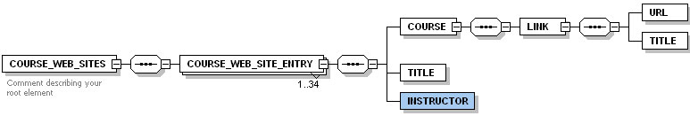

Mapping the content model
In this part of the lab, you will create a layout for the content type in your interaction.
- Open your favorite HTML editor (or use Word if you need to) and type in one instance of your content type.
- Format it the way you feel it needs to be formatted.
- Make sure it includes all elements
- You don’t need to type in a lot of text. But do make sure that the length of each element is about what you expect it to be.
- Take a screen shot of the completed text.
- Add call out’s for each of the elements on the screen shot in your favorite picture editor (or on paper)
- Paste the marked up screenshot below:

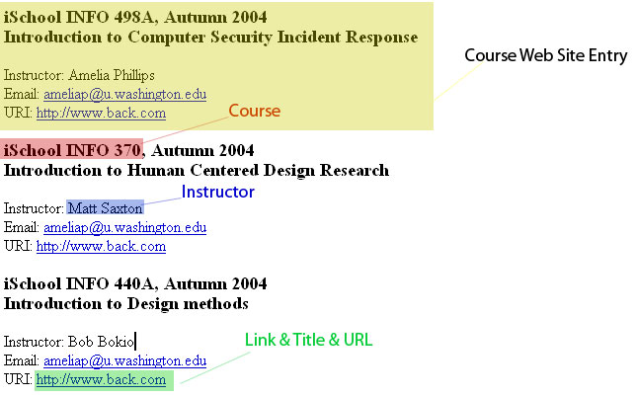

Mapping the subject taxonomy

Decide what sort of navigation your subject taxonomy might best be used for and create it as a separate page in your HTML editor (or paper if you need to). The taxonomy might yield:
- An outline
- A flat list of terms
- One or more cross references
- A next or previous feature

Paste a screen shot or scan of your navigation widget below:

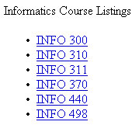

Building the page sequence as a wire frame
Using an HTML editor or paper, create a sequence of web pages that implement the interaction you chose:
- Use a page layout based on the user experience elements you thought were appropriate to this interaction.
- Add the content layout from above
- Add the subject navigation from above
- Add the basic way that the user navigates to the next or previous page in the sequence.
- Don’t add any navigation to other interactions or other parts of the site. You can however leave space on your wire frames for global navigation or external links.
- Don’t add any look and feel. This is a wire frame

Paste in screen shots or scans of your wire frames below

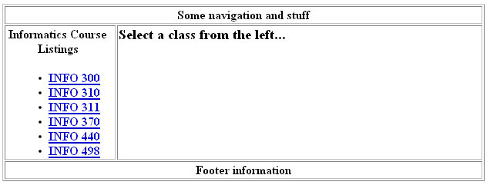

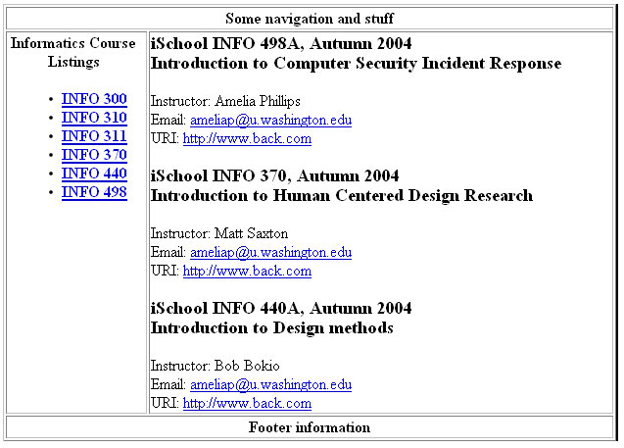

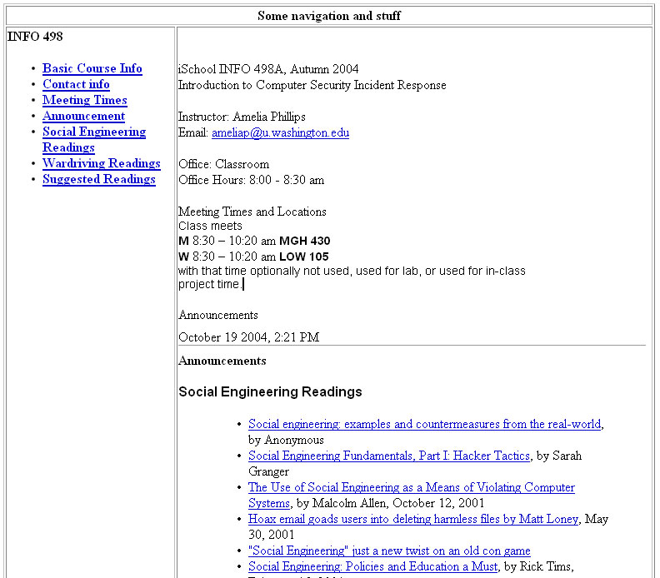

Adding the user experience and metaphors
Use the information you collected on metaphors, user experience elements and interaction design essentials to add flesh to your wire frame.

IT IS NOT ESSENTIAL THAT THE SCREENS YOU PRODUCE BE PRETTY, IN FACT, IF YOU SIMPLY WANT TO DISCUSS THE METAPHORS, EXPERIENCE ELEMENTS, AND DESIGN ESSENTIALS WITHOUT SHOWING THEM THAT IS JUST FINE. IN ANY CASE, THIS IS A LOW FIDELITY PROTOTYPE SO DON’T SPEND MUCH TIME TWEAKING.

Paste in screen shots or scans below if you created them. If you did not create screens, discuss how the screens would need to be created.

