INFO 440A Fall 2004

Information System Design

Lab Deliverable Document

LAB: Usability

Student Ryan Prins

Introduction
In this lab you will test a prototype you have developed.

Recall the set-up for the labs so far:

You have been hired by the iSchool student services office to design a Informatics Program Assistance System. The goal of the system is to give students all the program information they need to fully succeed in their courses. Here is the triple

By delivering course and program information to Informatics students we will be able to better prepare our students for their future jobs and degrees because they will be able to focus more on the subject matter of the curriculum and less on the logistics of their degree.

So far, you have:
- Tried to understand people by
  - Developing a persona
  - Gathering requirements.
- Tried to understand your information by
  - Developed a subject taxonomy.
  - Developing a content model.
- Tried to understand the tasks by
  - Charting the activities users want to accomplish
  - Stringing those activities into sequences (interactions) that users need to go through to accomplish a goal.
- Tried to develop the information system by
  - Developing a prototype of one of the interactions that your information system must support

In this lab we will conduct a usability test on the prototype you have developed. To do so, you will need information from your previous labs.
- The information about your target users from your persona lab
- The information of a selected interaction from your interaction lab
- The wire frame (or a sketch or a final design) from your prototype lab

Test plan
Refer back to your previous labs on persona, interaction, and prototype. Use the information you generated there as well as what you can come up with today to develop a usability test plan. Please answer the questions below.

What are your goals for this usability test? | The goals for my usability testing is to verify if the user can find the class that they are interested and then find the information they are looking for (class assignment).
Who are your target users? | My target users are Informatics students that are currently taking a class.
What is the goal of the interaction? | The goal of the interaction is that they can navigate and find the class that they are looking for. Then we hope that they can find their assignment for the class
What are the steps of the interaction? | 1. Locate the class  2. Find the assignments part of the page  3. Locate assignment needed  4. Download assignment
What is a task that the users may perform through this interaction? | The user will perform the task of downloading an assignment. This will be at the end of the interaction.
Usability measures | 1. Learnable  2. Errors  3. Satisfaction

Usability test
Find a partner to be your test subject. You will need a screen shot of your prototype (a sketch, a wire frame, or an html page).

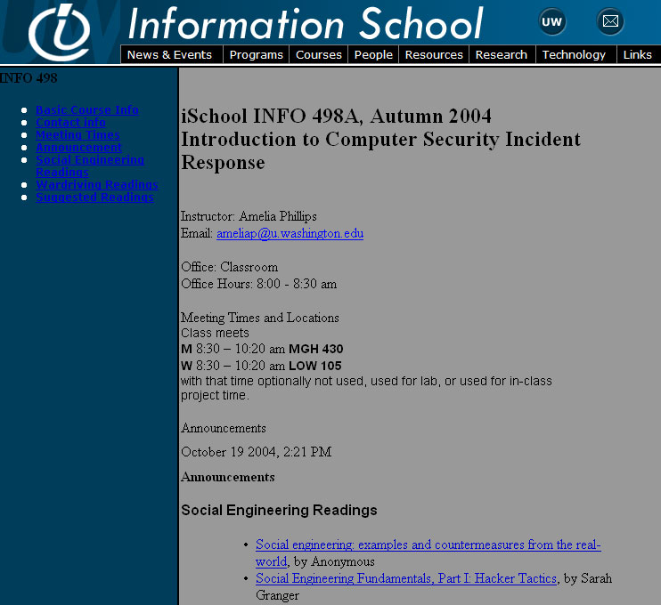

2.1 Reaction test
For the first part of the test, you will test whether the user gets it. You will show your partner the prototype (a sketch, a wire frame, or an html page) and find out if he/she understands the purpose of the site, how it works, how it’s organized, and so on. To do so, ask your partner the questions in the table and fill in his/her responses.

What do you think this page is used for? | I think that the page is used for class information.
What is the first thing you notice? | The amount of color. And the high amount of links on the page.
What do you think you would click on first? | The links on the left navigation, because I think it will help me.
Are there anything you like or don’t like? | The colors are pretty similar and there might be too many links.

2.2 Key task test
For the second part of the test, you will give your partner a task to perform. Here is how you will do it:
- Develop a task scenario of the tasks listed in the test plan section.
- Read the scenario to your partner
- Ask your partner to perform the task
- Tell your partner to think aloud while performing the task
- Write down your observation in terms of usability measures that you described in the test plan section

Task scenario | You are looking for course information. You have an assignment that is due and you need to figure out where you can get it. Your task is to locate the correct class and then to find the assignment you need.
Observation | - User clicks the correct class  - She browses the pages  - She finds the links on the left  - She doesn’t find what she is looking for  - She looks down  - Finds assignment

Report the usability test results
Type up a short list of the main problems you observed during the test.

Some of the links are not easy to find. You cannot locate them easily. So, this causes a problem when looking for an assignment. So, she had to scroll down to find the reading. The assignment was located under a different heading, but if it was under an assignments tab it would have been much easier to find.

Recommendations
Make recommendations in response to your usability test results. (E.g. How would you fix the problems that you observed? What could be changed to make the system more usable?)

Make it easier to locate current assignments within all of the listed assignments for the quarter. Make the left links more appropriate for the course content. Add and assignments link. Change the colors up a little bit. Right now they make the text and the links hard to read.

