Task Brainstorm and Priority
The highlighted tasks are the three that we chose to move forward on.

Lab | Possible tasks
Strategic Design | - Look for a major  - Find a major in time (e.g. by 90 credits)  - Look for pertinent information  - Obtain a recommendation on a major
Personas | - Find information about a major that I am interested in  - Find information about programs  - Help me see what jobs I can get with a certain degree  - Help me set up a time to meet with an advisor, if needed
Requirements | - Fill out questionnaire  - Provide feedback about system  - Ability to sign up for web advising  - Input past courses and gain suggestions of one or more majors
IA | - Click link to Majors to get more information  - Easily find path to major finder  - Find jobs related to certain majors  - Find information on how to get in contact with advisors  - Look up suggested tracks for classes to get into a major
Content Modeling | - Look at all of the courses that UW has to offer  - Research the different schools within UW  - Look into course evaluations for specific classes  - Figure out what the degree requirements are for a specific major

Metaphor Images

Task 1 Name: Look for pertinent information
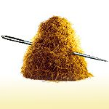

Task 2 Name: Input past courses to get suggestion for a major


Task 3 Name: Figure out what degree requirements are for a specific major
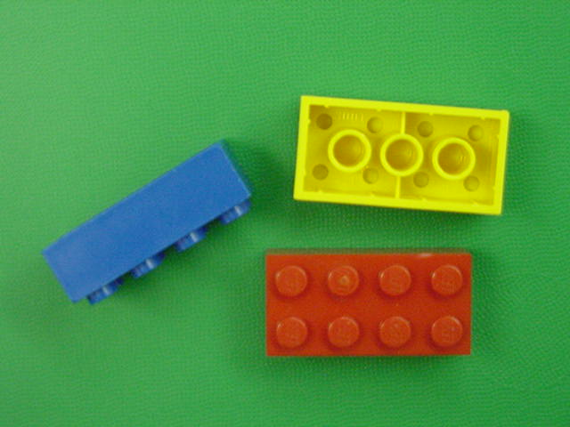

Hierarchical Task Analysis
TASK: “Figure out what degree requirements are for a specific major”

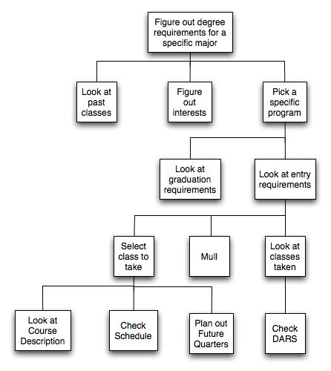
HTA 1.

How did you know when to stop including details and creating levels in the diagram? | We stepped through each of these processes when we got to them and we wrote them down as we saw them. There just seemed like a natural end when we reached the last level because the task looked to have been more than completed. We actually feel that we went a step further by actually looking at the courses and checking the schedule to see if they fit in what classes we were already taking. It seemed natural to keep going like we did because some questions were left unanswered if we didn’t. Questions like, “What is this class like?”, “Does it fit with my schedule?”, “Do I take it this quarter or plan to take it in the future?” So, we felt it important to continue until these questions were answered.
These steps probably would not always be done in the same way by different people, or by the same person from quarter to quarter. What could you do to account for that in your analysis? | Given our users’ persona, we account for the most important options which are: look at past classes, figure out interest. We anticipate that our users may or may not follow the same order. However, these two options are presented to them early enough in the model so that the order would not matter. We realize that the user will not be like us in every manner so options is a key component in making the system broad enough for everybody, including Maria, to use. Also, with the way our HTA is structured we realize that some steps will not need to be completed quarter after quarter. This is why options in the process is vital. Given options the user can accomplish anything within the system’s scope.

Mental maps

HTA 2.
Figure out degree requirements for a specific major
Check my status
Visit departmental website for more specifications
Figure out if this major match interest
Review past classes
See classes taken that are applicable to degree
Review UW grad. requirements
Review classes required before admission
Review classes required after admission
Make decision to register

What are the basic differences between your analysis and that of your partner? | The majority of the differences lie within the levels of details. Both HTAs seem to address the main processes that Maria would go through in order to figure out degree major requirements. These essential steps are: review past classes, match major to interest, and register if she sees fit. However, in HTA1 the level of details was taken to another level where Maria actually go to her myUW to register for these classes. Meanwhile, HTA2 allows some possibility that after looking through the requirements Maria may decide not to register.
What does exercise have to do with mental models? | It allows you to see how the way someone construct an approach to complete a task can be substantially differ from another person’s approach while doing the same thing.
What do mental models have to do with the design of information systems? | Although both designers on our team focus their design for Maria. However, they each came to very different HTA at the end. This gives us some insights on what to expect when we designer specifically for tasks our person might carry out.  We have to find a way to designer our information systems in such a way so that it would cover all the base cases first, matching it to Maria’s mental model.

User Experience

Illustration 1

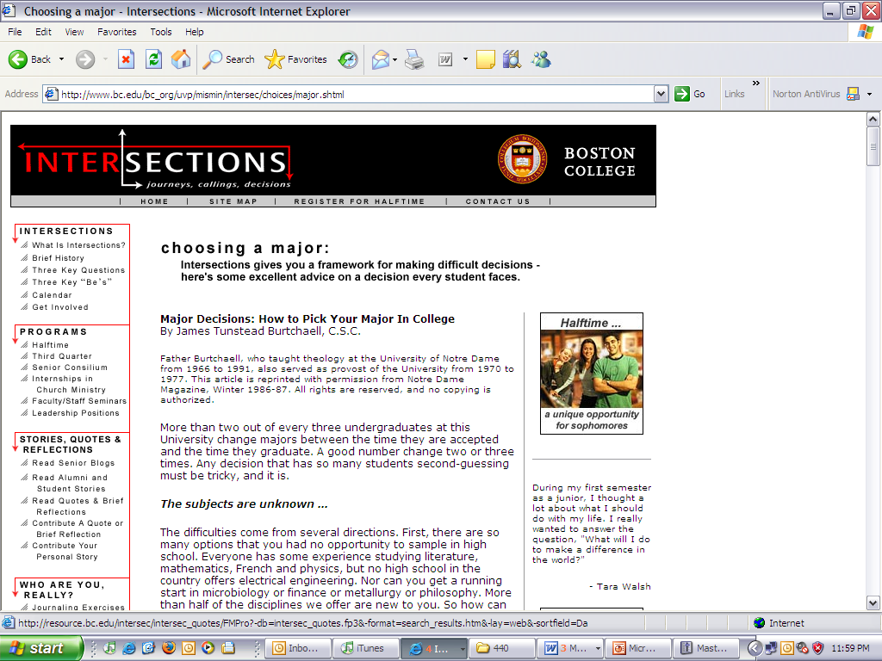

What elements do you want to use from this illustration and why? | We definitely like the logo at the top left of the page. It conveys very much what our system is trying to accomplish, that is help students make decisions at the cross road of their education career.  The breakdown on the left navigation bar is very helpful. It gives a good display of available topics without overwhelming amount of text.
What elements do you not want to use and why? | We would not use the same color schema because it is unrelated to our school color schema. The 3rd navigation bar on the right seems a big unnecessary. We feel testimonials and such would have their place within the construct of the left navigation bar. On top of that we would add a search bar, in case students need direct access to information without browsing.

Illustration 2

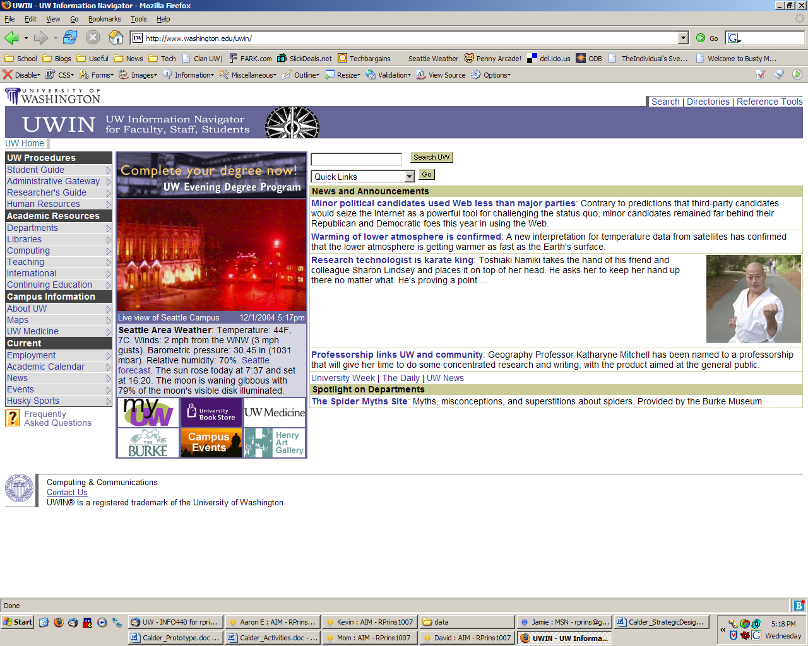

What elements do you want to use from this illustration and why? | We like the layout and the style. The one thing that is nice about all of the university pages is that they mostly have a uniformed style. They have a logo and who they are. So, you get the feeling that when you are at a page put up by the university that you are actually part of the larger system of pages. We also like the navigation and the way the content is laid out. It makes it very easy to find what you are looking for and your eyes easily float across the page.
What elements do you not want to use and why? | We would probably not keep all of the same navigation on our page. Our system will be different that the one presented above, so we will spend some time to revise our navigation to fit our needs. We will also probably drop the bottom footer on the page. It just doesn’t make this page feel very welcoming as a user.

Illustration 3

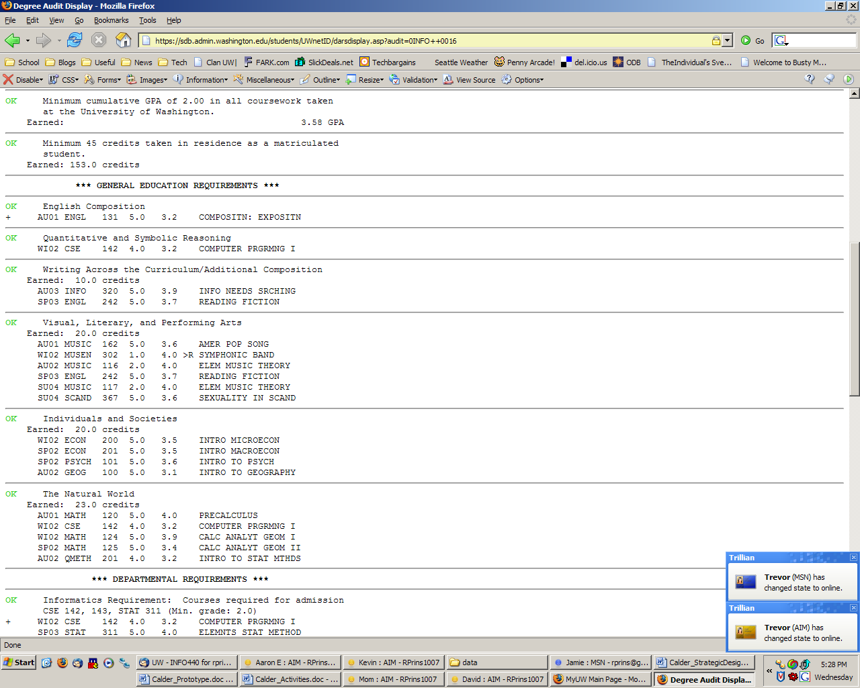

What elements do you want to use from this illustration and why? | We like the way that the course information is presented for each of the past course. While it is boring, it is easy to see what class was taken, when it was taken, the number of credits, and the grade that was received.
What elements do you not want to use and why? | The presentation is pretty boring. The textual layout isn’t really that appealing to look at. We don’t like the way it is split up. We would want it organized differently for our purposes. Also, we aren’t that interested about how they meet general education requirements, we are more interested in the classes that were taken.

