Type 1: Name: Schools
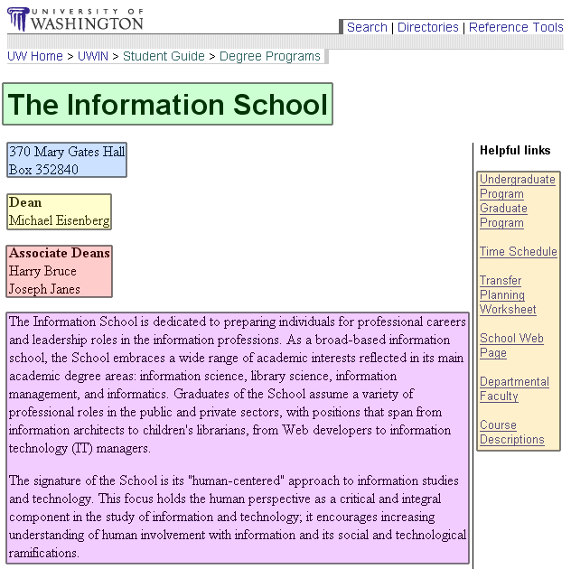

ID | Element name | Required? | Min and max | Constraints | Child of …
1 | SchoolName | Yes | 1 | The Name of School | StudentGuide
2 | Address | Yes | 1 | The true contact address
3 | Dean | Yes | 1 | The dean of the school
4 | AssociateDean | No | 0 - *
5 | Description | Yes | 1
6 | Links | Yes | 4 - * | 4 links are required, extras are supplied by the schools
7 | History | Yes | 1

Type 2: Name: Degree Programs
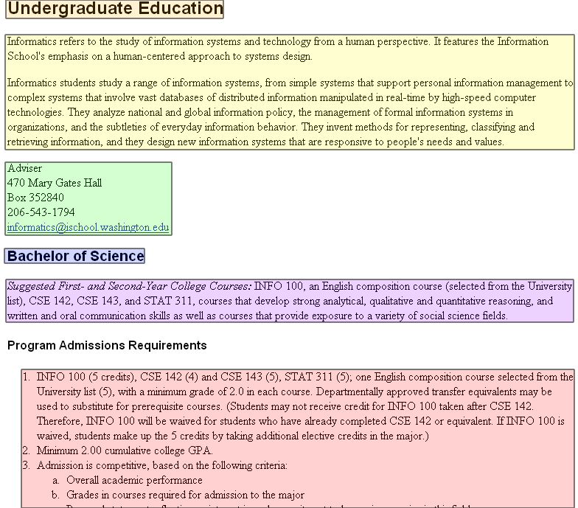

ID | Element name | Required? | Min and max | Constraints | Child of …
1 | DegreeSection | Yes | 1 – 2 | Undergrad. or Graduate | Schools
2 | Description | Yes | 1 |  | Schools
3 | ContactInfo | Yes | 1 |  | Schools
4 | Degree | Yes | 1 - * | Title of the degree | DegreeSection
5 | Suggestions | Yes | 1 |  | Degree
6 | AdmissionReqs | Yes | 1 | List of all requirements | Degree
7 | MajorRequirements | No | 1 | List of all requirements | Degree
8 | ContinuationPolicy | No | 1 |  | Degree
9 | StudentOutcomes | No | 1 | List of outcomes | Degree

Type 3: Name: Courses
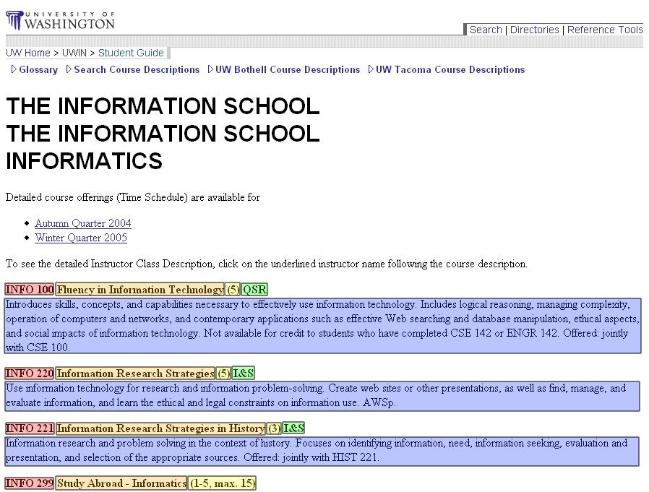

ID | Element name | Required? | Min and max | Constraints | Child of …
1 | Name | Yes | 1 | 8 – 16 chars
2 | Title | Yes | 1
3 | Credits | Yes | 1 | 1 – 15
4 | CreditType | No | 0 - # of types | NW, I&S, VLPA, W, etc.
5 | Description | Yes | 1 | Text Field

New Type: Degree Characteristics

ID | Element name | Required? | Min / Max | Constraints | Child of …
1 | RelatedJobs | No | 1-* | List of jobs related to degree | DegreePrograms
2 | RelatedInterests | No | 1-* | Example general interests of majors | DegreePrograms

The Content Domain

What one or two sentences fully summarize and capture the nature of the content in the types? This is your content domain statement. | The information about majors on campus and what it takes to get into these majors. This content also includes past classes and academic planning.
What few questions clearly put a piece of content within or outside the domain? | Is this offered at the University of Washington?  Could this help determine a path to success at UW?  How accurate is the information?  Will this information be needed to get into xxx major?

