Major Finder For Undergraduates

System Design Report

Prepared by : Team Calder

Pei-Wen Chang
Aaron Egaas
Irvin MacQuarrie
Dan Podhola
Ryan Prins
Kathryn Tong

Revision History
Date | Status | Revisions and comments
Fri, 12/3 | First draft | Multiple revisions made. This was the fist compilation of the entire report. – RP
Sat, 12/4 | Second draft | Added team responsibilities, User Analysis, made revisions, minor correction to report -KT
Sun, 12/5 | Third draft | Again, more revisions. Added in prototypes and usability. Updated parts of the appendix. – RP
Sun, 12/5 | Fourth draft | Added Overview, many more minor revisions. Reorganized Usability section -KT
Mon, 12/6 | Fifth draft | Reviewed previous changes. Added write-ups for two interactions that were not written about. Accepted past comments. Prepared file for submission. – RP
 | Final

Introduction

Overview of Methods
Our main goal in this report is to fully inform sponsors of the methods we used to design our information system. Below is a list of methods along with a brief summary of results we acquired through out this project. For specific details on particular methodologies and results please refer to their appropriate sections.

Methods used:

- The Design Problem
  - In this method, we considered essential key points such as Goals, Audiences, and Information to extract a triple statement that guide the rest of our design toward a specific direction.

- User Analysis
  - To better focus the team, and to have a clearer sense of targeted audience, we brainstormed, sketched and finally refined this audience to a single persona.

- High Level System Requirements
  - Interviews were conducted specifically to infer Information, Presentation, and Task requirements from our stakeholders for this design.

- Information Analysis
  - Topic mapping and card sort methodologies were used to get our final taxonomy and content structures. A clearer content domain statement was also derived from this.

- Activity and Interaction Analysis
  - We anticipate many main activity and interaction on our system via the profile of the created person. Through our hierarchical task analysis models we narrowed down to just three main interaction user will experience in using our system.

- Prototype
  - Rough wireframes were draft to present key content models of our system. Later our prototype developed into a more sophisticated and more realistic platform, the web, where many of major component were made interactive.

- Design Evaluation
  - For this final part of our design process, we opt to conduct several usability studies based on the prototype created. We gained many useful feedback from user that will be incorporate into our real design.

Team Roles and Responsibilities

Team Leader: Ryan Prins

Sub teams:
- Dan Podhola & Aaron Egaas
- Pei-Wen Chang & Irvin MacQuarrie
- Kathryn Tong & Ryan Prins

Our team consists of six members: Pei-Wen Chang, Aaron Egaas, Irvin MacQuarrie, Dan Podhola, Ryan Prins, and Kathryn Tong. As a group, we elected Ryan Prins our team leader at the outset of the project. He was in charge of setting up our team website (http://calder.lazyi.net), calling meetings and keeping the team on target. Given the deadline of our project, we decided to split up the work evenly between 3 subgroups. This is different from our first approach of two sub teams (Pei-Wen, Irvin, and Ryan in one group, while Kathryn, Aaron, Dan in another). However, after review of the time requirements for the project and the availability of team member we realized that three groups of two team members would be more feasible for this project.

Each sub team was in charge of working on two to three methodologies for our design system. At the end, Team A put together the presentation, Team B did one more methodologies than the rest, last but not least Team C put together the final paper. The complete breakdown of completed group work is outlined below:

Team A:
- Completed Content Modeling Section
- Completed Prototype Section (3 Interactions)
- Compiled Presentation

Team B:
- Completed Information Architecture Section
- Completed Interactions Section
- Completed Usability Section (3 Interactions)
- Completed Organization Overview

Team C:
- Completed Requirements Section
- Completed Activity Section
- Compiled Paper
- Revised Paper

In addition to the sections that were completed in teams of two, we also worked out the first two parts of the design as a team. The strategic design portion of this report was created as a team at our second meeting. This was to ensure that we all began the project with the same understanding and vision. Our persona was created by Aaron Egaas, Kathryn Tong, and Dan Podhola when we were working in the groups of three that was mentioned above. This was the only section completed with that team grouping. Over the entire course of the project this small team work within the larger team is what drove our report and our success to the product that follows.
Organization Overview

We are the Undergraduate Gateway Center at the University of Washington – Seattle. Our job is to help students with academic or administrative problems through advising, workshops, and other services. We are available to all UW students at no cost and appointments can be made at anytime for virtually any academic reason. Our advisors are available five days a week and also via the various workshops that we offer throughout the year.

We see this project as a way to better use the time of both students and our advisors. If we can provide a service to help students identify potential majors, not only will they be happier, but we will be able to better spend our time helping students with other issues such as academic probation, transcripts, etc… We believe that with the implementation of this system, students will find a major that match their interests which are unaffected by irrelevant factors, such as: picking only popular majors (i.e. CSE, Pharmacy, etc.). If students are content with their majors, there will be less changing of majors. This will subsequently lighten the load of our advisors and make better use of their expertise.

This project fits into what we do as an organization because this system is being developed to better help students with a very common problem, finding a major. We are in the business of giving students realistic choices. With the addition of this system we are leaving the choice in the student’s hands. Ultimately, they are the ones that will decide on what major to apply to. Therefore, it is up to them to see how they match up to an intended major. With the help of this system, we will reach our organizational goals, as well as make it easier for students to take more control of the process when finding a major.
The Design Problem

To solve our design problem, we felt that as a group it was important we meet to discuss the strategic design lab and formulate our triple. On Monday, November 1st, 2004 we met as an entire team to discuss ideas for our project and develop a triple for our system.

As a team, we completed the strategic design lab. We discussed the different possibilities of our system, major finder for undergraduates, and how these could be accomplished with the system we would be designing. We had a very robust discussion on all parts of this lab. The participation of the entire team was very high and we wanted to make sure that at the end of the meeting everybody was on the same page. We felt that starting from the same point was crucial to completing this design project. The following is a summary of the main points found in the strategic design lab.

Goals
- Help Students find majors faster
- Help majors find applicants
- Save advisors time

Audiences
- Program Advisors/Coordinators
- Students
- Undergraduate Gateway Advisors

Information
- Requirements to get into a program/major
- Type of job you can get with that major
- Past classes
- Things that match student interest

From the information gathered during this process we came up with our initial triple:

By delivering recommendations for a major that matched student interests to students we will be able to help them find their major faster because the service will contain pertinent information

This triple was used for the entire design process. However, at a later team meeting, we realized that we were straying away from this initial triple. Our first thought was to design a system that would provide the student with an interest questionnaire and then base the results off of that questionnaire. Later, in the process of discussing activities and interactions, we found that this was not as important a requirement and was something that we were not going to be designing for. So, we went back and slightly altered our triple to reflect the changes that we had been performing all along. The modified triple looks as follows:

By delivering recommendations for a major that are based off past classes to students we will be able to help them find their major faster because the service will contain pertinent information

The only change in the triple was the removal of “matched students interests.” We replaced this with “based off past classes.” This change was made, not because we thought that we were on the wrong track with our triple, but to reflect the current status of the project. We soon realized that the triple revision did not need to be completed and the revised triple was discarded.

But, again, as is common in any design process, another discussion was brought up in regards to our triple. We felt that the initial triple would be sufficient for our project and that a change in triple would render the work that we had already completed under our initial triple useless. The scope of the project would have completely changed. However, we looked at the part of the triple that we were discussing, “matched students interests,” and we took that a step further by limiting that interest to their past classes. As you read through this design report, you will see that this is prevalent throughout.

Lastly, to avoid confusion, the final triple we agreed to use for this design process is listed below:

By delivering recommendations for a major that matched student interests to students we will be able to help them find their major faster because the service will contain pertinent information

An information system that we feel will meet the challenge of this triple is some sort of online form. This system will assess students past classes and will produce a list of majors that could be of interest to the student. Students will also have the opportunity to have certain past classes be excluded for this recommendation. Everyone takes a class that they dislike and we will give them the chance to exclude that class from the information system.

This system will also only produce recommendations for the students to later look at for more information. It will not start any process of application to a major. We feel that by assessing their prior classes we can design a system to help these undecided students find a major that will be of their liking. Students will also be able to browse various majors in one location as well as view specific information about those majors in the same location.
User Analysis

Methods We Used

After understanding our organization’s goals, we are faced with the challenge of meeting the needs of our targeted audience. Since our audience will basically be any current UW students and any transfer students who have yet to pick a major, it will be difficult to scope our design for all of them. In order to have a better design target, our team decided to follow Wodke’s methodology of creating a persona.

For this part of our design process, a meeting was held on November 4th, 2004 to discuss the needs of our audience. Since we already are immersed in the natural setting of our intended audience, we decided to keep the research to a minimum, focusing more on the brainstorming process. Our group brainstormed to combine the many stereotypical characteristics of undecided college students into a persona into a large list. We fine-tuned this list by removing unnecessary details, we then sketched out how the characteristics of this persona relate to one other.

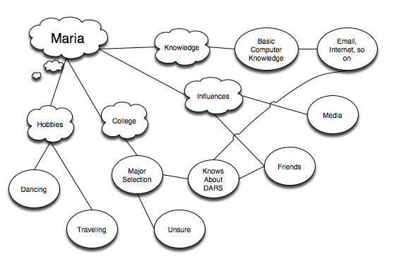
Figure 1: Persona Brainstorming Map

To sum it up, below is our archetypal persona:

Who is she?

Maria Sangria is a sophomore at UW. She wants to enjoy college and doesn’t hold a job. She likes to have a good time. She likes many of her classes, but doesn’t know what major she wants to commit to. She knows there are many majors out there and is unsure where to go next.

She is the oldest of two in her family. She lives at home with her parents because she’s a very family oriented. She was born in the states but can speak a little of Spanish at home. She wants a job or career she enjoys but make a decent living at the same time.

What she wants

- Find a good job after graduation
- Do well in School
- Enjoy school with friends
- Stay close to family
- Find a major that she would enjoy

How should it be delivered to her?

- On web site
- In person
- Email

What she doesn’t like

- Being pressured into picking a major
- Overwhelmed by information overload

Out of this process, we gathered our persona’s major goals, her essential demographics, current attitudes about our service, past experience, needs and desires for our new system design. Lastly, to pull it all together, we personalized this persona, making her more real our team, by giving her a name, typical personalities of our users, and we even included a picture. Below is our completed persona:


Maria Sangria

19/female/single/Yakima, WA

“I just want an easy way to find a major on my own time, without having to wait in line at the Gateway center.”

Profession: Student
Personal background: Mexican American, bilingual college student from Yakima, Washington. She graduated with honors from Yakima High School. Marla is the first one in her family to attend college, and it is a very big deal to her that she graduates from the University of Washington and is able to pay off her student loans, but that won’t stop her from having a good time along the way. She is very ambitious and has many dreams and aspirations. She hopes that the university can help her meet some of those.

Goals: Marla wants to become a party planner to the stars. However, she wants something concrete she can fall back on if P. Diddy doesn’t choose her to plan his next birthday party. She enjoys volunteering and being active in social issues that interest her. The problem is, there are many majors to choose from that Marla could perform well in. Marla wants to find a major that will help her fit her life goals with her academic goals.

Now, with a clearer sense of what our users are about, we will be able to deliver exactly what they need. Our next step is to consider how we can do this in a manner that will support our organizations’ goals and requirements.

High Level System Requirements

Methods We Used
To complete this section of the system design we held a meeting between the designer (Ryan Prins), student (persona played by Kathryn Tong), and our boss (fellow student Jamie Yaptinchay). This meeting took place on Tuesday, November 9th. We sat down for around an hour and the discussion was lead by the designer. Both open ended and close questions were asked to get as many responses as possible.
After the meeting concluded the designer completed some notes about what was discussed and focused his answers to questions in four requirement categories. These categories and the requirements are described below.

The information that we took from the past meetings were our persona, Maria, and also our triple for our system. These two items were crucial for us to complete this meeting in a timely manner. It should also be pointed out that boss characteristics were created to give our acting boss a better idea what our real boss would be like.

The Designer
Driving the conversation about the requirements was the designer. He asked many open and close questions to get a feel for what the system was envisioned to be. There was a large need to get as much information as possible to then take to the design table. Because of this, many questions were asked to gather information. The information that he gathered was funneled into four sets of requirements:

- Information Requirements
- Presentation Requirements
- Task Requirements
- Technology Requirements

Each of these four categories generated a lot of conversation between the designer, student, and boss. Below, the main points from each of these categories will be outlined. These requirements are not presented in a preferential order.

Information Requirements
The information requirements were gathered to find out what kind of information was desired of the system. This information was deemed pertinent to the system and is presented below. The sub point is a brief description of each requirement.

- Information about programs
  - Requirements, admission material, community college equivalents.

- A timeline of steps for applying to a major
  - This is a timeline of events that should be taken from admission to UW to applying for a major. It should depict when students should looking for majors.

- Contact information for program advisors
  - Information about the different program advisors and how to contact them for further questions.

- Interest survey
  - After students take this interest survey they will be provided with a list of how some potential majors may apply to their specific interest.
  - “After I take the survey I want to know how my interests apply to specific majors. Have both a general questionnaire for all majors and also major specific ones to see if the major is actually right for me.”

- Reverse course listing to related majors
  - “If I take CSE142, what majors can I get into?”

- Listing of courses
  - The basic run of the mill listing of courses for each major.

- Related majors based on a class taken
  - Similar to how schedule finder works, student expects to see majors based on a class she is either taking or plans to register for.

- Related majors
  - “What majors are related to CSE? I want them to know so that they realize that they have options.”

- How to contact advisors
  - Basic contact information for campus advisors. This should information should be on every page.

Presentation Requirements
The presentation requirements were gathered to see how the above information should be presented to the user. These requirements are just as important as the information requirements. Particular detail was given to how they wanted the information presented. The presentation requirements are presented below. More information about these requirements are located in the sub points.

- Look professional, but not overly professional
  - Want it to look cool and fresh, but not so professional looking that it will turn students away.
  - “Facilitate the feeling that we want them to get in the presentation of the page.”

- Not intimidating
  - Sometimes less is best. Friendly is better.

- Ability to browse majors
  - No static list to select from.
  - “If I have an idea I want it to be geared for me.”

- No Pink on the page
  - Studies say that men do worse when pink is on the screen, or so it is heard.

- List suggested majors in order of suggestion
  - Need the listing explained if you are to do it this way.
  - “I am unsure how it is already so I want to know what they are doing to suggest things to me.”

- It is ok to look different than stock university layout
  - Must look credible, but it could also be different from what is the current status quo on university pages.
  - “It just needs to look ‘official’”

- Open extra information in a new window
  - “I want to have my results in one window and all of the extra information presented in separate windows for my review.”

Task Requirements
The task requirements were needed so that the system could take shape for the types of tasks that will be performed on the system. These tasks are in addition to what the system is designed to do (help students find a major based on interests and/or past classes). It is important to hear from the boss and the student what they want the system to accomplish. They have preconceived notions on what they want it to do, so we want to make as many of these tasks happen as we can. The task requirements are presented below. For more information about these requirements please review the sub points for each requirement.

- Obtain Feedback
- Get feedback on the system from those who use it so that we know what we need to upgrade or what to keep.

- Open to all students
  - Don’t limit it to just UW students, we might have community college students using this system as well.

- Remind me later
  - Send a reminder on things that I have found or make a profile that I can review at a later date. Similar to how DARS operates with its reports. Like a “My Cart” for finding a major.

- Ability to schedule an appointment with an advisor
  - Make it easy to get in touch with advising to setup an appointment.

Technology Requirements
The technology requirements are collected so that the system designers know their technological limitations when designing the system. They want to avoid any conflict with currently implemented systems and to be able to have the system be integrated as seamlessly as possible. The technology requirements are presented below. For more information about these requirements please review the sub points for each requirement.

- Web Advising
- Meeting an advisor in person is intimidating and if there was a way to do it online there would be less intimidation. This could be in the form of a web chat or e-mail. The boss doesn’t like this idea at all.

- Work in multiple browsers
  - We want all students who use multiple browsers to be able to use the system the same way.

- Seamless technology
  - Make it seem simpler than it really is. I don’t care what it does in the background, just as long as it works.

- Keep technology in line with what is currently in place
  - We want to use technology that we currently have in place. Nothing new that could potentially throw the whole system out of sync.

All of the previously outlined requirements are very important to us when we are designing this system. We want to make sure that we take into account all aspects of the requirements for the system. Below, the student and our boss will go through how they thought the meeting went and also what they require of the system.

Student Stakeholder
Maria Sangria was asked to participate in an evaluative interview for a new Undergraduate Online Advising system. Maria has a lot at stake in this new system. She is in the midst of starting the process of major-hunting. Having this system in a way that she would find useful will help increase her chances at finding a major, based off of her interests, in a much shorter period of search time. Here are some of the things Maria recommended for the system, in a ranked list.

Essential Needs:
- A timeline of steps for applying to a major
- Interest Survey
- Reverse course listing
- Listing of courses
- Related majors based on a class taken
- Ability to browse majors

Wow Features:
- List suggested majors in order of suggestion
- Open extra information in a new window
- Remind me later
- Web Advising
- Seamless technology

Final Thoughts:
After participating in this interview, Maria stated that she felt the designer did a good job of listening and understanding her needs. She would like to also have the option of referring majors to close friends and likewise have majors referred to her by friends, if they happen to stumble across majors that they feel might fit each other. Maria is glad she was able to participate, but however, did not feel completely confident that her design ideas will have a lot of impact on the actual design of the future system. She knows it will be difficult to steer away from traditional advising methods. She also knows that this system would provide her some help, but ultimately she might have to do what she dislikes very much, consult with an advisor in a face-to-face session. She has great hopes that this system will at least provide her with enough major choices to have her prepared for this advisory meeting.

Boss Stakeholder
The boss is expecting to see a system that will alleviate some advising workload in the office, but not completely eliminate the current method of advising. She truly feels meeting with advisors in person is an invaluable tool to students, and they should have this option available at all time. If not for her boss pressing for such a system, she would not have wanted this system implemented. Since this needs to be done, she wants it to be as efficient as possible. Below are some things she wants incorporated into the new system.

Essential Needs:
- Requirement information about programs on campus.
- Contact info for program advisors
- Listing of courses
- Related majors
- How to contact advisors
- Look professional, but not overly professional
- List suggested majors in order of suggestion
- Open to all students
- Ability to schedule an appointment with an advisor

Pluses:
- Work in multiple browsers
- Keep technology in line with what is currently in place

Final Thoughts:
The boss felt that the designer mostly asked all the important questions, although he failed to ask about the budget. She plans to discuss this later with him in a another meeting, as this is a concern from her boss as well. The boss was able to voice her opinions many times, especially with regards to contacting actual advisors in person. She feels that designer will create something very close to her expectation. Since she has worked with this team of designers in the past, she is confident that this will incorporate many of the students’ needs as well as her department’s needs.

Information Analysis

Information Architecture

Methods We Used
We took the information from the triple, persona, and requirement analysis in order to derive a list of words to form the overall architecture for the information that will reside on our system. This is crucial for us, because it gave us an idea of what our users are actually looking for and expecting in our system.

Since there aren’t any existing websites that we know of to compare and extract content types, we decided to use the University of Washington Course Catalog (http://www.washington.edu/students/gencat/) as a base for modeling our content. The models derived were basic, but contain all of what is required to get the essential information to the users. Further research would be necessary to write questions that would help recommend programs and classes to students. The questions would need to be professionally analyzed to determine if they could be used to recommend result that students would like, benefit from, and courses the students could excel in.

In order to better understand the information we need and the relationship between them, we applied the topic mapping and card sort methodologies. After reviewing the triple, persona, and requirements that we have gathered thus far, we made a list of 34 words and phrases that describe the information that our stakeholders would like to have in the system. We then sorted the words and phrases into two categories: subject words and type words.

After this, we narrowed the list of subject and type words down to 27 words and clustered them in a topic map . We used lines and circles to indicate the relationships between the information..

See our topic map below:

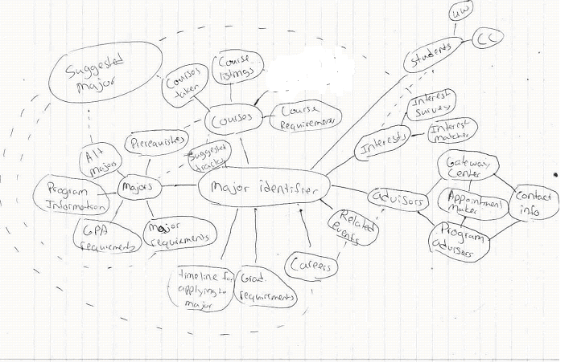
Figure 2: Topic Map

Then we tested our set of words with two users by using the card sort methodology To do this, the terms we chose in the topic map stage were written on a set of post-it notes. On the back of every post-it note we gave each a unique ID number, this is so that we can identify these topics later even if the users decide to change the names on the original label. Users were asked to categorize and subcategorize as they see fit the labeled post-it notes. Additionally, we also provided blank post-it notes so that users can add or modify terms as needed (open card sort). Both users were asked to do this task without any idea how the other might have sorted the post-it notes. We noted the results from each user’s categorization.

After the card sorting, we compared the users results with our initial thoughts and then produced a final taxonomy that takes the users into account.

Final Taxonomy

Term Id | Term
25 | Students
2 | Community college students
3 | UW students
27 | Advisors
18 | Gateway center advisors
9 | Advisor contact Information
11 | Program advisors
1 | Appointment maker
26 | Interests
12 | Interest survey
4 | Interest Matcher
20 | Suggested majors
22 | Suggested tracks
8 | Careers
6 | Related Events (Event)
15 | Majors
5 | Timeline for applying to a major
23 | Alternate majors
16 | Program information
17 | Major requirements
21 | GPA Requirements
13 | Classes Taken
7 | Prerequisites
10 | Courses
14 | Course Requirements
24 | Courses Listing
19 | Graduation requirement
Figure 3: Final Taxonomy

The access structures will provide users a method of getting around the site and also help them determine where within the site they are. It will also help us group our content better. Our most important and unique access structure would be a form to help recommend classes and programs to students. This application will look at the student’s transcript to determine feasible majors, minors, and recommend classes and schedules

Based our participants categorizations, we decided to have only five top level hierarchies, which are Students, Advisors, Interests, Event, and Majors. In the Students, Advisors, Interests and Events group, there are only two levels of hierarchies. That includes a name of the top level hierarchies and subcategories. For example, Student is the top category with two subcategories, which are Community College students and UW students. However, in the Majors category there are three level of hierarchies due to the Major Requirements subcategories.

Justifications

As stated above, we decided to have only five top level hierarchies, which are Students, Advisors, Interests, Event, and Majors. Contrast to our initial thought, which can be seen in our topic map, our participants tended to group Career Information with Interest.

For the Student and Advisors groups all participants agreed with our initial categorization; therefore, we kept the grouping the same in our final taxonomy. In the Interests group, our participants’ definition of “related event” differed. One participant thought that it was related to the interest but the other thought that it’s the event for different major departments. We decided this topic deserves its own independent section. For example, an event could be both related to a students interest and a major. Moreover, events that we are talking about here also include all events that are related to major choosing.

For the Major group, we decided instead to have only two levels of hierarchies. We chose to give it more depth, as a result to participant two’s taxonomy. Lastly, we decided to put all the requirements under major requirement section inside the Major group.

Content Models and Access Structures

We modeled our content structures from UW’s current model for displaying information regarding schools, majors and classes from the University’s website at http://www.washington.edu. The content types are listed below:

 | Content Type Name | Quantity on the site | How this type supports the triple
1 | Courses | As Many Courses that UW offers | Courses are what every major consists of and therefore must be available for prospective students to browse when selecting a major.
2 | Degree Programs | As many degrees that UW offers | Looking individually at all the degree programs the UW offers is a great way to find a major that interests you.
3 | Degree Requirements | One for every undergraduate degree | Degree requirements inform prospective students of “what they’ll be getting into” before selecting a major. If students find a major and then find out that the courses in the degree requirements are not what they expected, they might find a different major.
4 | Course Evaluations | Thousands | Course evaluations help students evaluate courses in a degree program. For example, after looking at some of the degree requirements for a major a user might then examine the course evaluations.
5 | Student Services Contacts | About 100 | The student support staff is instrumental in helping students who are confused about picking a major find needed information and pick a path.
6 | Course Grades | Total number of classes taken | Students need to be realistic about what majors they can get into (especially competitive majors) and knowing your grade break down can assist with that.
7 | Schools | 150+ | The list of schools within the UW is a gateway to degree programs.
8 | Class Schedules | Number of courses per quarter | Planning a schedule is important to know if a student is planning on starting a path for a particular major and if it is at all possible because of time constraints.

Table 1: Listing of Content Types

The main access structure needed to drive this application home is the questionnaire forms. These assist students by recommending majors, and classes and schedules to students and we expect the users will use this the most to find our content. We will also build a search component to help students find more information about majors and classes they hope to take, if they have an idea of what they want, we won’t force them to answer a bunch of questions, they can have instant access to the information. Thirdly, we plan to implement the taxonomy we derived from above to help give structure to the wealth of information present in our system, and it will help our users navigate the tool effectively.

Access Types
To further define our content, we came up with a list of access types that describes the restrictions we apply on content of our system. The following table is the complete listing of our access types. Each of these access types has a very different use in the overall scheme of our system.

Name | Type | Where is it used? | What content types does it allow you to access? | How does it support the triple?
Academic Planning, Seattle Campus Menu | A list of links to academic planning links | Towards the top of the MyUW page | Courses, Course Evaluations, Student Services Contacts, Schools, Degree Programs, Degree Requirements, Class Schedules | Provides access to information to assist students in selecting an appropriate major. Students need access to good information about how to plan their academic career and these links help them do just that.
Student Personal Services | Links to student-specific information | Towards the top of the MyUW page, above the academic planning menu | Course Grades | Provides student-specific information to the student. This enables them to make realistic decisions when choosing a major. It will also show them what they have done in the past, items related to finances, and other issues that are related to a student being enrolled at UW.
Search UW | Searching System | Top of Every page directly in the UW system | Potentially everything but course grades. | It allows the student to search for things that they are interested in. They can search for specific information that might be hard to find, but a search might bring it up for them. This helps the triple because it is giving the student the information they need to make a decision about choosing a major.
List of prior classes* | Ability to use classes to help find a major | Transcripts, DARS, all over MyUW | Courses, Course Grades | The use of past classes will allow students to see what majors they are close to getting into as well as what majors they are currently available to get into. This supports the triple because this information will show students how close they are or could be to getting into a major.

Table 2: Listing of Access Types

Content Domain

To clearly state what content users can expect to find or not to find on our information system, we have to develop some type of statement to inform the users of our content domain. That domain specifies what sort of information we will allow on our site. Based on the above listed content types and access types, we have formulated the following content domain:

The information about majors on campus and what it takes to get into these majors. This content also includes past classes and academic planning resources.

How This Could Scale

In order to increase the scalability of our stated content domain, we would first need to analyze all of the current types to verify that over the large scale (across all of campus) that it would work for our system. From there, we would compile the data in a format that our system would use. This could be the creation of new content types to meet the need of our system or keeping existing content types in place. Once all of the data about the majors on campus has been collected we could then see what new content types are created off this aggregation of data. It is important that we cover as much of the available content domain as possible. This system is designed to be implemented for the entire UW system. We need to be sure that all of the content types and information from these individual departments or majors will be incorporated into our system. Much of this information is already available online. However, we need to validate that this information is up to date. The last thing that we need is to have our system report that a student is close to getting into a major, or is already eligible, when in fact the requirements have changed.

Activity and Interaction Analysis

Methods We Used (Activity Analysis)

Up to this point, we have clearly stated our organization’s goal, developed a clear image of our persona, gathered main requirements, and also further defined the information within our system through methods of information of architecture. Our main goal in this section is to use all of the specifications from these previous methodologies to establish a better understanding of our users interaction with our system, anticipate these interaction activities and figure out a way for the system to deliver.

After reviewing each of the past methodologies, we extracted three major possible tasks that our persona would likely want to accomplish through the use of our systems. For each of these tasks, we further defined them with a brief description, how our persona would go about completing this task, whether or not she already has an existing process, and how incorporating this into the system would support our triple. Lastly, we came up with metaphors for each of these tasks. Below is the complete information about these three tasks.

The Tasks
- Look for pertinent information
  - Description: Maria (our persona) is really interested in finding information that is relevant to what she is looking for. There is some information that she already knows, but there is a wealth of knowledge that is out there that she is looking to absorb. However, she doesn’t have the time to sift though all of that information to find the pertinent information. So, she is looking for information that is labeled well and that will fulfill her information need.

  - Frequency: Since selecting a major is more likely than not a one time thing, we anticipate that this tool will be used heavily during her first two years of studies while at UW. She would most likely use this system when she has to register each quarter to see what classes she needs to take for the upcoming quarter to stay on track to get into a major. Once she is in a major, we believe that the use of the tool will fade away.

  - Current Process: Right now she spends a lot of time looking around the various UW sites trying to find out what she is interested in. But, it is hard for her to cross compare the different programs in her mind. What she usually does is start at the UWIN site and navigate here way to the different schools’ websites to see what requirements they have for their major and what the program is really like.

  - Support Triple: We understand that Maria is interested in a lot of the classes that she takes. But, she needs to be able to round that down and pick a major based on her interests. By providing her pertinent information about what program(s) meet her needs/requirements as a student she will be able to pick a major that she will enjoy. It is of importance to her that she finds a major because she is the first of her family to ever attend college and she doesn’t want to let her family down.

  - Metaphor We think the metaphor of a needle in a haystack is a good representation of this task. Maria has to sift through all of this information to find that one piece of information (needle) amongst all of this other information (haystack). If the pertinent information is presented to the user they will not have to spend a lot of time digging through the haystack of information to find that needle that they are looking for.

- Input past courses and gain suggestions of one or more majors
- Description: It is often difficult to figure out what majors are relevant to the previous classes taken. So, we want to provide Maria a way to input the classes that she has taken and see what majors she could apply to or be close to applying to based on the classes that she has input. This will hopefully help her round down the list of majors that she is interested in and help her focus on getting into a major that she will enjoy.

- Frequency: Maria would probably not use this tool that frequently. Its use would be centered around the times when she will register and also when deadlines are due for major applications. We recognize that some majors take more courses to get into than others, so this tool would be most helpful in the beginning when seeing what classes still need to be taken for a major based off of the classes that she has already taken. The benefit of this to Maria is that it gives her options taking into account what she has already done.

- Current Process: Maria probably does not have a current system for looking in majors and what classes she has taken are required for that degree. She is so consumed with her classes and how much she enjoys them that she has not had much time to look back at what she has taken to be able to apply them to a specific major. What she does currently is look forward. She looks at a program that interests her this quarter and takes some classes in it that she might enjoy. However, this changes quarter by quarter and she has yet to set her self up to get into one specific major.

- Support Triple: We are interested in helping Maria find a major that she would enjoy. She is always mentioning that she loved the classes that she took and by letting her put those into a system that will provide majors that she can apply those classes towards, she will hopefully find a major that she enjoys as well.

  - Metaphor: Because Maria is taking something that she has in order to get something out of it we feel that the metaphor of a cook book is a good one. A cookbook takes things that you already have (or maybe there are things you need to get) to reach an end goal. So, we feel that it is fitting based on this task to use a cookbook as the metaphor.

- Figure out what the degree requirements are for a specific major
  - Description: One of the things that every student needs to figure out when they are at UW is what major they want to take. To do this, they need to find out what requirements are needed to get into that major. Some are open, some have competitive admissions. Beyond that, there are specific classes that need to be taken to get into each major. This task aims to make it easy to see what is required to get into a specific major as well as what is required once students are in that major.

  - Frequency: This task could be completed a lot when deciding what major Maria is interested in pursuing. We don’t see this task getting a lot of use after they are in their major since DARS does a great job of outlining what needs to be completed for their specific degree. So, this is a tool that we feel will be used as a pre-major so that Maria can see hat she needs to take to get into the major and also what the requirements are if she decides to pursue that major and gets into that major.

  - Current Process: Right now she goes to the different web pages put online by the different programs on campus to look for what she needs to complete and what would be required of her. But, she doesn’t like doing this all over the UW site. She wants it in one location. She feels that it will save her time, as well as frustration if she can get all of this information from one location.

  - Support Triple: This task supports our triple because it is providing the aggregated information that Maria needs in a single location. Mainly, it supports our triple because it will show her what needs to be completed for entrance into a degree as well the requirements when she gets into that program.

  - Metaphor: The metaphor of LEGO blocks is one that is fitting for this task. Each class is like a LEGO block. You need so many to complete one task, but there are more blocks needed to complete the overall goal (graduating w/ degree).

Based on these tasks, we then used a method called Hierarchical Task Analysis to map out the mental processes of our persona. Our take-away for this part was two HTA models mapping out the third task (Figure out what the degree requirements are for a specific major ). The main difference that we found when comparing the HTAs was their levels of complexity. One HTA had very complex steps and was very thorough, while the second HTA was more top level and contained more general categories. What both of the HTAs agreed upon was the general process, to varying degrees of detail. This common general process, identified by both HTAs, was for students to first review past classes, then match a major to interests, and then try to register for classes for that major.

While neither HTA approach is the “right” approach, the fact that we can see the difference between the two HTAs is our take-away is from this exercise. Being able to see the differences is key when looking at the broad scope of what users might do to complete a specific task. We also completed this task so that we can gain a better understanding of our user’s mental model. Making two mental models helped us to appreciate the range of differences when it comes to a person’s mental thought processes. It also opened us up to a wider range of possibilities on how to complete the same task.

Through the course of identifying likely activities, we also searched the web and found similar web sites that provide students with guidance about majors. We highlighted key elements that make them a good web site and other elements that we could learn to improve from. Below we will outline the rough idea of what we liked and what we didn’t like. Also, following the breakout of our likes and dislikes you will see the illustrations that we based these findings off of.

What We Liked
- Logo at the top left
- Breakdown on the navigation bar (easy to follow)
- Uniformed style between pages
- Easy viewing of the pages—easy on the eyes
- The way course information was presented in DARS

What We Didn’t Like
- Color schemas
- Excess navigation—navigation on the left and the right
- Footer on pages
- Textual presentation—makes for a very boring webpage

From these likes/dislikes we are able to take these forward to the designing process later on in prototyping. These will be very important parts to take forward and by having these we will better be able to create wire frames and prototypes that will satisfy our system design.

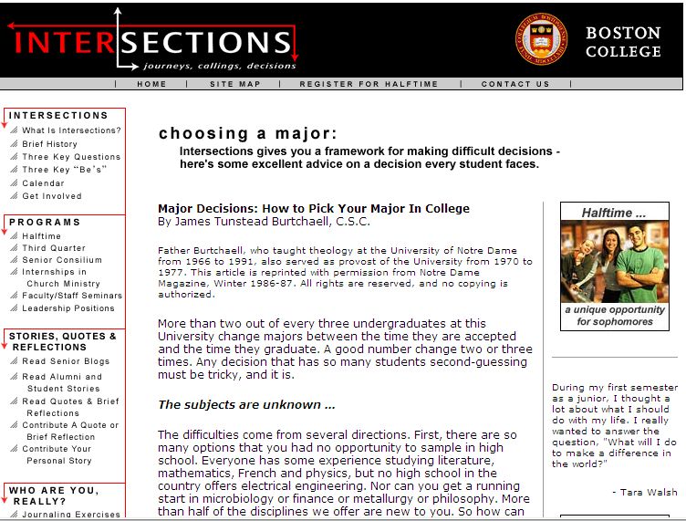

ILLUSTRATION 1: Boston College Choosing a Major Website

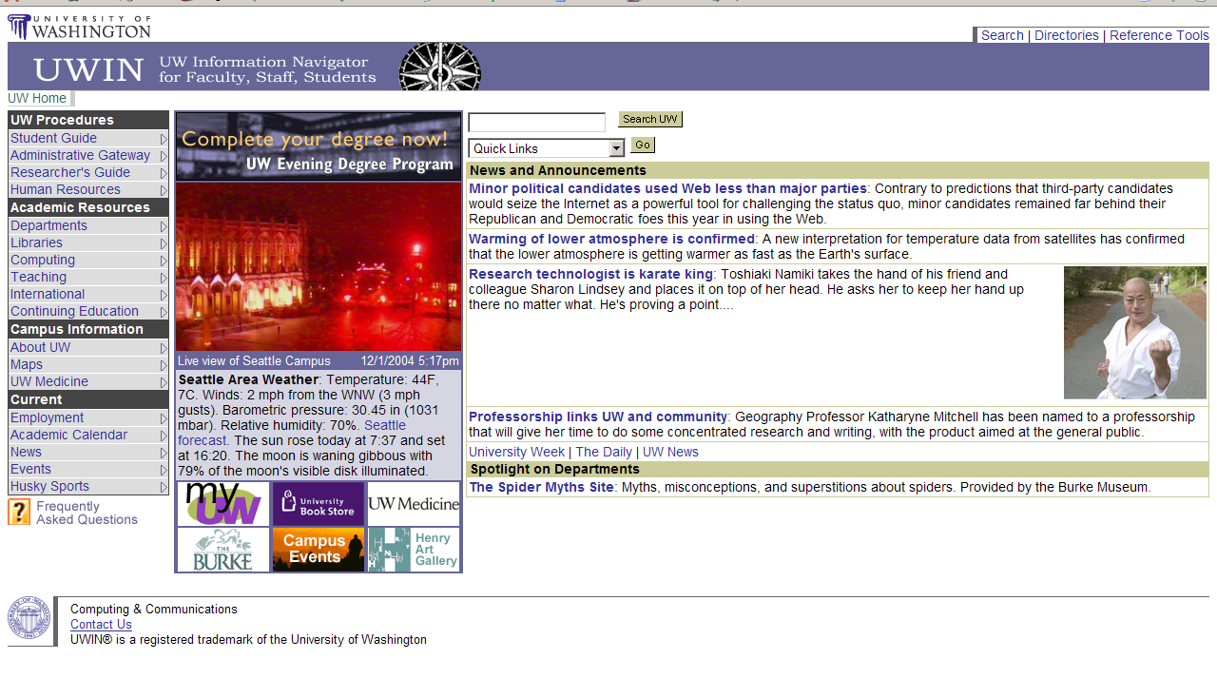
ILLUSTRATION 2: UWIN Site Found at www.washington.edu/uwin

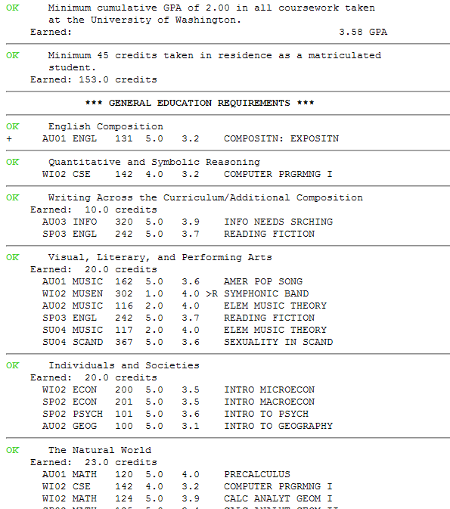

ILLUSTRATION 3: Output From a DARS Report

Methods We Used (Interaction Analysis)

To begin the process of interaction analysis we first created a site map of the three activities outlined above. This was only done after information was brought in from our persona and the activities section.

When diagramming the interaction some of the interactions contained similarities. For example, most pointed to action within the interaction “Look at a specific major.” For obvious reasons, the scope of this project being the largest, you can see why this would be a highly used activity within an interaction. All of the tasks resulted in a satisfied user and will quell any emotions of confusion or frustration that the user may have. The generated site map can be seen below.

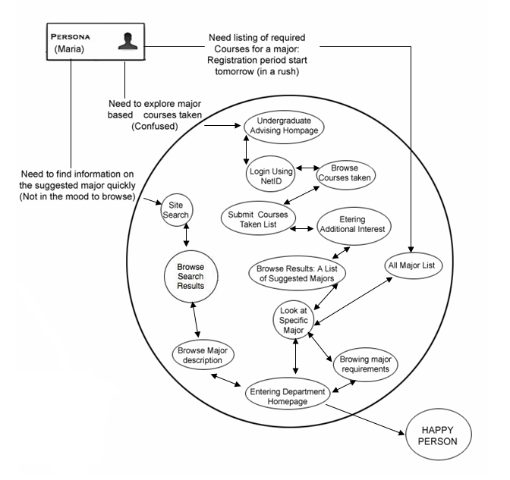

After we have diagramed three activities in our site path diagram we further defined all three interactions. What follows is a breakdown of all three interactions.

Interaction 1: Input Courses to Get Suggestion for a Major

This was because our persona, Maria, wanted to explore a major based on a past class that she took. You can think of this interaction like a recipe maker. You take what you have, a prior class that was liked, and output something that you can make with it, or in our case a major you might enjoy.

We then further outlined the path that we anticipate users will take in this system. We took into account the initial state of confusion and then went through the steps that a typical user might take in this system. For each action, a corresponding system response is listed showing how the system will respond to the anticipated actions of our users. These actions are then depicted in a visual flow chart that illustrates possible end points for the user. The user could give up because they find the system too difficult or the process can result in one or more of three successful outcomes (Check Requirement, Homepage of the Major, Browsing the Brief Information About The Major).

After this process was complete, we examined some key questions that will help our users deal with their interaction with our system. These questions explored things such as monitoring the current status of the user or how the system will respond with proper feedback or error responses. Below is a summary of these responses.

How will you indicate where the user is?
- Large titles on each page
- Clearly labeled links
- Interaction ends when the user wants it to end
- User presented with option to go back, if necessary

How will you indicate what just happened?
- If the action is successful, the page will change
- If the action is not successful, an error will be displayed to the user and what they can do to remedy the problem
- If the system crashed, it will attempt to save the data so that the process can be continued later.

How will give the user the feeling the she gets to do it her way?
- Option to select as many or as few courses as they wish
- Once majors are displayed to the user to browse, they can select any major that they want. They are not limited to only one selection.
- No defaults for the system

Interaction 2: Look for Pertinent Information

As was similar in the previous interaction, our persona, Maria, wants to get only the pertinent information for whatever she is looking for. It is important to her that her time is used wisely and that no extra information is presented that will confuse her. Right now, she has to filter though a lot of different sources to get the information that she needs. However, this is very time consuming and she does not have the time to accomplish this. So, she wants to see only pertinent information.

We again further defined the interaction by defining the intermediary steps for the interaction to be completed. From this we took in the user’s beginning state (not in the mood to browse) and wanted to end up with a happy persona. We took the approach of doing a site search to complete this interaction. This will yield the information that she is looking for in a very short amount of time.

After we completed this interaction we asked ourselves some questions on how our users will interact with our system. Below are the questions and the summary of responses.

How will you indicate where the user is?
- Large titles on the pages
- Highlighted link in navigation

How will you indicate what just happened?
- Leave the query in the search box
- Display results once a query has been executed
- If fail, display error page and offer the user the ability to start over

How will give the user the feeling the she gets to do it her way?
- No default query, the user has complete control over the query
- They get to select the results that they want to read
- Make it familiar to what users currently use

Interaction 3: Figure Out What Degree Requirements are for a Specific Major

Every student, at some point during college, needs to select a major that they wish to pursue. This time can be very stressful and confusing. Our persona is no different. She has taken a lot of classes that she has enjoyed, but she doesn’t know if a major that she picks will be right for her or not. So, she wants to look into look into the requirements for a major to see if they are classes that might interest her.

We took a look at the necessary steps that needed to be completed to get this information about a major. She will enter in her state of confusion and in a rush (she’s trying to register). From this she will look at list of majors and then select the major that she is interested. From that, she will be presented with the requirements for the major program.

Once this interaction was completed we again asked ourselves the same three questions like we did with the past two interactions. Below are the questions and the summary of results.

How will you indicate where the user is?
- Large titles on the pages
- Provide “back” button on each page
- Link to “start over” the process
- Good labels on links
- Interaction ends when the user’s information need is satisfied

How will you indicate what just happened?
- Load the corresponding page with an appropriate title
- If error, display error page and provide user with options on how to fix error

How will give the user the feeling the she gets to do it her way?
- They get the choice of doing a search or browsing for the major
- If the user gets side tracked by another task, the user will be able to find a link to easily return on the main page
- They will lead the interaction from beginning to end. The system has no defaults for them to follow.

Conclusion

With our Interaction section completed we had a much better picture of how to move forward to the prototyping stage of the design process. At that stage we will be putting to practice what we have developed thus far in all of the prior labs. It will be the culmination of our past work. Because of this it was vital to take the time to think through these processes before advancing to the Prototype phase so that we will not have to backtrack at a future point in time.
Prototype

Building the prototype was a culmination of all the previous methods for system design that were used before. After reviewing the previous methodologies we proceeded through the prototyping process step by step. We opted to create a prototype worksheet for each of the interactions we had developed. We were able to keep a considerable amount of information from previous sections and put it into the initial part of prototype worksheets – everything but the interactions descriptions. Some new information had to be developed for two of the interactions because in previous work only one interaction was developed fully.
The taxonomy was partially implemented because of the prototype nature of the work. However, there is a place for the remainder of the content types to be implemented once a final version of the information system is implemented. Our taxonomy does not equate directly to our site navigation for a couple central reasons. Firstly, we were aiming to please our persona – things needed to be intuitive, not unclear links to chunks of data. The data we classified is still within the site (or ready to be implemented into the site), it just does not appear until the user is closer to his or her needs.

Developing Wireframes
Once we had information regarding what we are creating in order, the wireframes and prototype were built in Adobe Photoshop and OmniGraffle. We used Photoshop because we feel it is a better tool for generating storyboard type images for evaluation, and we have more experience with it, so while it might not be a perfect tool for the job, it was faster than learning something new. OmniGraffle was also useful for creating the wireframes very quickly. Wireframes from all three interactions follow below.

Interaction 1: Explore Possible Majors Based Off Of Past Courses

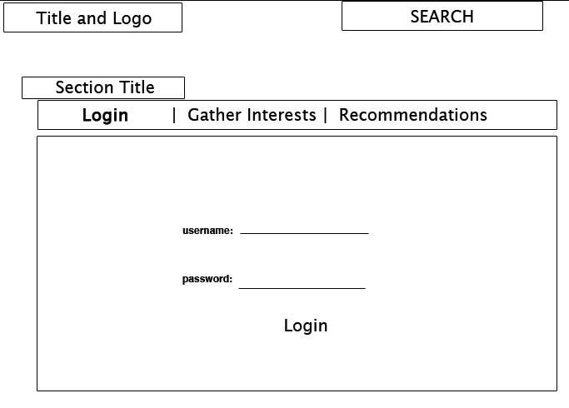
Figure 1: Log-in Screen

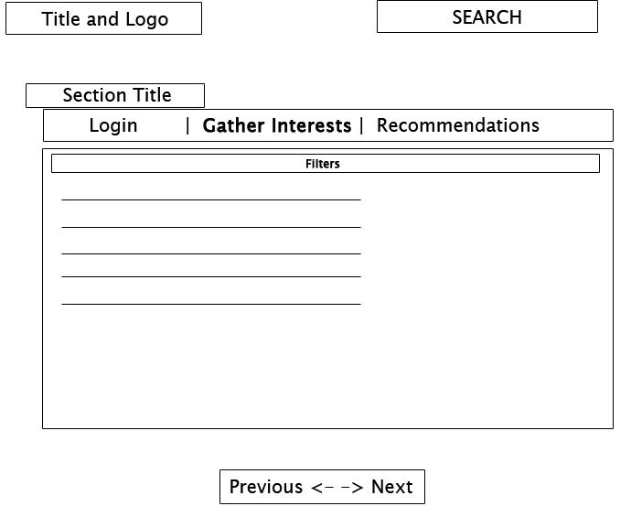
Figure 2: Gathering Interests

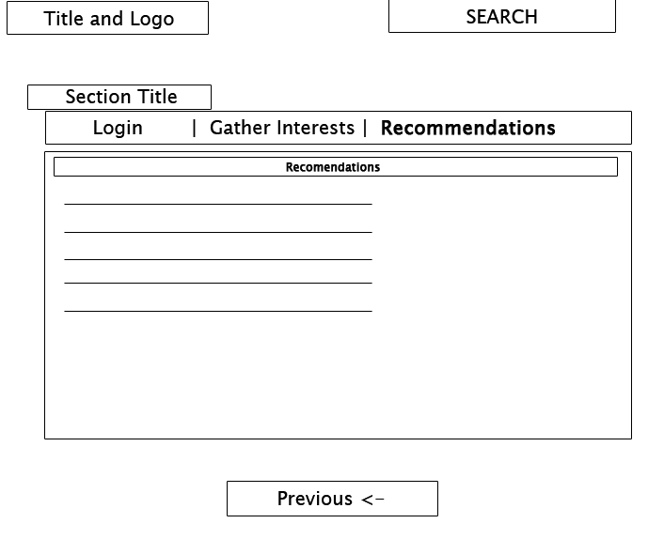
Figure 3: Listing Recommendations

Interaction 2: Find Information Quickly About A Specific Major

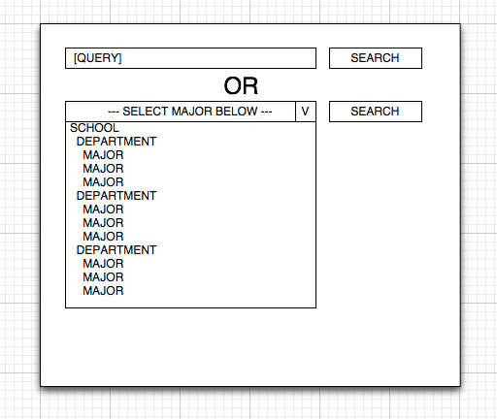
Figure 1: Selecting/Searching for a Major

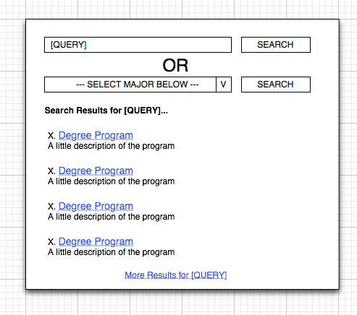
Figure 2: Browsing Majors After Completing a Search

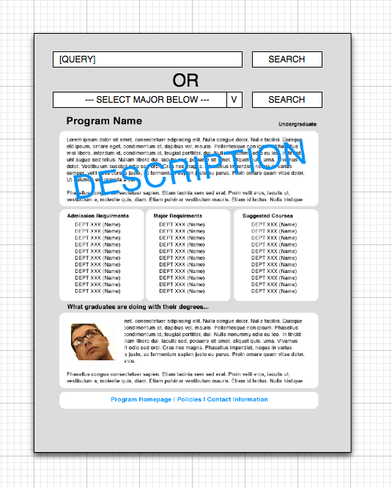
Figure 3: Information Page For A Specific Major

Interaction 3: Need to Know The Requirements For A Specific Major

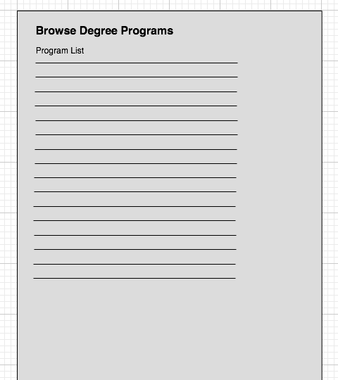
Figure 1: List of Degree Programs

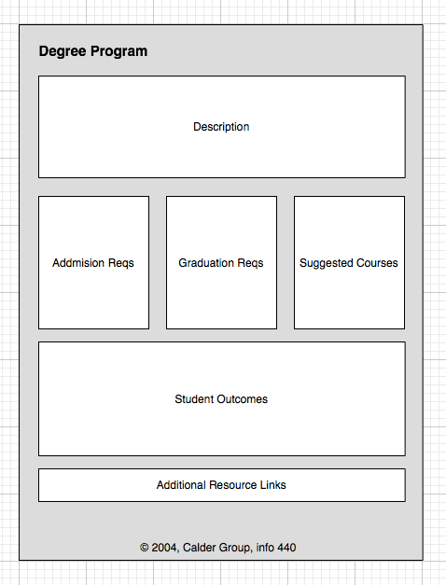
Figure 2: Presentation of Information for a Specific Program

Developing Prototypes
We developed a prototype for all three interactions. We did this using some general intuition about what looks good and tried to follow the persona’s needs closely. Prototypes for three separate tools were created to address the tasks: a recommendation tool, a list for browsing, and a search tool. Once we had conceptual drawings (much like concept artwork), we developed prototype web pages to closely match the concept drawings but implemented simulated functionality. We feel this method works well because we can achieve some internal analysis of the drawings before creating the web page.
The design process of the web page consisted of three parts. The first part was to design a general template page to fit the content into. The second part was fake and/or build-in functionality. The third step was to insert and alter the format of any real content needed to be on the web page to make the experience of the using the prototype seem realistic to users in our following usability studies. Also, because no challenging coding was done for these prototypes, there is no attachment to the work, and changes can be made freely, if necessary. We chose to have this simpler prototype to reduce the cost that our boss is concerned about and also to avoid superfluous development of the system before the actual design process is completed.

Below are the conceptual prototypes that were mocked up before the design of an interactive model.

Interaction 1: Explore Possible Majors Based Off Of Past Courses

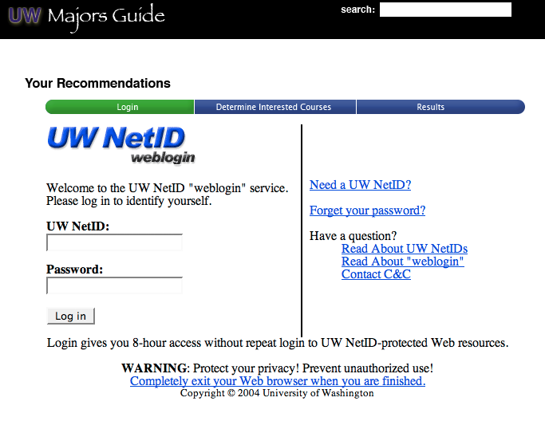
Figure 1: Page 1 - Logging in with UWNetID

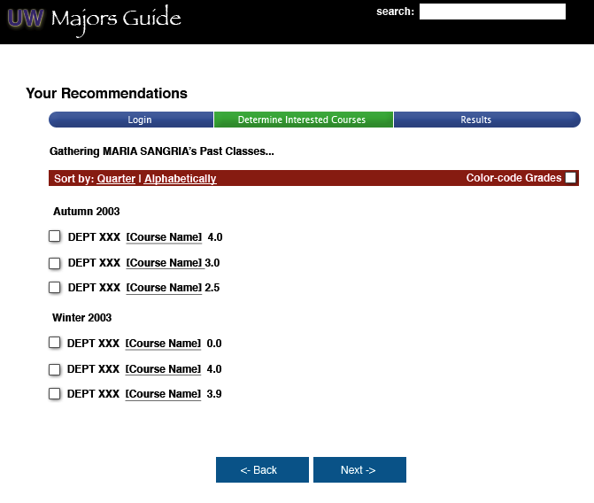
Figure 2: page two, transcript loaded, ready to indicate interests
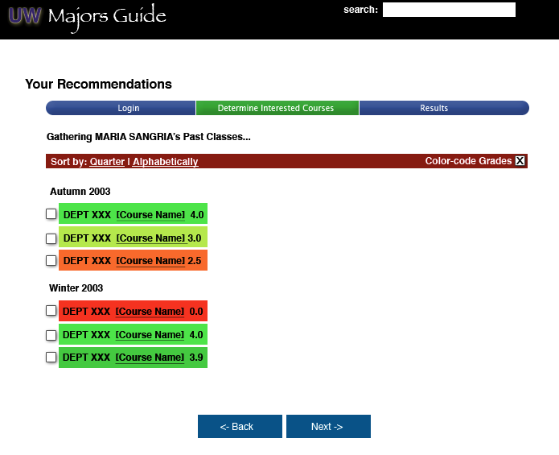
Figure 3: Major Selection Page with colors indicating Grades

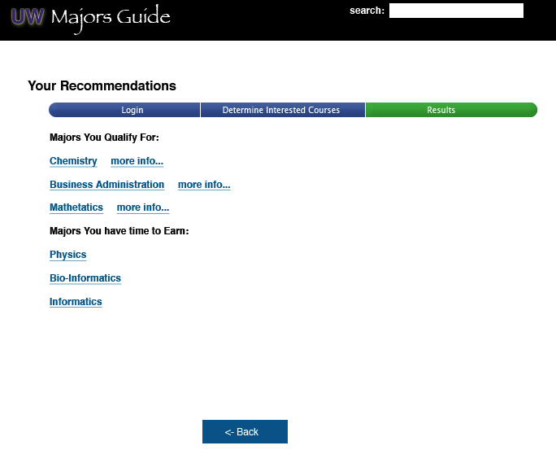
Figure 4: Results page indicating recommended majors

Interaction 2: Find Information Quickly About A Specific Major

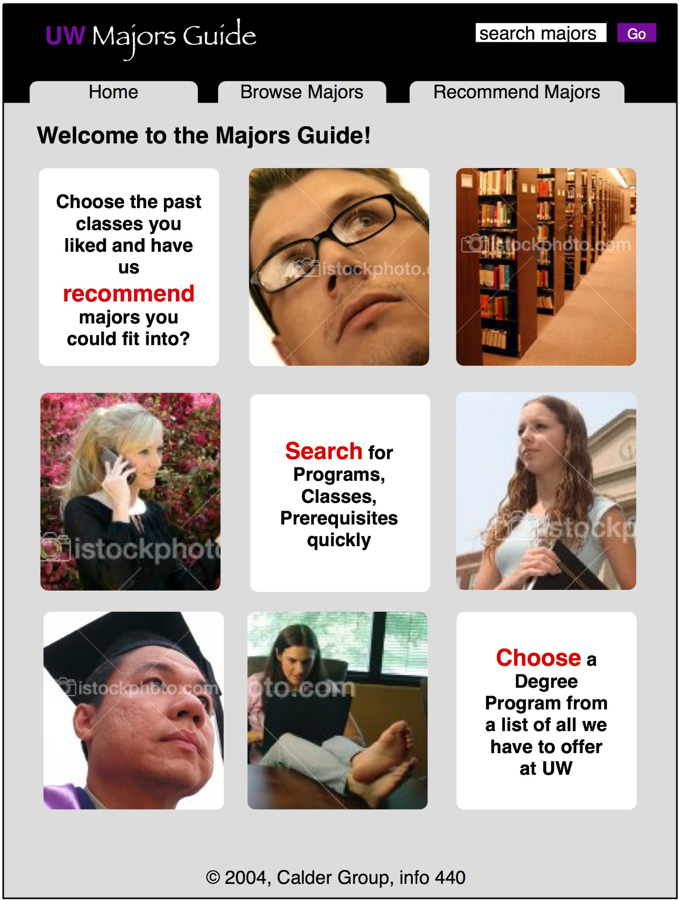
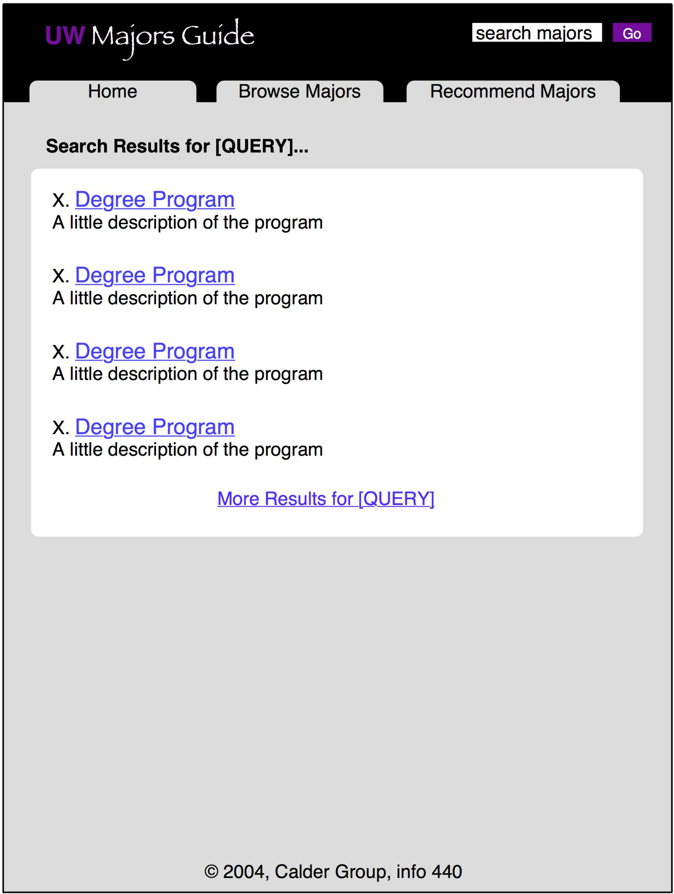

Figure 1: Introductory Page to Majors Guide Figure 2: Results of a search query

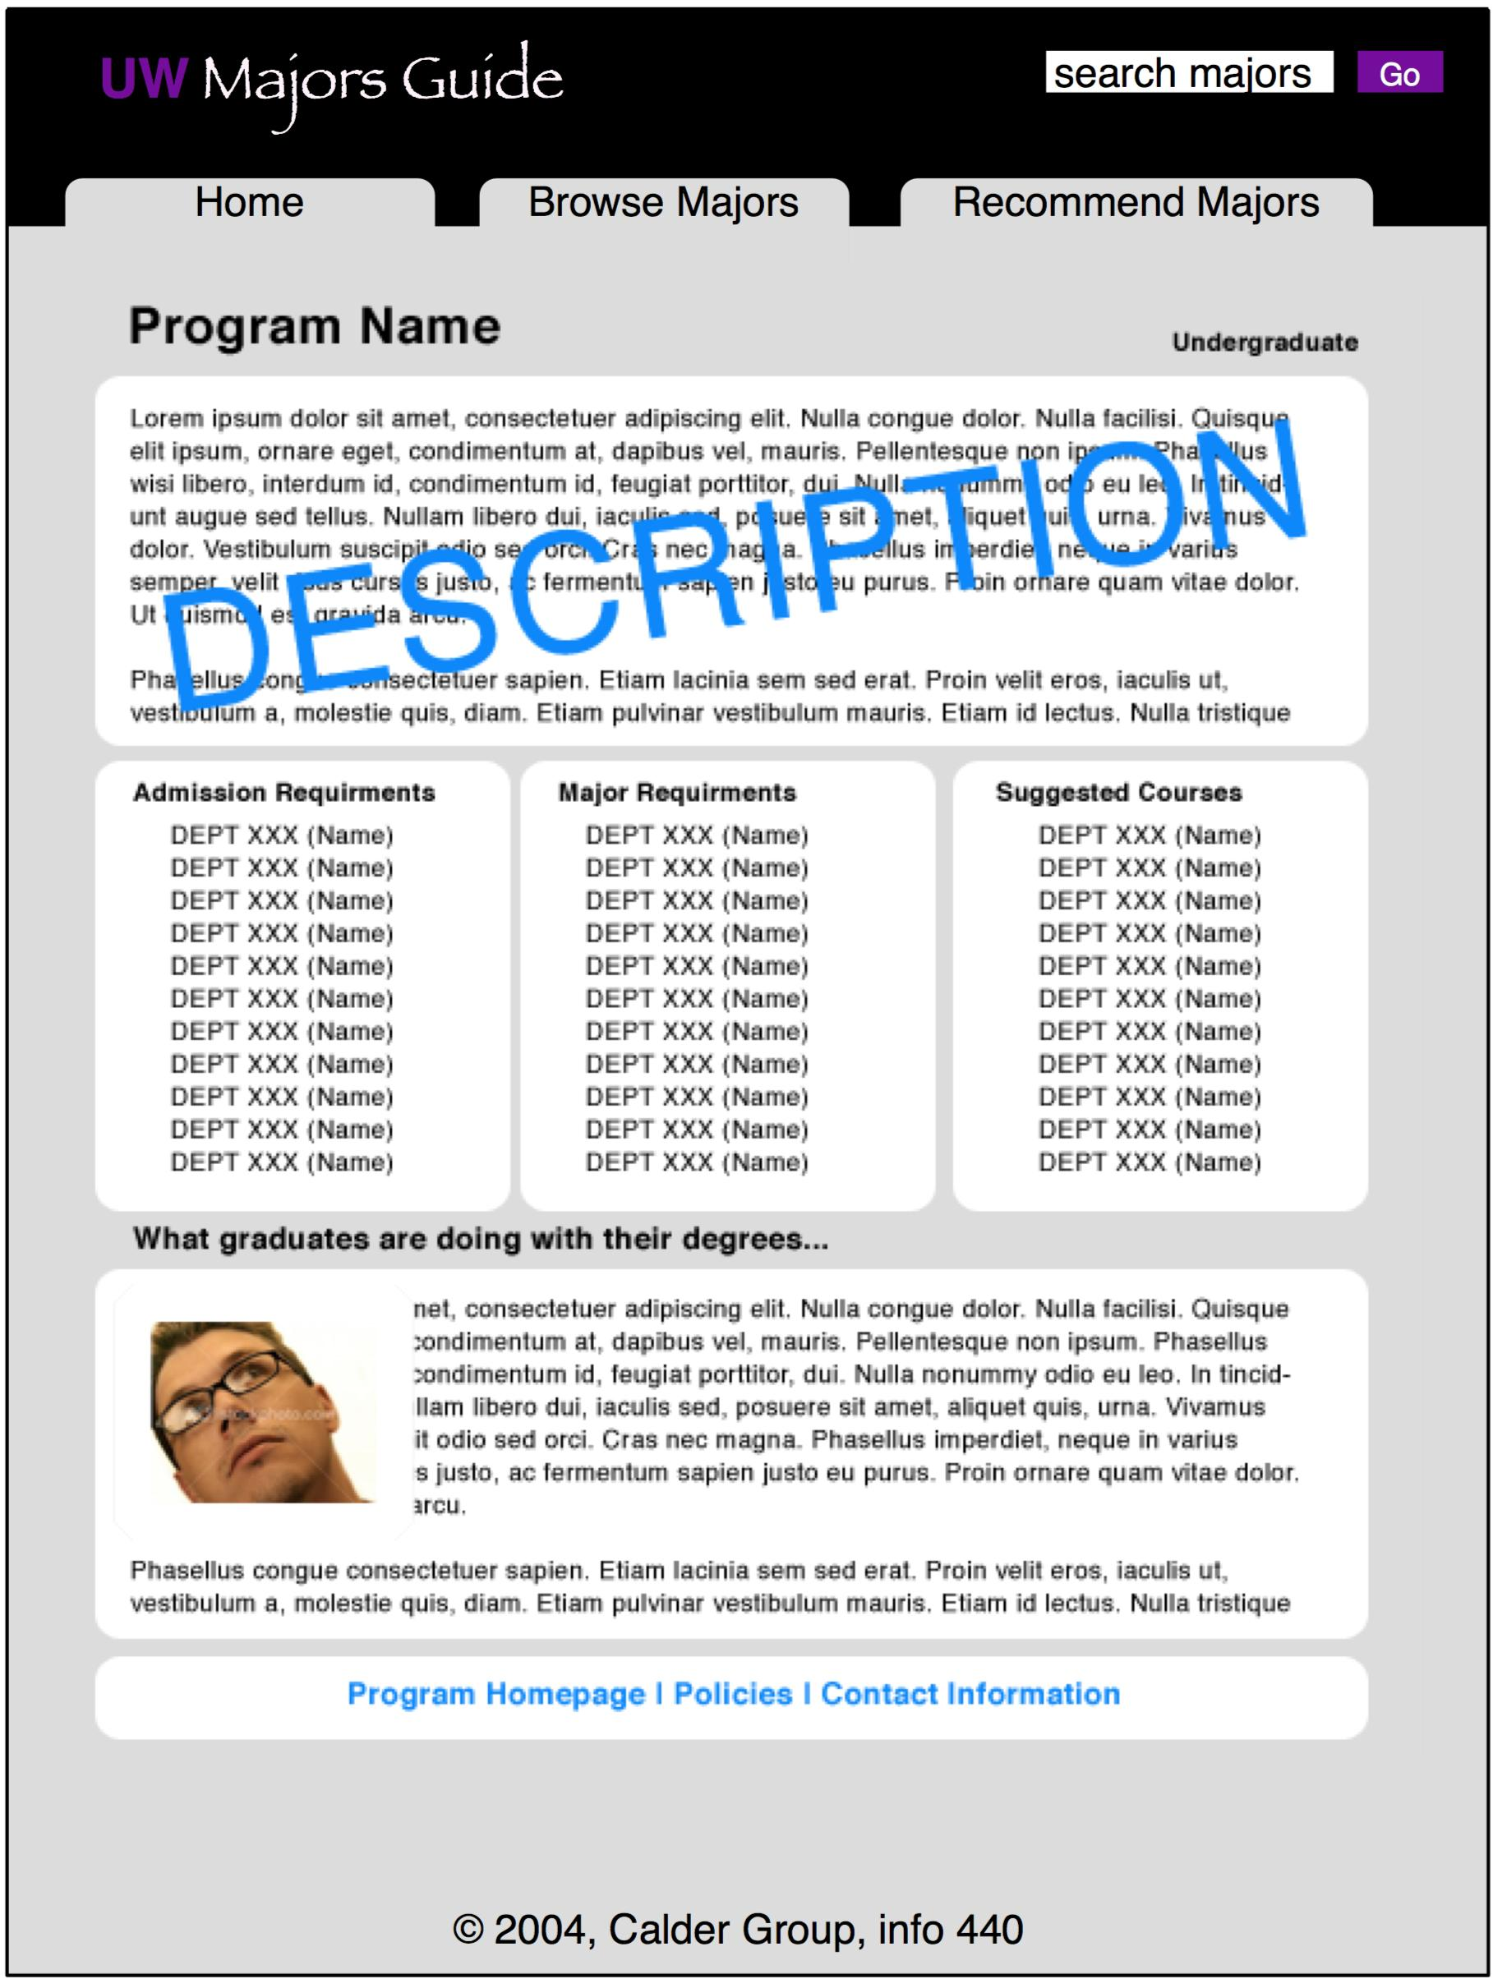

Figure 3: Information page about specific major

Interaction 3: Need to Know The Requirements For A Specific Major

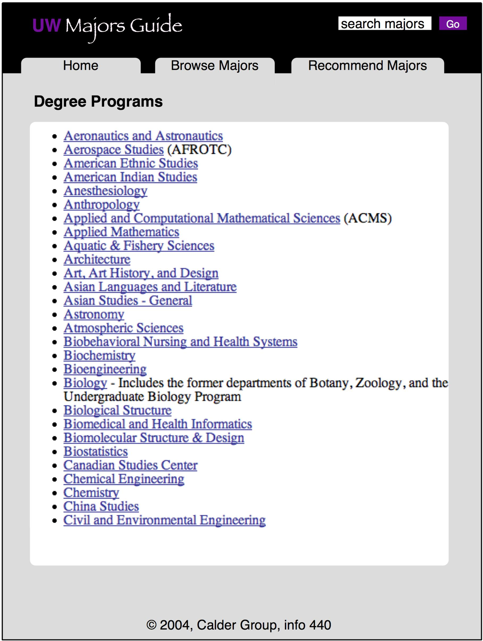

Figure 1: Introductory Page Figure 2: Listing of majors

Figure 3: Information page about specific major

Results

Our website, located at http://calder.lazyi.net/, is the final result of the prototype portion of this project. This site contains interactive web pages for each of the three interactions that were outlined above. While it is not entirely functional, it is designed to help participants in our usability study to visualize and understand the concepts we're presenting in a tangible way. It is based on the concept sketches and wireframes we made previous to the final prototype. We understand that building a functional prototype is not necessary, but we felt it would be useful to test out the interactions with real people, and concept sketches are simply not the same. Also, it will help to show anyone we pitch the idea to later. The live demo makes it feel possible and tangible, instead of confusing and unrealistic.

Design Evaluation

In this section of the report we will cover the usability testing for each of the three interactions that were outlined in the prototyping section. These interactions were:

- Explore past majors off of past courses
- Browse majors for information
- Search to find information about a major

Each interaction has a full write-up and analysis. However, we will first cover the methods, testing plan, goals, and our target user. These are common over the entire usability study and are presented below.

Methods We Used
To complete this section of the system design we invited a freshman to view the prototype we developed and go through a task scenario. During the process we asked questions to better understand how she associates the links and the site. We compared and contrasted her thinking process with our initial thought of how user might interact with the system. Based on her feedback and problems we observed, we made recommendations of how our design can be improved.

Test Plan
Before we actually bring in a participant for our usability test, we made a plan to set our goal. We reviewed our persona before deciding who should test our prototypes so that the feedback we receive can apply to our users. The selected interaction information from our interaction stage was also reviewed, so we kept in mind of what to look when participant is testing our prototype. The following is the plan we designed:

Goal
- Observe how the user will react to the wire frame
- Find out how user will interact with our system
- Can user follow the basic navigation
- Observe what areas need to be changed or improved

Target User
Our target user will mostly be made up of freshmen and sophomores. They might be:
- Undecided on a major
- Uncertain about their educational plan
- Looking for a second major
- Looking to change major

We decided to bring in a freshman with undecided major status and have her go through our prototype.

Usability of Interaction #1: Explore majors off of past courses

Participant: Amy (freshmen from Sunnyside, WA)
Observer: Irvin MacQuarrie

Steps of the Interaction
These are steps user will need to take to find majors the system will recommend according to their interests and courses they already took:

  - The user goes to the webpage of the major finder.
  - The user logs in using NetID.
  - The system uploads courses the user has taken.
  - The user checks courses that they are interested in.
  - The system prompts for additional interests.
  - The user submits the information.
  - A list of majors is outputted with links to additional information.
  - The user does as much research on the various majors as they feel they need. This includes such things as description of the major, visiting departmental websites, and contacting advisors.

Task Users may Perform through this Interaction
The user will be able to find a major by looking through a list of suggested majors generated by our system. If they are still uncertain, they will at least have a better idea of available majors and the necessary requirements. Moreover, the system is letting them know of all the possible major they qualify for with their current status.

Usability Measures
We will evaluate our current prototype according to:
- The user understands how the major finder works.
- The user feels that the system can do everything that they would like it to do.
- The user knows the logical steps to take in the process.
- The user is satisfied with the outputted majors and feels that they match up well with their interests and abilities.

Reaction test
Irvin showed our participant our wire frame for each interaction and tried to study her understanding of the site, how it works, and how it’s organized. The participant first thought the site is used for researching information but was not quite sure what exactly the system is capable of searching for. She noticed that she needs to have a username and password in order to use it. Amy then figured the site can help her choose a major, which she initially thought won’t help her because she already has something in mind. She made the assumption that the next thing she would use is the search feature on the site. The graphic did attract her, especially the image of a guy with the glasses. The bright and red “choose” link grabbed her attention. She first clicked on it because there is something about the word “Choose” that was very attention grabbing. Overall, she thought the site is wonderful mostly because of the friendly feeling the graphic gives her. There wasn’t anything that she didn’t like about the system at this point.

Key Task Test
For this test, we gave our participant a task to perform. Irvin read our task scenario to the participant and asked her to talk through her thinking process and actions she would take.

Task Scenario:
Find a major based on your interest and classes you’ve taken.

Observation:
She wasn’t quite clear on what the gather interests section was used for. After some clarification, she didn’t think much of the feature that uploaded classes she has taken. She has only taken three classes so far and isn’t interested in any of them. She liked the idea of being prompted for additional interests beyond classes that she has taken. She expected that the working system would output results under the recommendations tab.

Report the Usability Test Results
Based on the observation from the key task test, we notice the “gather interests” section wasn’t as clear as it could have been. Without clarification the user has no idea of what this section is about by just looking at the name. There are limitations in the system for freshmen who may not have taken a lot of classes and who aren’t sure where their interests are. The system is limited in terms of what it can accomplish for them.

Recommendations
From the feedback of the user and the observations, there are few changes that can be made:
- Change the name of the “Gather Interests” section so that the user knows what the section is for.
- Put in an extensive filtering system, so that if you encounter a freshman who has only taken 3 classes that they still will be able to find something that meets their needs.
- Provide more features for the system, such as a link to potential careers with a major. This will make the system seem more powerful and will enhance user satisfaction.

Usability of Interaction #2: Browse majors for information

Participant: Amy (freshmen from Sunnyside, WA)
Observer: Irvin MacQuarrie

Steps of the Interaction
These are steps user will need to take to find out what majors University offers and spend time exploring through them:

- The user goes to the webpage of the major finder.
- They use the “Choose a Degree Program from all that we have to offer at UW” feature.
- A list of all the majors at UW comes up.
- The user browses through the list of majors.
- The user selects a major that they are interested in.
- A recommendations page comes up with a description, requirements, and information about what you can do with the major.
- The user does as much research on the various majors as they feel they need to. This includes such things as reading the available information, visiting departmental websites, and contacting advisors.

Task Users may Perform through this Interaction
The user will be able to find out what the available majors are in the University and find which ones they might be interested in by exploring.

Usability Measures
We will evaluate our current prototype according to:
- The user understands how the major finder works.
- The user selects the right feature for the assigned task.
- The user knows the logical steps to take in the process.
- The user is satisfied with all of the information that is returned on the selected major.

Reaction test
Irvin showed our participant our wire frame and try to study her understanding of the purpose of the site, how it worked, how it’s organized and so on. Amy first thought the site can help her choose a major, which she initially thinks that this won’t help her because she already has something in mind. The graphic did attract her, especially the guy with the glasses. The bright and read “choose” link grabbed her attention. She would first click on it because there is something about the world “Choose” that she wants to react to it. Overall, she thinks the site is wonderful mostly because of the friendly feeling the graphic gives her.

Key Task Test
Irvin read our task scenario to the participant and ask her to talk through her thinking process and actions she would take.

Task Scenario:
You’re not sure what to major in so you what to get an idea of all that’s available.

Observation:
Somewhat surprisingly, she chose the “Recommend” feature in her first attempt. After finding out what that was, she went back and chose the “Choose” feature which is the one that we had anticipated the user would click for this interaction. The next step for her would be to scroll through the list and find a major that she was interested in. She would then read the description followed by what she could do with the major. If she was still interested, she would then read the necessary requirements.

Report the Usability Test Results
Through her interactions with our system, the only noticeable problem is that she did not use the expected feature the first time. She clicked on “Recommend” first instead of “Choose”. Perhaps she thought that her past courses might be more helpful for finding something she is interested in or perhaps it was because it was closer to the top.

Recommendations
The only recommendation would be to play around with the titles for the features on the home page. Perhaps instead of “Choose a Degree Program from all that we have to offer at UW”, it could be “Browse through all degree programs at UW” or something to that nature. To get these titles right would require more usability testing with more users. However, this doesn’t appear to be a major problem in our design as the user was completely happy with everything else in the system and couldn’t find any other issues.

Usability of Interaction #3: Search majors for information

Participant: Amy (freshmen from Sunnyside, WA)
Observer: Irvin MacQuarrie

Steps of the Interaction
These are steps user will need to take to search for the information about the major they are interest in:

- The user goes to the webpage of the major finder.
- They use the search feature in the middle of the page
- The results of the search query are listed.
- The user clicks on the major they were searching for.
- A recommendations page comes up with a description, requirements, and information about what you can do with the major.
- The user does as much research on the various majors as they feel they need to. This includes such things as reading the available information, visiting departmental websites, and contacting advisors.

Task Users may Perform through this Interaction
The user will be able to find out information on a major that they know they are interested in. This interaction require user to have a major in mind already and then give she/he a more depth information on the major.

Usability Measures
We will evaluate our current prototype according to:
- The user understands how the major finder works.
- The user selects the right feature for the assigned task.
- The user knows the logical steps to take in the process.
- The user is satisfied with the results of the search query.
- The user is satisfied with all of the information that is returned on the selected major.

Reaction test
Irvin showed our participant our wire frame and try to study her understanding of the purpose of the site, how it worked, how it’s organized and so on. Amy first thought the site can help her choose a major, which she initially thinks that this won’t help her because she already has something in mind. The graphic did attract her, especially the guy with the glasses. The bright and read “choose” link grabbed her attention. She would first click on it because there is something about the world “Choose” that she wants to react to it. Overall, she thinks the site is wonderful mostly because of the friendly feeling the graphic gives her.

Key Task Test
For this test, Irvin spend sometime to ask her few question about her interest and what is her intended major if she has any. After that we designed a task scenario for Amy to perform. Irvin read our task scenario to the participant and ask her to talk through her thinking process and actions she would take.

Task Scenario:
You know you are interested in “Chemistry”, so how would you go about searching for information on “Chemistry”.

Observation:
She selected the “Search” feature in the middle of the page which is what we were hoping for. She commented that although it was unusual, she liked having the search feature right in the middle. The next step took her to the outputted results of her search on “Chemistry”. She then decided that the next step would be to click on the link for “Chemistry”. She said she would read course requirements and then about what people might do with the major.

Report the Usability Test Results
Based on the observation from the key task test, there weren’t any observable problems from the test. Amy went through the steps as expected and didn’t have any complaints about the website. The only foreseeable problem would be if someone searched for a major that wasn’t offered. However, since this was not a working prototype, that could not be tested.

Recommendations
Based off of the test, there are not recommendations that can be made. The user was very satisfied with the way the system react to her course of action. Amy had no complaints, even after prompted by Irvin for any kind of problems.

Conclusion

Challenges / Difficulties

Throughout the entire design process there were definitely some challenges and difficulties that we encountered as a team. Since we all have different schedules outside of class, it was very difficult to find time to meet as a group. Below (in “Meeting Agendas” appendix) you will see a listing of our meeting agendas. We had to compact a lot of information in these meetings and at the end of the meetings we had to make sure that we were all on the same page. This worked out well in the beginning, but as the complexity of the labs increased, so did the confusion on where the team was going. To counter act this, various e-mails and personal interactions were completed to make sure that people could “get on track.” These interactions proved very useful for the entire group. When the project progressed, less questions were about “what are we doing?”, but were more on “how do I do this?” These questions were great for the team to answer and helped everybody out tremendously.

Another difficulty was making sure that the work completed was up to standard for the entire group. Since these groups were randomly selected we had group members with varying amounts of expectations of the project and the work that they would put into it. Because of this, we had to set some basic guidelines on what the team found acceptable work. These guidelines were followed more often than not, but when they were not it was difficult to move forward in the project. This was mainly due to the way the labs were set up. Since each methodology built on the previous, it was very hard to do work simultaneously resulting in a time lag between groups. This was because labs could be confusing to follow, and the write-up in the design report might not make sense. So, the team group that followed the less than completed work had difficult times to complete their sections. However, with a little communication, these problems were over come very quickly.

Another challenge that we had actually came at the end of the process and actually at the writing of this design report. We had a different interpretation of how many prototypes/wireframes that needed to be completed. While the clarification was nice, it gave us time to make some new prototypes, it was also a challenge because we had structured our group’s time in such a matter that this was “overtime” on the project. While we understand that things can change at any moment, this was just unexpected. However, we grabbed this problem and ran with it and everything worked out just fine.

Major Achievements

As with all challenges and difficulties there are some achievements that we accomplished as a team. When we first started the project we realized that we would not be able to do this entire project with all six of us working on each part together. We felt that would be counter productive. So, our alternative was to do this as pairs. We set up a timeline of due dates and split up the work. Everybody on our team got their parts in on time with no questions asked. We held regular meetings to make sure everything is on track. We even have a group web site that was frequency maintained with updated material from members. A listserv was created to better serve communication purposes for this team as well. This was great because we didn’t have to nag on other team members to get their parts completed, we simply just waited until the due date was past and we had the completed parts delivered. This workflow gave our team members ample time to complete their sections.

As far as teamwork goes, we worked well as a team. Our team dynamics were very good for this project. We were not at fisticuffs during any point in the project and everybody’s opinions were listened to. This really added to the work that we completed as a team. We welcomed ideas and did not want to shut anybody out.

Lastly, our biggest achievements is that we completed this design project. The work was not easy at times and with the help of our team we have a product that we can be proud of. Having this experience made us realize the hard work of designing system, and it has helped us developed a true appreciation for the design process.

Steps Toward Real System

The next thing that we would need to do in order to make this into a real system is to actually make a contact with the Department for Undergraduate Education to find out if a project like this would be feasible, or even of interest to them.

If the project was of interest, we would need to have a more robust persona base. One persona is not enough to base our entire system off of. We need to be able to have a large enough sample pool of personas that all of the student stakeholders are well represented. After that has been accomplished, we would need to dig deep into the fact if students thought that this would he helpful. If there was no student demand for this, then all of the time spent designing the system might be for little to no use.

After we have gathered our persona base and reset our triple for the project we would move forward with in-depth interviews with all of the key players in the project (students, administrations, advisors, counselors, boss, and designers). The process that we would complete would be very similar to the one we have just completed, but it would be on a much larger scale. More time would need to be taken on each step in the design process. A more robust prototype might be generated and much more emphasis would be stressed on usability.

Overall, this project gave us a very good idea on what we would need to do in order to get this project off the ground and running. But, we would have to change the scale quite a bit. This would also be an exciting, but challenging, project to work on if there was ever a demand for it.

Appendix: Data From Design Methods

- Design Problem – Formulating the Triple
- User Analysis – Defining our User
- Requirements – What Does the System Need?
- Information Analysis – Building the Navigation
- Information Analysis – Content Modeling
- Activity – What Do You Want To Do?
- Interactions Analysis
- Prototype – Make a Model
- Usability Testing
- Meeting Agendas
- Information Management
- Project Deadlines
- Group Photos

Design problem – Formulating the Triple

Goals

Goal | Description | Why is it important?
Help students find majors faster | Help students find majors that interest them faster. | To get them out of the university on time. Also, get them into a program that they want to be in faster by showing them majors that are relevant to what they like.
Help majors to find applicants | There are a lot of majors on campus that are small, like Informatics was, which are good majors but just don’t have the publicity or resources to get the word out about their majors. Large majors also can attract applicants which may not have considered their major in the past. | Helps programs that have little publicity get students into their program. Also, helps students see options from lesser known programs. Provides more choices in one location. It is mainly free publicity for these majors.
Save advisors time | Advisors can spend more time helping with issues that are not related to finding a major. When students go to ask help from an advisor when a resource is available online they are tying up advisors time on these issues. | Can help advisors by freeing up time for more important issues where information is not made available online. Saves the university money and resources because advising traffic is moved to online.

Audiences

Audience Name | Audience Description | How can they help you meet your goal?
Program Advisors/Coordinators | Advisors from each major or school on campus. These are the advisors that are specific to a particular major or department. | They can provide additional information about their programs and schools to those who wish to receive that information. They are the experts about the degree and what it is like, the requirements, and they also have other relevant information.
Students | Students at the University of Washington. | By finding a major in an efficient amount of time, students will be able to have a higher probability of graduating on time and using less advising resources to find a major.
Undergraduate Gateway Advisors | General advisors for the undergraduates. They are the currently existing system that helps students in all matters related to their education. They can help with finding a major, classes, or minors that would interest students. | They are the local experts. They will get students to think about selecting a major based on what they like and what classes they have taken. They can use the system as a tool to assist with helping students find a major that they might like.

Information

Type of information | How does it help the audience help you meet your goal? | How would they most like to see this information delivered?
Requirements to get into the program/major | They are able to know what to get into that major. It outlines for them what they need to take and to show them what they have already taken towards that major. | They want to see it presented on a web site. Show the required classes in a simple to follow manner in an elegant interface. Should hook into DARS that will recommend majors based on what you have taken in the past.
Type of job that you can get with that major | It is motivation to pick a particular major. They may know what job they want to get but they do not know what majors can help them get that job. | Feedback from alumni and program advisors on a website. An email listserv from people who have graduated and are passing along advice to undergraduates.
Past Classes | These are the past classes that a student has taken. | Commonly this is presented in the form of a transcript or via DARS. However, students want to see this delivered by quarter or alphabetically.
Things that match your interest | They can focus more and will have more motivation because they are looking at a major that they are interested in. | Online questionnaire. Results presented in a fashion similar to DARS but with a better interface. Also, an E-Mail component if something new happens after you have completed the survey.

User analysis – Defining our User

Interview: Who is she?
Job or position | Full time sophomore at the university of WA, doesn’t work
Age | 19
Sex | Female
Birth place | Yakima, WA
Education | Completed high school, second year of college still a non-major
Hobbies | Salsa Dancing, Traveling, Movies, Shopping, Hanging Out with Friends

Interview: Attitudes
Beliefs about us | Don’t know where to start with major requirements. Have to make appointments to see advisor to get help. Has heard from friends, knows she needs to contact us at some point.
Styles | Teen magazines, brand named clothing, spontaneous personality
How much they need us | Not sure what to major in, but definitely needs some info to start out with. Unsure whether the Gateway center is the place to go to for that information.
How much influence we have | Not much. Only heard of us from friends

Interview: Experience
Systems like ours | DARS, websites that tell you which majors are open or whatnot, Undergraduate Gateway center
What they use now | DARS, asking friends, undergraduate gateway website
Computer savvy | basic understanding of how to use internet, can check email, online shop etc
Subject matter

Interview: Needs and desires
What are the:  - Necessary features  - Desired features  - Wow features | *NECESSARY*  - All the majors/degrees information, which ones are available, and what they all are about.  *DESIRED*  - Info about what the majors do, potential future jobs with those majors, major demographics  *WOW*  - A questionnaire that matches students with a set of possible majors, a list of majors that is tailored to classes that I have taken in the past.
How often | once or twice a quarter for the first two years until she figures it out
Use duration | about an hour

Refining the Sketch

Who she is (1-2 paragraphs) | Maria Sangria is a sophomore at UW. She wants to enjoy college and doesn’t hold a job. She likes to have a good time. She likes many of her classes, but doesn’t know what major she wants to commit to. She knows there are many majors out there and is unsure where to go next.  She is the oldest of two in her family. She lives at home with her parents because she’s a very family oriented. She was born in the states but can speak a little of Spanish at home. She wants a job or career she enjoys but make a decent living at the same time.
What she wants (ordered list) | - Find a good job after graduation  - Do well in School  - Enjoy school with friends  - Stay close to family  - Find a major that she would enjoy
How it should be delivered (ordered list) | - On web site  - In person  - Email
Strong negatives (bullet list) | - Doesn’t like being pressured into picking a major  - Overwhelmed by information overload

Requirements – What Does the System Need?

The designer

Information requirements

Requirement | Stakeholder | Comment
Information about programs on campus | Boss | Requirements, admission stuff, community college equivalents.
A timeline of steps for applying to a major | Student | This is a timeline of events that should be taken from admission to UW to applying for a major. It should depict when you should looking for majors.
Contact info for program advisors | Boss | Information about the different program advisors and how to contact them if you have further questions.
Interest Survey | Student | After I take the survey I want to know how my interests apply to specific majors. Have both a general questionnaire for all majors and also major specific ones to see if the major is actually right for you.
Reverse course listing to related majors. | Student | “If I take CSE142, what majors can I get into?”
Listing of courses | Student / Boss | Your basic run of the mill listing of courses for each major.
Related majors based on a class taken | Student | Based on this class(es) that I have taken what major(s) can I get into. Similar to how schedule finder works.
Related majors | Boss | What majors are related to CSE? I want them to know so that they realize that they have options.
How to contact advisors | Boss | Basic contact information for campus advisors. This should information should be on every page.

Presentation requirements

Requirement | Stakeholder | Comment
Look professional, but not overly professional | Boss/Student | Want it to look cool and fresh, but to so professional looking that it will turn them away. Facilitate the feeling that we want them to get in the presentation of the page.
Not intimidating | Boss | Sometimes less is best. Friendly is better
Ability to browse majors | Student | No static list to select from. If I have an idea I want it to be geared for me.
No Pink on the page | Boss | Studies say that men do worse when pink is on the screen, or so it is heard.
List suggested majors in order of suggestion | Student/Boss | Need the listing explained if you are to do it this way. I am unsure how it is already so I want to know what they are doing to suggest things to me.
It is ok to look different than what current pages are | Boss | Must look credible, but it could also be different from what is the current status quo on university pages. It just needs to look “official”.
Open extra information in a new window | Student | I want to have my results in one window and all of the extra information presented in separate windows for my review.

Task requirements

Requirement | Stakeholder | Comment
Obtain Feedback | Boss | Get feedback on the system from those who use it so that we know what we need to upgrade or what to keep.
Open to all students | Student/Boss | Don’t limit it to just UW students, we might have community college students using this system as well.
Remind me later | Student | Send a reminder on things that I have found or make a profile that I can review at a later date. Similar to how DARS operates with its reports. Like a “My Cart” for finding a major.
Ability to schedule an appointment with an advisor | Boss | Make it easy to get in touch with advising to setup an appointment.

Technology requirements

Requirement | Stakeholder | Comment
Web Advising | Student | Meeting an advisor in person is intimidating and if there was a way to do it online. This could be in the form of a web chat or e-mail. The boss doesn’t like this idea at all.
Work in multiple browsers | Boss | We want all students who use multiple browsers to be able to use the system the same way.
Seamless technology | Student | Make it seem simpler than it really is. I don’t care what it does in the background, just as long as it works.
Keep technology in line with what is currently in place | Boss | We want to use technology that we currently have in place. Nothing new that could potentially throw the whole system out of sync.

Student stakeholder

Did the designer understand you? | Yes, I felt the designer did a good job of probing the questions.
Did the designer take your opinions seriously? | Yes, he restated the ideas I brought up in a different way, just to make sure he has it down
Did the designer miss anything you would have asked? | I think I would like to have a referral system as well, in addition to all the comments I made. This referral system, would be for friends browsing through majors, finding one that s/he thinks could be of interest to a close friend and have the ability to mail it to him or her.
Why do you or don't you trust the designer to create a great system for you? | I do trust the designer to an extent. There were certain things I asked for that could not be done. Example: Online Q&A from advisor. So that made me lose some confidence in the fact that the designer will be able to complete this project to my expectations. However, the boss had a part to do with this as well.

Boss stakeholder

Did the designer understand you? | I think he did. There were times when he nodded but he never explicitly said he understood what I was trying to get at. Because he did not ask twice about my responses I take that he understood my needs and concerns for this project.
Did the designer take your opinions seriously? | Yes. There wasn’t an instance in which he disregarded my opinions.
Did the designer miss anything you would have asked? | No, he gave plenty of opportunities for me cover anything that he may have missed.
Why do you or don't you trust the designer to create a great system for you? | I trust the designer to create a great system for me, mainly because I have seen his work in the past and found past examples to be impressive. However, he seemed more interested in what the student to say, but I suppose that makes sense because they are the user. That would be my only source of doubt, but his previous work testifies to a good ending system.

The Boss (Persona)
Note that this profile is not of any real person. We made it up to provide a challenging person for the project.

- Your boss would really like to see this tool made. Advisors time would be freed up and he feels that it would be a valuable tool for the students to have.

- The only reason that the push is being made for this project is because we had a little money left over from the last fiscal year and we want to apply it to something that will enhance the service that we give our undergraduates.

- The project is being taken on by a student group within the university. So, they are not professionals, yet. Their work from the past was quite remarkable and I anticipate that they will produce high caliber work this time around as well.

- Some of the advisors don’t like the idea of this tool because it will take away from their contact with students regarding this manner. They feel that they could do a better job than a computer could, and rightfully so. However, we need this skills in other areas of advising.

- On the flip side, the majority of advisors see this as a great tool and one that could help students with the exploration of finding a major. They realize that advising will never be replaced by a computer system, but anything that the students can explore on their own is a plus.

- I really don’t have any idea on what we run for an IT Infrastructure. All I know is that it runs smoothly and there are hardly and hiccups in the system. My preference is to keep it that way after this system is completed.

- As for features, we just want to make the students happy. The last thing we need is a student who uses the tool and then gets into that major and hates it. We want to avoid this at all costs.

- Lastly, it must have a nice interface and easy to use. I should be able to use it and you know how little I know about technology.

Information Analysis – Building the Navigation

Topic map

Brainstormed Words
- Program Information
- Timeline for applying to a major
- Program Advisors
- Advisor Contact Information
- Interest Survey
- Course Listings
- Reverse Course Listings
- Related Majors
- Major listings
- Major Requirements
- Admission information
- Major questionnaire
- Classes taken
- Major identifier
- Related Events
- Careers
- Alternate majors
- Interest matcher
- Gateway Center Advisors
- UW Students
- Community College Students
- Appointment maker
- Referral System
- GPA requirements
- Prerequisites
- Suggested tracks
- Course Requirements
- Graduation Requirements
- Suggested Major
- Program
- Interests
- Courses
- Majors
- Advisors

Subject words | Type words
Program Advisors | Suggested Tracks
Related Majors | Timeline for applying to a major
Classes Taken | Referral System
Related Events | Interest Survey
Careers | Course Listings
Alternate Majors | Reverse Course Listings
Gateway Center Advisors | Major Listings
UW Students | Suggested Major
Community College Students | Admission information
Prerequisites | Major Questionnaire
Program | Major Identifier
Interests | Interest Matcher
Courses | Appointment Maker
Majors
Advisors
Major Requirements
Graduation Requirements
Course Requirements
GPA requirements
Program Information
Advisor Contact Information

User sort 1

Term Id | Term
25 | Students
2 | Community collage students
3 | UW students
26 | Interests
4 | Interest Matcher
12 | Interest Survey
6 | Related events
20 | Suggested majors
8 | Careers
26 | Interests
4 | Interest Matcher
12 | Interest Survey
6 | Related events
20 | Suggested majors
8 | Careers
15 | Majors
16 | Program Information
22 | Suggested tracks
23 | Alternate majors
5 | Timeline for applying to a major
21 | GPA requirements
17 | Major requirements
19 | Graduation requirement
7 | Prerequisites
10 | Courses
13 | Classes taken
14 | Courses requirement
24 | Courses Listing
27 | Advisors
18 | Gateway center advisor
9 | Advisor contact Information
11 | Program advisors
1 | Appointment maker

User sort 2

Term Id | Term (to indent press ctrl-tab)
15 | Majors
5 | Timeline for applying to a major
6 | Related events
23 | Alternate majors
16 | Program information
17 | Major requirements
14 | Course Requirements
21 | GPA Requirements
13 | Classes Taken
7 | Prerequisites
19 | Graduation requirement
25 | Students
2 | Community collage students
3 | UW students
10 | Courses
24 | Course Listing
26 | Interests
22 | Suggested tracks
4 | Interest Matcher
20 | Suggested majors
8 | Careers
12 | Interest survey
27 | Advisors
18 | Gateway center advisor
9 | Advisor contact Information
11 | Program advisors
1 | Appointment maker

Information Analysis – Content Modeling

Type 1: Name: Schools
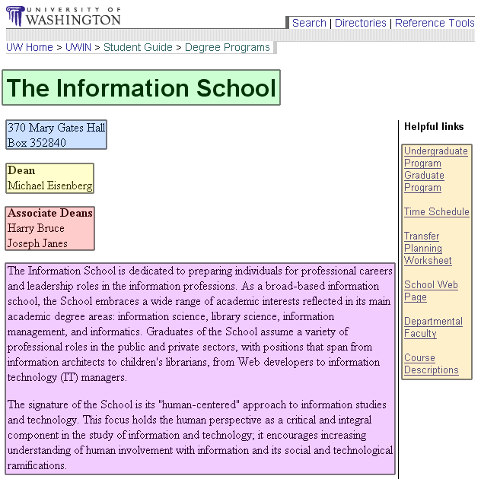

ID | Element name | Required? | Min and max | Constraints | Child of …
1 | SchoolName | Yes | 1 | The Name of School | StudentGuide
2 | Address | Yes | 1 | The true contact address
3 | Dean | Yes | 1 | The dean of the school
4 | AssociateDean | No | 0 - *
5 | Description | Yes | 1
6 | Links | Yes | 4 - * | 4 links are required, extras are supplied by the schools
7 | History | Yes | 1

Type 2: Name: Degree Programs
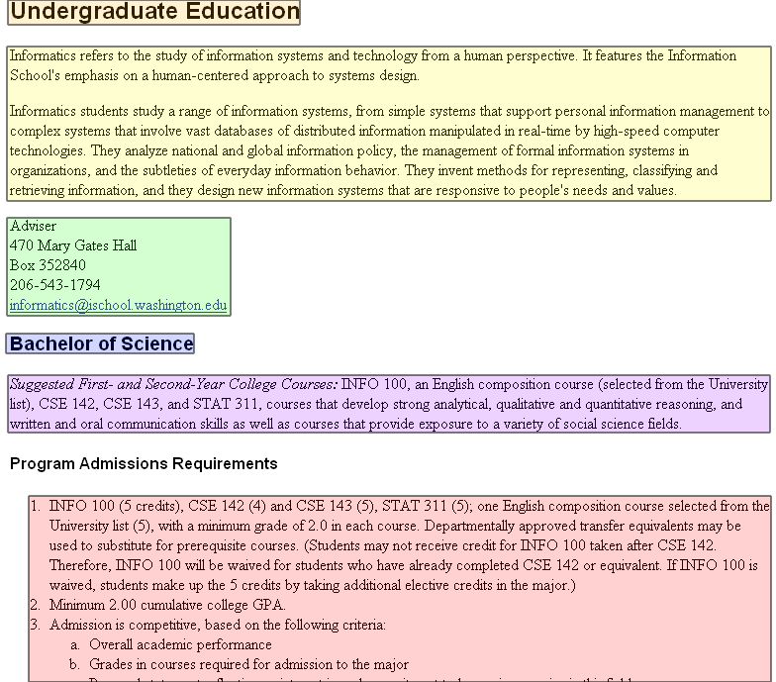

ID | Element name | Required? | Min and max | Constraints | Child of …
1 | DegreeSection | Yes | 1 – 2 | Undergrad. or Graduate | Schools
2 | Description | Yes | 1 |  | Schools
3 | ContactInfo | Yes | 1 |  | Schools
4 | Degree | Yes | 1 - * | Title of the degree | DegreeSection
5 | Suggestions | Yes | 1 |  | Degree
6 | AdmissionReqs | Yes | 1 | List of all requirements | Degree
7 | MajorRequirements | No | 1 | List of all requirements | Degree
8 | ContinuationPolicy | No | 1 |  | Degree
9 | StudentOutcomes | No | 1 | List of outcomes | Degree

Type 3: Name: Courses
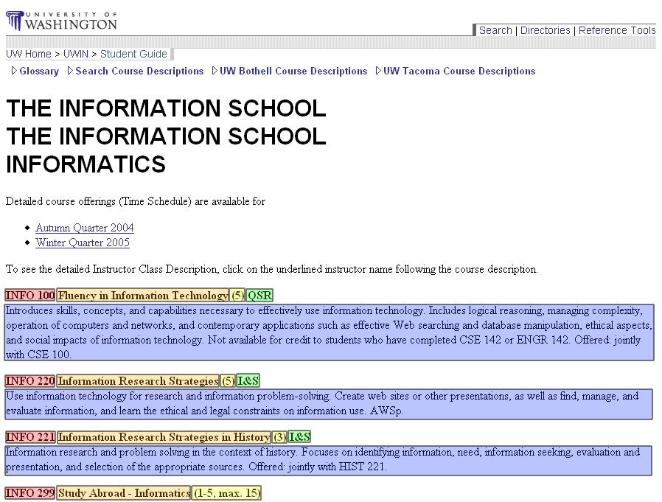

ID | Element name | Required? | Min and max | Constraints | Child of …
1 | Name | Yes | 1 | 8 – 16 chars
2 | Title | Yes | 1
3 | Credits | Yes | 1 | 1 – 15
4 | CreditType | No | 0 - # of types | NW, I&S, VLPA, W, etc.
5 | Description | Yes | 1 | Text Field

New Type: Degree Characteristics

ID | Element name | Required? | Min / Max | Constraints | Child of …
1 | RelatedJobs | No | 1-* | List of jobs related to degree | DegreePrograms
2 | RelatedInterests | No | 1-* | Example general interests of majors | DegreePrograms

The Content Domain

What one or two sentences fully summarize and capture the nature of the content in the types? This is your content domain statement. | The information about majors on campus and what it takes to get into these majors. This content also includes past classes and academic planning.
What few questions clearly put a piece of content within or outside the domain? | Is this offered at the University of Washington?  Could this help determine a path to success at UW?  How accurate is the information?  Will this information be needed to get into xxx major?

Activity – What Do You Want To Do?

Task Brainstorm and Priority
The highlighted tasks are the three that we chose to move forward on.

Lab | Possible tasks
Strategic Design | - Look for a major  - Find a major in time (e.g. by 90 credits)  - Look for pertinent information  - Obtain a recommendation on a major
Personas | - Find information about a major that I am interested in  - Find information about programs  - Help me see what jobs I can get with a certain degree  - Help me set up a time to meet with an advisor, if needed
Requirements | - Fill out questionnaire  - Provide feedback about system  - Ability to sign up for web advising  - Input past courses and gain suggestions of one or more majors
IA | - Click link to Majors to get more information  - Easily find path to major finder  - Find jobs related to certain majors  - Find information on how to get in contact with advisors  - Look up suggested tracks for classes to get into a major
Content Modeling | - Look at all of the courses that UW has to offer  - Research the different schools within UW  - Look into course evaluations for specific classes  - Figure out what the degree requirements are for a specific major

Metaphor Images

Task 1 Name: Look for pertinent information
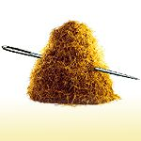

Task 2 Name: Input past courses to get suggestion for a major


Task 3 Name: Figure out what degree requirements are for a specific major
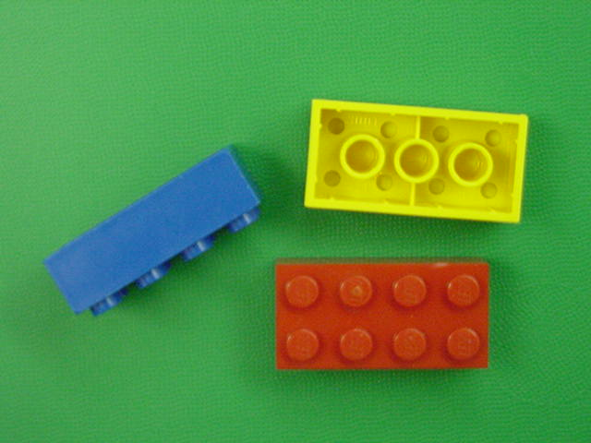

Hierarchical Task Analysis
TASK: “Figure out what degree requirements are for a specific major”

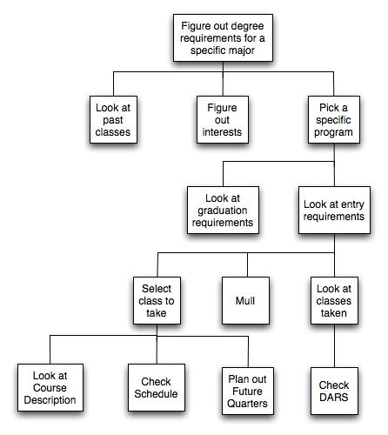
HTA 1.

How did you know when to stop including details and creating levels in the diagram? | We stepped through each of these processes when we got to them and we wrote them down as we saw them. There just seemed like a natural end when we reached the last level because the task looked to have been more than completed. We actually feel that we went a step further by actually looking at the courses and checking the schedule to see if they fit in what classes we were already taking. It seemed natural to keep going like we did because some questions were left unanswered if we didn’t. Questions like, “What is this class like?”, “Does it fit with my schedule?”, “Do I take it this quarter or plan to take it in the future?” So, we felt it important to continue until these questions were answered.
These steps probably would not always be done in the same way by different people, or by the same person from quarter to quarter. What could you do to account for that in your analysis? | Given our users’ persona, we account for the most important options which are: look at past classes, figure out interest. We anticipate that our users may or may not follow the same order. However, these two options are presented to them early enough in the model so that the order would not matter. We realize that the user will not be like us in every manner so options is a key component in making the system broad enough for everybody, including Maria, to use. Also, with the way our HTA is structured we realize that some steps will not need to be completed quarter after quarter. This is why options in the process is vital. Given options the user can accomplish anything within the system’s scope.

Mental maps

HTA 2.
Figure out degree requirements for a specific major
Check my status
Visit departmental website for more specifications
Figure out if this major match interest
Review past classes
See classes taken that are applicable to degree
Review UW grad. requirements
Review classes required before admission
Review classes required after admission
Make decision to register

What are the basic differences between your analysis and that of your partner? | The majority of the differences lie within the levels of details. Both HTAs seem to address the main processes that Maria would go through in order to figure out degree major requirements. These essential steps are: review past classes, match major to interest, and register if she sees fit. However, in HTA1 the level of details was taken to another level where Maria actually go to her myUW to register for these classes. Meanwhile, HTA2 allows some possibility that after looking through the requirements Maria may decide not to register.
What does exercise have to do with mental models? | It allows you to see how the way someone construct an approach to complete a task can be substantially differ from another person’s approach while doing the same thing.
What do mental models have to do with the design of information systems? | Although both designers on our team focus their design for Maria. However, they each came to very different HTA at the end. This gives us some insights on what to expect when we designer specifically for tasks our person might carry out.  We have to find a way to designer our information systems in such a way so that it would cover all the base cases first, matching it to Maria’s mental model.

User Experience

Illustration 1

What elements do you want to use from this illustration and why? | We definitely like the logo at the top left of the page. It conveys very much what our system is trying to accomplish, that is help students make decisions at the cross road of their education career.  The breakdown on the left navigation bar is very helpful. It gives a good display of available topics without overwhelming amount of text.
What elements do you not want to use and why? | We would not use the same color schema because it is unrelated to our school color schema. The 3rd navigation bar on the right seems a big unnecessary. We feel testimonials and such would have their place within the construct of the left navigation bar. On top of that we would add a search bar, in case students need direct access to information without browsing.

Illustration 2

What elements do you want to use from this illustration and why? | We like the layout and the style. The one thing that is nice about all of the university pages is that they mostly have a uniformed style. They have a logo and who they are. So, you get the feeling that when you are at a page put up by the university that you are actually part of the larger system of pages. We also like the navigation and the way the content is laid out. It makes it very easy to find what you are looking for and your eyes easily float across the page.
What elements do you not want to use and why? | We would probably not keep all of the same navigation on our page. Our system will be different that the one presented above, so we will spend some time to revise our navigation to fit our needs. We will also probably drop the bottom footer on the page. It just doesn’t make this page feel very welcoming as a user.

Illustration 3

What elements do you want to use from this illustration and why? | We like the way that the course information is presented for each of the past course. While it is boring, it is easy to see what class was taken, when it was taken, the number of credits, and the grade that was received.
What elements do you not want to use and why? | The presentation is pretty boring. The textual layout isn’t really that appealing to look at. We don’t like the way it is split up. We would want it organized differently for our purposes. Also, we aren’t that interested about how they meet general education requirements, we are more interested in the classes that were taken.

Interactions Analysis

Close-up on an interaction

Use Case #1

User entry information need | Input past courses to get suggestion for a major  (Need to explore a suggested major based on courses taken)
User entry attitude | Confused, but curious
Interaction
  User Action | System Response
  (1) Type in the web address of the Undergraduate advising page | (2) Loading the undergraduate advising page
  (3) Login using UWnetID
  (4) Click enter | (5) Loading all the courses the user took
  (6) Click continue for majors suggestion | (7) Loading page with boxes so user can enter additional interests
  (8) Click submit for majors suggestion | (9) Matching up the information with the database
   | (10) Loading the results: a list of all majors suggested by the system and a short description of each.
  (11) Read the results
  (12) Select a major that you want more information about | (13) Display a short description of the major, requirement to enter the major and the homepage of the department
  (14) Read the information
  (15) Click on the department link of the major | (16) Loading the department homepage
  (17) A smile on the user’s face

Flow Chart
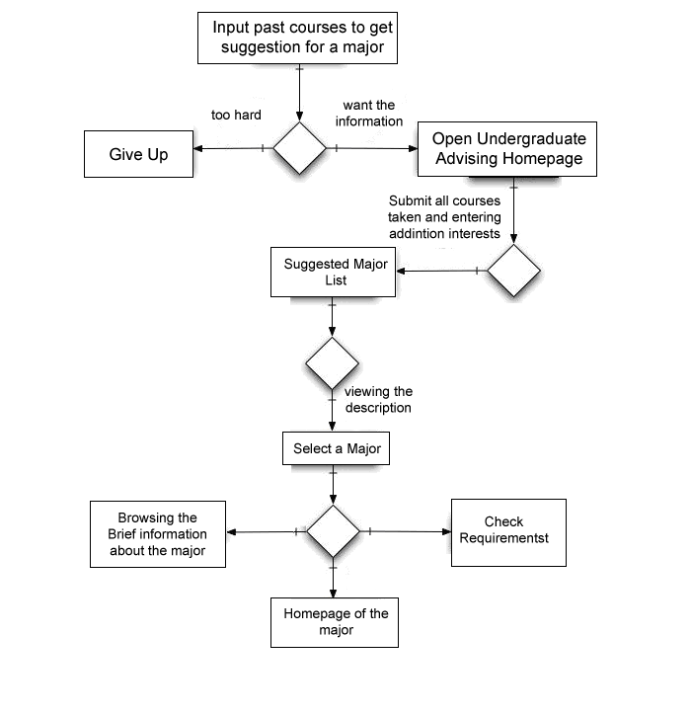

Interaction design essentials

Essential question | Your answer
How will you indicate where the user is?  - Current Status  - What comes next  - Where the end of the interaction is  - Undo (how to go back) | The user will know where they are through nice large titles on each page. All of the links will be clearly labeled so that the user knows exactly where they are going. The interaction will be over when the user decides that is over. The end of the process can either end with browsing the major information, going to the webpage of the major, or checking requirements. They will also have the opportunity to look up information about other information. The user will also be presented with the option of going back to where they were and will tell them where they are going back to.
How will you indicate want just happened?  - Feedback  - Error recovery | If the action is successful, the page will change and a new title will be present so that the user will know they are in the right place. If there is an error that is user initiated (such as not putting in all the criteria), the system will notify the user and prompt them for the missing information. If there is a system failure, the system will save as much information as possible and will give the user the option of trying again.
How will you give the user the feeling that she gets to do it her way?  - Accounting for divergent goals  - Leveraging the user’s conceptual model  - Defaults | The user has the option to put in as many or as few courses as they would like in order to output a major. After the process is complete, several majors will be outputted in order to not restrict the user to one major. This gives the user the feeling that they still have some freedom in the selection process. The tasks is options will be clearly defined so the user should be able to adjust their conceptual model to the system. There will be no defaults as the system can only work off of user input. There is the possibility of outputting the most popular majors if the user doesn’t have any input for the system.

Use Case #2

User entry information need | I need to know what are the requirements for getting into a specific major.
User entry attitude | Intrigued, curious, and anxious
Interaction
  User Action | System Response
  (1) Go to the undergraduate advising page | (2) Load undergraduate advising page
  (3) Select find requirements for major link | (4) Load find requirements for major page
  (5) Select major from alphabetic listing
  (6) Click link for a specific major | (7) Load webpage with information about that major
  (8) Mull over the information on the page
  (9) Locate the required classes to get into that major
  (10) Write down what classes are need to be taken to get into the major
  (11) Satisfaction that information about a major has been found.

Flow Chart
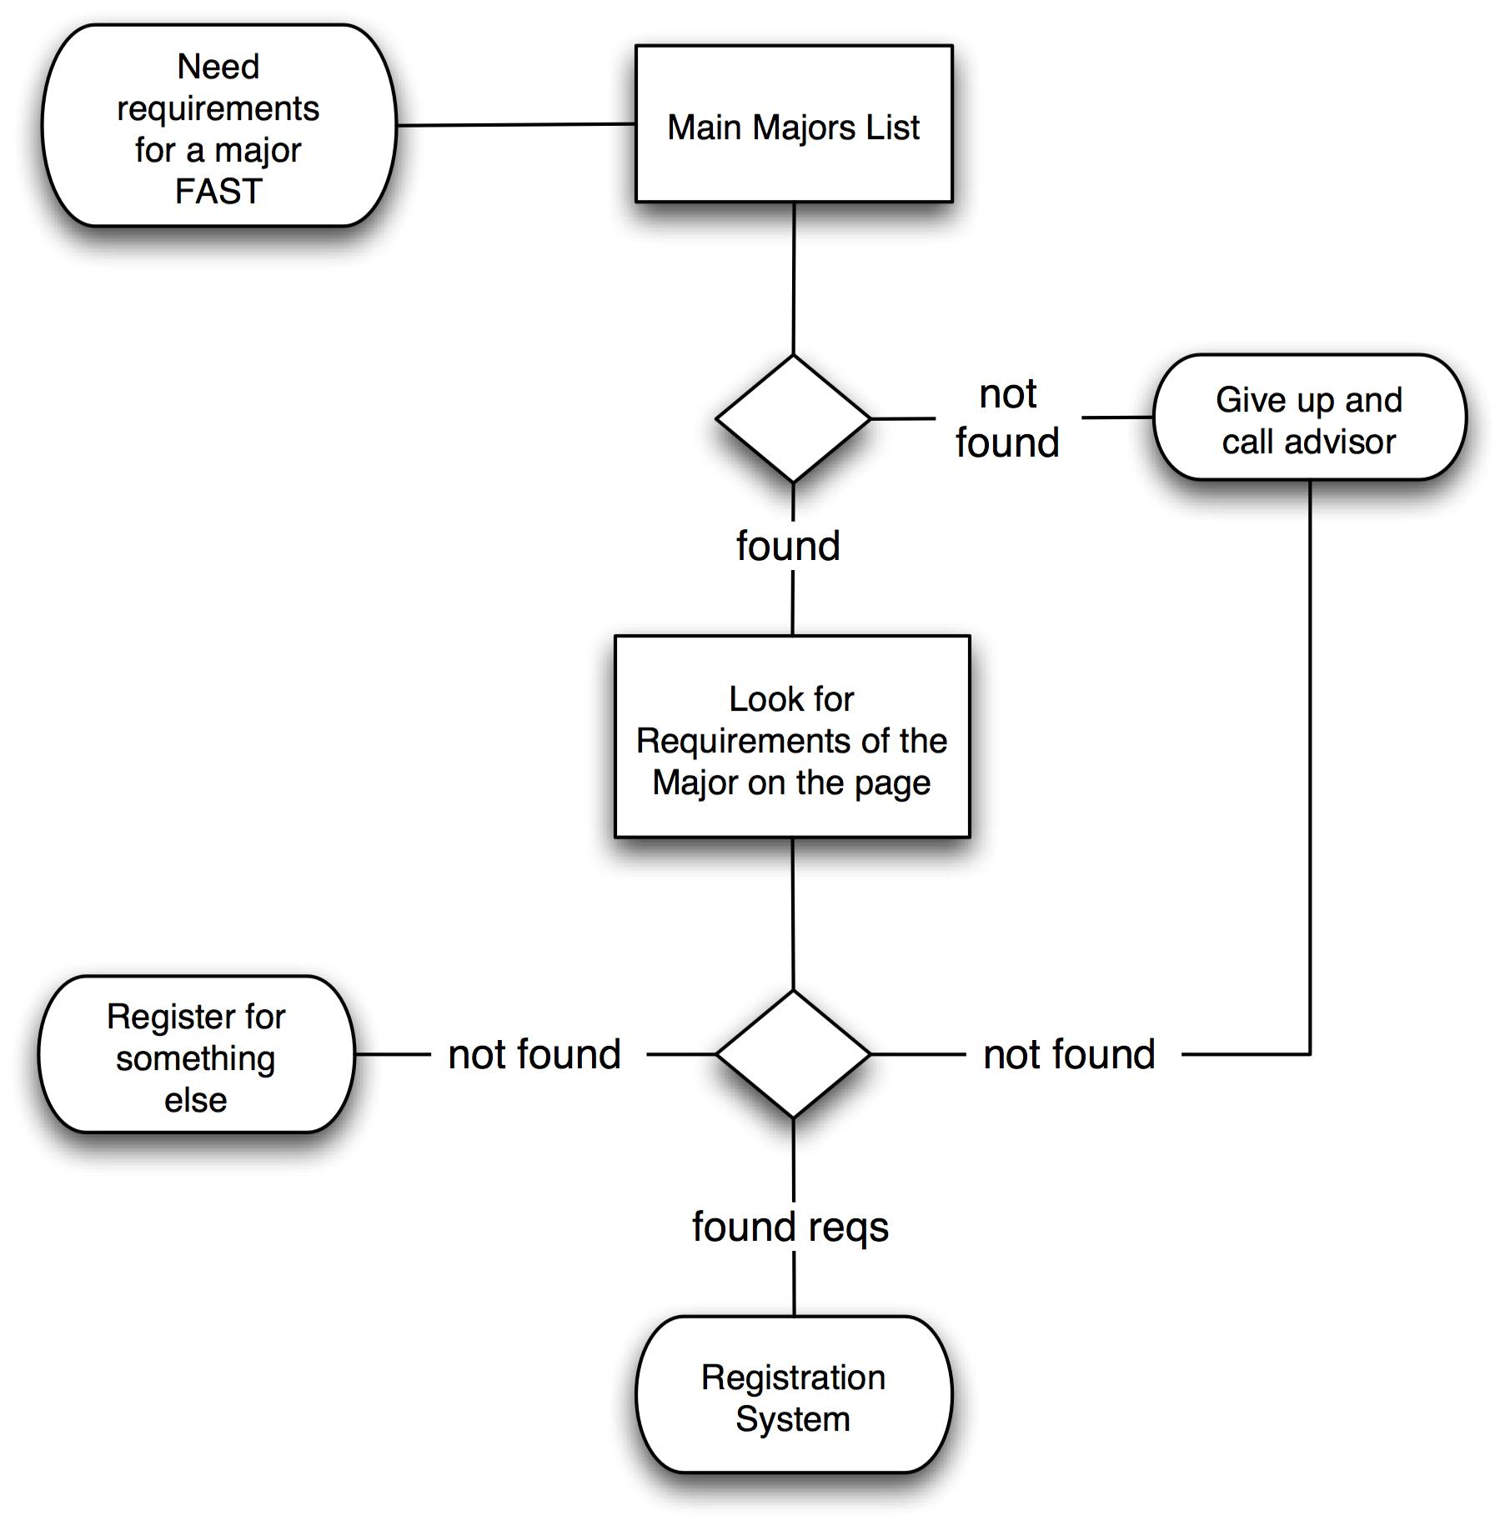

Interaction design essentials

Essential question | Your answer
How will you indicate where the user is?  - Current Status  - What comes next  - Where the end of the interaction is  - Undo (how to go back) | To show where the user is we will use large titles on each page that the user visits. When they are looking at the specifics for a particular major, we will tell them on the screen (via breadcrumbs) where they are. This will make it easy for them to find their way back. We will also provide them a “back” link at the bottom of the page so that they can find their way back to the listing of majors. Also, in addition to a back button, we will provide them a link to “start over.” This will give them a way to start over whenever they want. To give them an idea what it next we will label the links so that they have an idea on what is next in the process. Also, the user will decide when the interaction is over. They might look at one major or multiple. It is completely up to them. So, the ending of the interaction is when the user decides that their information need has been fulfilled.
How will you indicate want just happened?  - Feedback  - Error recovery | We will display the page to them with an appropriately labeled title. By showing that the page has been loaded, the user will have confidence in the system that it is loading what is expected. If there is an error, a message will be displayed informing the user what needs to be done to continue with the interaction. It will also provide links to go back to the last page, or to restart the interaction.
How will you give the user the feeling that she gets to do it her way?  - Accounting for divergent goals  - Leveraging the user’s conceptual model  - Defaults | We will provide the user with two ways to select a major. The will be able to search for a major (text search) or to browse alphabetically. Also, if the user gets side tracked and leaves the page, the link is readily available on the advising webpage (this is an addition to the current site). Also, there are no defaults for this interaction. So, the user will have complete control of this interaction. They will lead the interaction from beginning to end. This will benefit the user’s conceptual model because finding a major is a very personal thing and we give them complete control over this interaction.

Use Case #3

User entry information need | Need to quickly find information on a specific major.
User entry attitude | Maria’s in a hurry, doesn’t want to interact a lot, just get in, get out
Interaction
  User Action | System Response
  (1) Comes to site
  (2) Types a Query into the Search Box | (3) Processes Query
   | (4) Returns list of best matched majors
  (5) Browses major to find the correct one
  (6) Presses link for proper major | (7) Loads information for selected major
  (8) Browses presented information to find the information she needs
  (9) Makes a note of the information she needs
  (10) Maria ends happy interaction!

Flow Chart
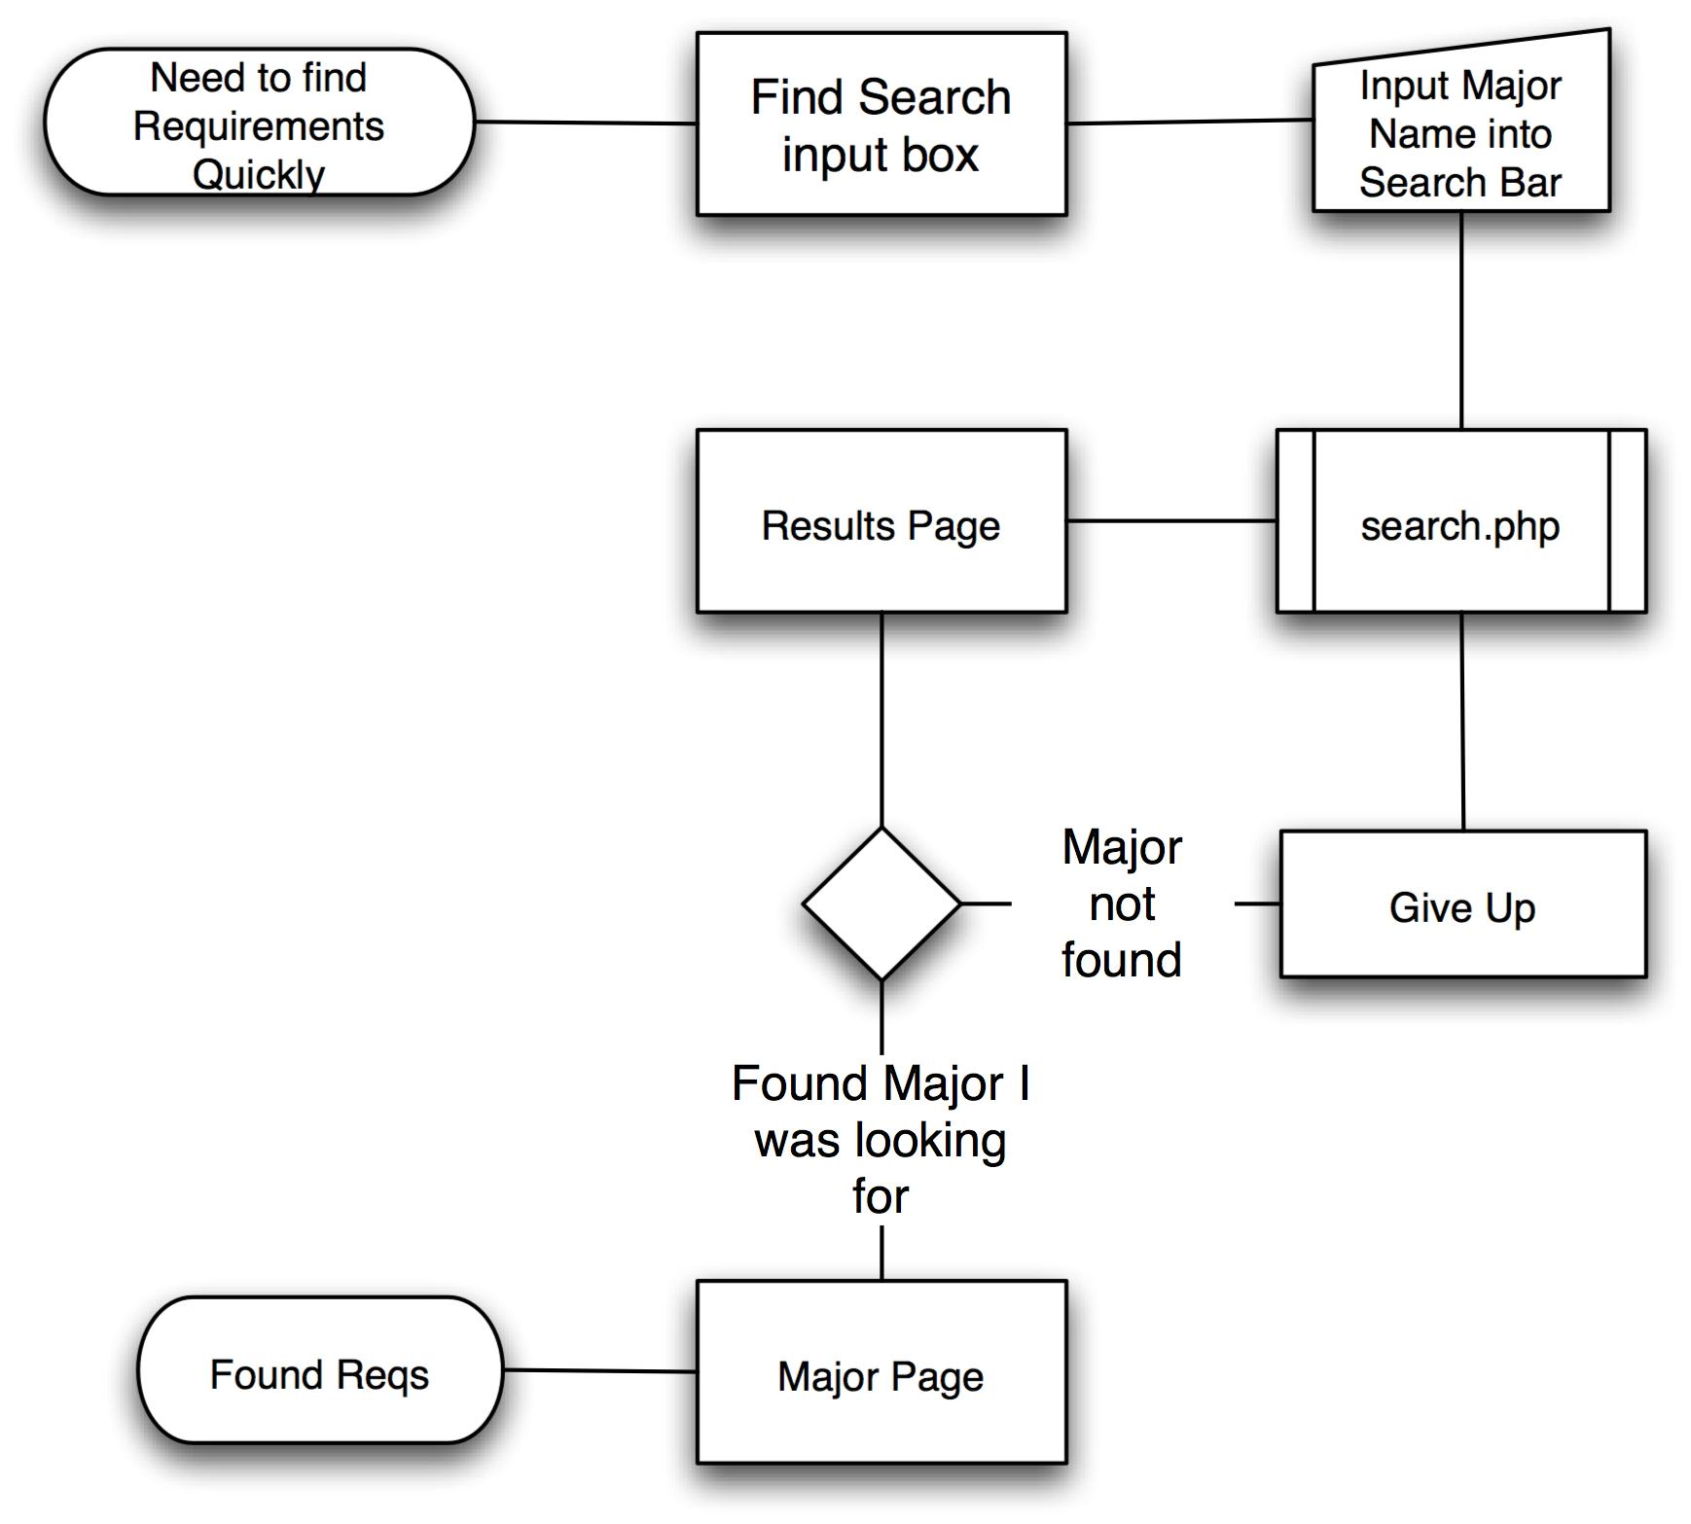

Interaction Design Essentials

Essential question | Your answer
How will you indicate where the user is?  - Current Status  - What comes next  - Where the end of the interaction is  - Undo (how to go back) | We’re going to take a cue from Google here and base a lot of visual cues letting the user know where he or she is in the system. Leaving the query in the box is a huge help to the user. The title at the page will read “Search Results for ‘[QUERY NAME HERE]’” to let the user know their search worked. The button to initiate the search will have text on it that will welcome the user to begin the searching process. Text like “Search” could be used to accomplish this task. If the uses messes up along the way and they want to start over, they will have no problem doing this since we are including the search feature on every page. This way, if they get lost in their interaction or of they messed up they can go back.
How will you indicate want just happened?  - Feedback  - Error recovery | If the search result fails (no results found) they would be given an error message saying that no results were found, and they will be given a listing of all majors, and another search box to make another search if the user wants. If the system has another error that is not necessarily of the user’s doing a system error message will be presented and the user will be informed what that error is and to please be patient with the system as it appears to be having technical difficulties.
How will you give the user the feeling that she gets to do it her way?  - Accounting for divergent goals  - Leveraging the user’s conceptual model  - Defaults | Allowing to search in a list or typing in a query will keep the user in control. No 404’s (page not found errors) or search failed error messages. We will always give an alternative to get the information if something goes wrong. However, there are no defaults in the searching process. If she searches for a blank query we will inform here that she did so and to try again. To accommodate for the user’s conceptual model we will make this process as intuitive as possible. People search for information on the internet frequently and if we make our process similar to what they are familiar with we will better enable this interaction to fit into her conceptual model.

Prototype – Make a Model

Prototype 1: Need to find information quickly about a major

Content model (Major)

ID | Element name | Required? | Min and max | Constraints | Child of …
1 | DegreeSection | Yes | 1 – 2 | Undergrad. or Graduate | Schools
2 | Description | Yes | 1 |  | Schools
3 | ContactInfo | Yes | 1 |  | Schools
4 | Degree | Yes | 1 - * | Title of the degree | DegreeSection
5 | Suggestions | Yes | 1 |  | Degree
6 | AdmissionReqs | Yes | 1 - * | List of all requirements | Degree
7 | MajorRequirements | No | 1 - * | List of all requirements | Degree
8 | ContinuationPolicy | No | 1 |  | Degree
9 | StudentOutcomes | No | 1 | List of outcomes | Degree

Mapping the content model
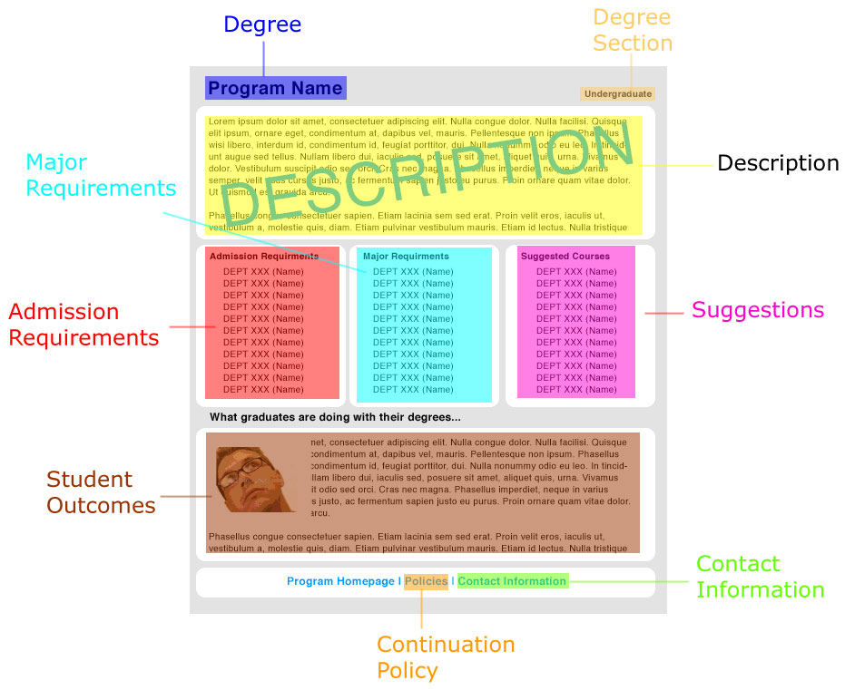

Mapping the subject taxonomy

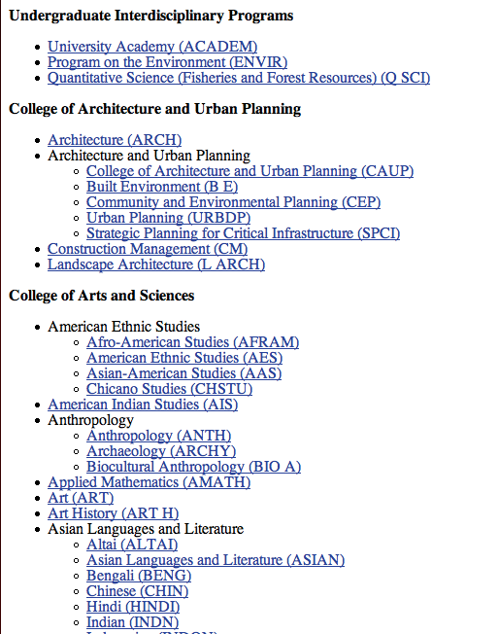

Building the page sequence as a wire frame

Adding the user experience and metaphors

Prototype 2: Find a major based off of past classes of interest

Content model
For the content type that this interaction concerns, enter in it’s elements below
Name: Courses

ID | Element name | Required? | Min and max | Constraints | Child of …
1 | Name | Yes | 1 | 8 – 16 chars
2 | Title | Yes | 1
3 | Credits | Yes | 1 | 1 – 15
4 | CreditType | No | 0 - # of types | NW, I&S, VLPA, W, etc.
5 | Description | Yes | 1 | Text Field

Mapping the content model
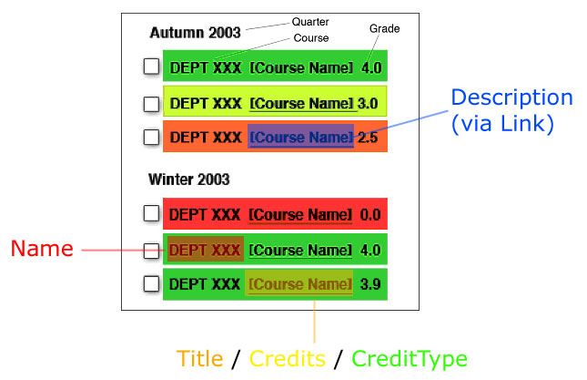
Figure 5: Grade Coloring mockup

Mapping the subject taxonomy

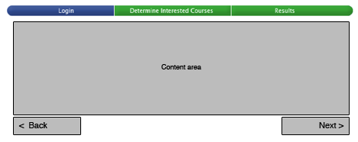

Building the page sequence as a wire frame

Adding the user experience and metaphors

Figure 6: Page 1 - Logging in with UWNetID

Figure 7: page two, transcript loaded, ready to indicate interests
Figure 8: Major Selection Page with colors indicating Grades
Figure 9: Results page indicating recommended majors

Prototype 3: Checking requirements for a specific major

Content model (Major)

ID | Element name | Required? | Min and max | Constraints | Child of …
1 | DegreeSection | Yes | 1 – 2 | Undergrad. or Graduate | Schools
2 | Description | Yes | 1 |  | Schools
3 | ContactInfo | Yes | 1 |  | Schools
4 | Degree | Yes | 1 - * | Title of the degree | DegreeSection
5 | Suggestions | Yes | 1 |  | Degree
6 | AdmissionReqs | Yes | 1 - * | List of all requirements | Degree
7 | MajorRequirements | No | 1 - * | List of all requirements | Degree
8 | ContinuationPolicy | No | 1 |  | Degree
9 | StudentOutcomes | No | 1 | List of outcomes | Degree

Mapping the content model

Mapping the subject taxonomy

Building the page sequence as a wire frame

Adding the user experience and metaphors

Design Evaluation – Testing for Usability

Usability on: Taking Past Courses To Produce A Major Recommendation

Test plan

What are your goals for this usability test? | We want to see how the user will react to the wire frame and to see what areas need to be changed or improved.
Who are your target users? | Our target users are students who are either undecided on a major, looking for a second major, or looking to change majors. This group will mostly be made up of freshmen and sophomores.
What is the goal of the interaction? | The goal of the interaction is to take in students’ interest and output a list of recommendations for them.
What are the steps of the interaction? | 1. The user goes to the webpage of the major finder.  2. The user logs in using netID.  3. The system uploads courses the user has taken.  4. The user checks courses that they are interested in.  5. The system prompts for additional interests.  6. The user submits the information.  7. A list of majors is outputted with links to additional information.  8. The user does as much research on the various majors as they feel they need. This includes such things as description of the major, visiting departmental websites, and contacting advisors.
What is a task that the users may perform through this interaction? | The user is able to find a major or at least have a much better idea of available majors and the necessary requirements.
Usability measures | 1. The user understands how the major finder works.  2. The user feels that the system can do everything that they would like it to do.  3. The user knows the logical steps to take in the process.  4. The user is satisfied with the outputted majors and feels that they match up well with their interests and abilities.

Usability test

2.1 Reaction test

What do you think this page is used for? | I would say that it is used for researching information.
What is the first thing you notice? | I have to have a username and password to use it.
What do you think you would click on first? | The first thing I would have to do is login. I guess the next thing I would use is the search feature.
Is there anything you like or don’t like? | No, I don’t see anything that I don’t like about the system.

2.2 Key task test

Task scenario | Find a major based on your interest and classes you’ve taken.
Observation | She wasn’t quite clear on what the gather interests section was used for. After some clarification, she didn’t think much of the feature that uploaded classes she has taken. She has only taken three classes so far and isn’t interested in any of them. She liked the idea of being prompted for additional interests beyond classes that she has taken. She expected that the working system would output results under the recommendations tab.

Report the usability test results

The “gather interests” section wasn’t as clear as it could have been. There are limitations in the system for freshmen who may not have taken a lot of classes and who aren’t sure where their interests are. The system is limited in terms of what it can accomplish.

Recommendations

Change the name of the “Gather Interests” section so that the user knows what the section is for. Put in an extensive filtering system, so that if you encounter a freshman who has only taken 3 classes that they still will be able to find something that meets their needs. Provide more features for the system, such as a link to potential careers with a major. This will make the system seem more powerful and will enhance user satisfaction.

Usability on: Browsing Major Requirements

Test plan

What are your goals for this usability test? | We want to see how the user will react to the prototype and to see what areas need to be changed or improved.
Who are your target users? | Our target users are students who are either undecided on a major, looking for a second major, or looking to change majors. This group will mostly be made up of freshmen and sophomores.
What is the goal of the interaction? | The goal of this interaction is for the student to be able to browse through the majors that the University has to offer.
What are the steps of the interaction? | 1. The user goes to the webpage of the major finder.  2. They use the “Choose a Degree Program from all that we have to offer at UW” feature.  3. A list of all the majors at UW comes up.  4. The user browses through the list of majors.  5. The user selects a major that they are interested in.  6. A recommendations page comes up with a description, requirements, and information about what you can do with the major.  7. The user does as much research on the various majors as they feel they need to. This includes such things as reading the available information, visiting departmental websites, and contacting advisors.
What is a task that the users may perform through this interaction? | The user is able to find out what the available majors are at the University and to find which ones they might be interested in.
Usability measures | 1. The user understands how the major finder works.  2. The user selects the right feature for the assigned task.  3. The user knows the logical steps to take in the process.  4. The user is satisfied with all of the information that is returned on the selected major.

Usability test

2.1 Reaction test
For the first part of the test, you will test whether the user gets it. You will show your partner the prototype (a sketch, a wire frame, or an html page) and find out if he/she understands the purpose of the site, how it works, how it’s organized, and so on. To do so, ask your partner the questions in the table and fill in his/her responses.

What do you think this page is used for? | This is a home page that will help you get somewhere to help you choose a major.
What is the first thing you notice? | The guy with the glasses.
What do you think you would click on first? | I would click on the red “Choose” button in the bottom right hand corner. It’s bright and red and there is something about the word “Choose”
Is there anything you like or don’t like? | No, I think it’s wonderful.

2.2 Key task test

Task scenario | You’re not sure what to major in so you what to get an idea of all that’s available.
Observation | Somewhat surprisingly, she chose the “Recommend” feature with her first attempt. After finding out what that was, she went back and chose the “Choose” feature which is the one that we had expected. The next step for her would be to scroll through the list and find a major that she was interested in. She would then read the description followed by what she could do with the major. If she was still interested, she would then read the necessary requirements.

Report the usability test results

The only noticeable problem is that she did not use the expected feature the first time. Perhaps she thought that her past courses might be more helpful for finding something she is interested in or perhaps it was because it was closer to the top.

Recommendations

The only recommendation would be to play around with the titles for the features on the home page. Perhaps instead of “Choose a Degree Program from all that we have to offer at UW”, it could be “Browse through all degree programs at UW” or something similar. To get these titles right would require more usability testing with more users. However, this doesn’t appear to be a major problem as the user was completely happy with everything else in the system and couldn’t find any complaints.

Usability on: Searching For a Specific Major

Test plan

What are your goals for this usability test? | We want to see how the user will react to the prototype and to see what areas need to be changed or improved.
Who are your target users? | Our target users are students who are either undecided on a major, looking for a second major, or looking to change majors. This group will mostly be made up of freshmen and sophomores.
What is the goal of the interaction? | The goal of the interaction is for the student to be able to search for a major they know they are interested in
What are the steps of the interaction? | 1. The user goes to the webpage of the major finder.  2. They use the search feature in the middle of the page  3. The results of the search query are listed.  4. The user clicks on the major they were searching for.  5. A recommendations page comes up with a description, requirements, and information about what you can do with the major.  6. The user does as much research on the various majors as they feel they need to. This includes such things as reading the available information, visiting departmental websites, and contacting advisors.
What is a task that the users may perform through this interaction? | The user is able to find out information on a major that they know they are interested in.
Usability measures | 1. The user understands how the major finder works.  2. The user selects the right feature for the assigned task.  3. The user knows the logical steps to take in the process.  4. The user is satisfied with the results of the search query.  5. The user is satisfied with all of the information that is returned on the selected major.

Usability test

2.1 Reaction test

What do you think this page is used for? | This is a home page that will help you get somewhere to help you choose a major.
What is the first thing you notice? | The guy with the glasses.
What do you think you would click on first? | I would click on the red “Choose” button in the bottom right hand corner. It’s bright and red and there is something about the word “Choose”
Is there anything you like or don’t like? | No, I think it’s wonderful.

2.2 Key task test

Task scenario | You know you are interested in “Chemistry”, so how would you go about searching for information on “Chemistry”
Observation | She selected the “Search” feature in the middle of the page which is what we were hoping for. She commented that although it was unusual that she liked having the search feature right in the middle. The next step took her to the outputted results of her search on “Chemistry”. She then decided that the next step would be to click on the link for “Chemistry”. She said she would then read course requirements and then would read about what people do with the major.

Report the usability test results

There weren’t any observable problems from the test. She went through the steps as expected and didn’t have any complaints about the website. The only foreseeable problem would be if someone searched for a major that wasn’t offered. However, since this was not a working prototype, that could not be tested.

Recommendations

Based off of the test, there are not recommendations that can be made. The user was happy with the system and had no complaints even after being prompted for any kind of problems.

Meeting Agendas

What follows are the meeting agendas for Team Calder. The meeting dates were as follows:

- October 25th, 2004
- November 1st, 2004
- November 8th, 2004
- November 22nd, 2004
- December 6th, 2004

Agenda For October 25th, 2004

Location: TBD
Time: After INFO 370
Duration: ~1 hour

Agenda

- Discuss meeting times and how often we should meet.
  - Mondays @ 12:30
- Do we want an ePost, or other online forums?
  - Already done
- Figure out what system we want to do.
  - Program Finder (Major/Minors)
- Create our triple for the system.
  - To do next week

Go through triple worksheet for next week.

Agenda For November 1st, 2004

Location: TBD
Time: After INFO 370
Duration: ~1 hour

Agenda

- Work on Triple
- Split team into two sub teams
  - Team Monday
    - Dan
    - Aaron
    - Kathryn
  - Team Thursday/Friday
    - Ryan
    - Pei-Wen
    - Irvin
- Divide out Persona
  - Due by noon on Friday

Agenda For November 8th, 2004

Location: TBD
Time: After INFO 370
Duration: ~1 hour

Agenda

- Discuss Personas
- Select a Persona
- Look over revised document Boiko put online
- Divide out tasks for this upcoming week
- Set timeline of project parts

Agenda For November 22nd, 2004

Location: TBD
Time: After INFO 370
Duration: 15 minutes

Agenda

- Discuss Progress
- Discuss where we are going in the upcoming weeks
- Look over due dates
- Answer any questions about project

Agenda For December 6th, 2004

Location: TBD
Time: After INFO 370
Duration: ~1.5 hours

Agenda

- Review presentation
- Complete run-through of presentation
- Discuss any last minute revisions to paper

Information Management

Over the course of this project we needed a way to manage all of our information. This information included, but was not limited to:

- Team members names and e-mail addresses
- Team listserver and archives
- Team ePost (forums)
- Due dates for project sections
- Links to relevant lab files
- Our completed data files

An initial discussion was brought up at our first meeting on how to accomplish this. One idea proposed was to use a wiki system prodded my the MediaWiki group (http://www.mediawiki.org). However, after discussion, we decided that this would not be practical for a project like this. Many of the team members had not used a wiki in the past and learning how to function in a wiki environment was something that we felt we did not have time for. This lead us to a discussion on a simple webpage.

Ryan Prins took up the lead and created a e-mail list (info440_calder@u.washington.edu) and an online forums for the team to use. In addition to those tools he also created a basic webpage that had the same outline as the report. This website was protected by a .htaccess file that restricted use, by UW Net ID, to only those students who were on the team. All of the information needed for each section (related labs, our completed files) was kept on this web page. Each section also contained a due date. The date was kept red if it was still outstanding, but if the section was completed the color was turned to green.

In order to make sure team members knew when files were last uploaded to the site a simple PHP script was generated to display the last edit time of each file on the site. This was done to make sure that team members were using the most current files and that if there was a difference they could check very easily.

Since there was only one webmaster, all of the files had to go through him. This process involved sending all completed files to the webmaster for upload (almost always within 24 hours). After the update was completed of the site (changing team Excel due dates file, uploading files, updating html, etc..) an e-mail was sent out to the entire team via the team e-mail list to inform them that the files were uploaded and that the next group was up to work on their part. This process lasted for the duration of the project and proved to be a very effective manner to treat the information for this project.

For a demo of our team site, please view the site with the URL provided below.

Team Web Page: http://calder.lazyi.net

Project Deadlines

The following spreadsheet is what we used as our schedule for the project. Each part of the project had the appropriate lab listed, when that lab was completed in class, when that part was due for our team, if it was completed or not, and who was responsible for that part.
Task | Lab Name | Done in Lab | Calder Due Date | Completed? | Who?
Organization Overview | N/A |  |  | YES | Irvin
The Design Problem | Strategic Design | Tu, Oct 5 | Mon, Nov 1 | YES | Calder
User Analysis | Persona | Tu, Oct 12 | Fri, Nov 5 | YES | Calder
High Level System Req | Requirements | Tu, Oct 19 | Wed, Nov 10 | YES | C
Information Analysis | IA | Tu, Oct 26 | Sat, Nov 13 | YES | B
 | Content Modeling | Tu, Nov 2 | Tue, Nov 16 | YES | A
Activity and Interaction Analysis | Activity | Tu, Nov 9 | Fri, Nov 19 | YES | C
 | Interactions | Tu, Nov 16 | Mon, Nov 22 | YES | B
Prototype | Prototype | Tu, Nov 23 | Mon, Nov 29 | YES | A
Design Evaluation | Usability | Tu, Nov 30 | Fri, Dec 3 | YES | B
 | TOTAL PARTS LEFT TO COMPLETE | 0
 | Project Due: | Tu, Dec 7
 |  |  | Team Name
 |  |  | A | Dan / Aaron
 |  |  | B | Pei-Wen / Irvin
 |  |  | C | Kathryn / Ryan

Group Photos

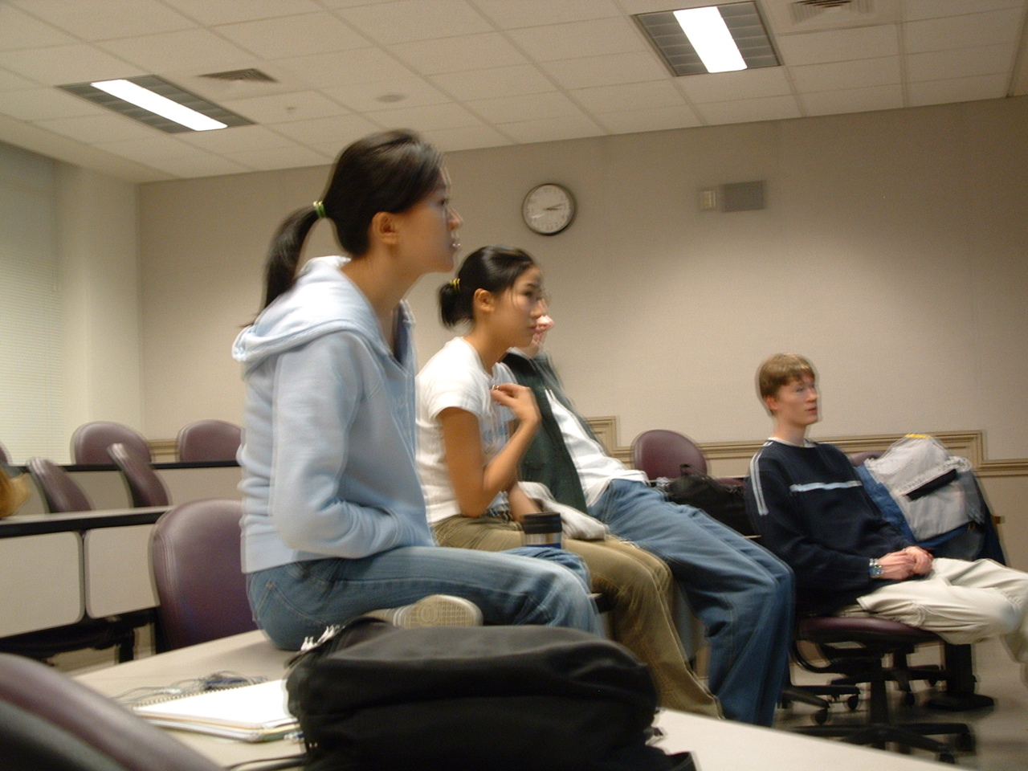
Team Calder at one of our group meetings.

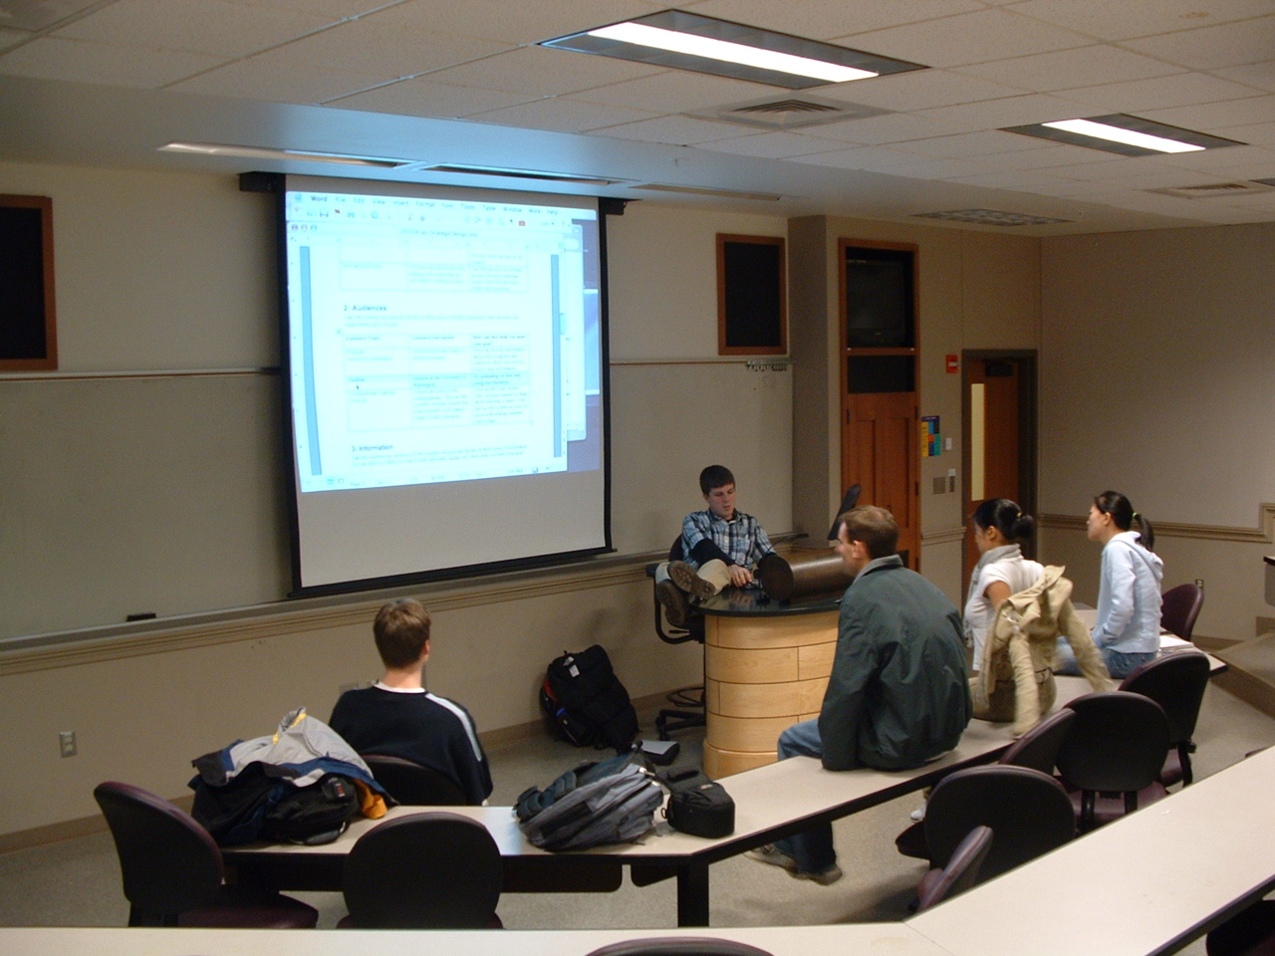
Team Calder working through the design problem lab and formulating a triple.

