Topic map

Brainstormed Words
- Program Information
- Timeline for applying to a major
- Program Advisors
- Advisor Contact Information
- Interest Survey
- Course Listings
- Reverse Course Listings
- Related Majors
- Major listings
- Major Requirements
- Admission information
- Major questionnaire
- Classes taken
- Major identifier
- Related Events
- Careers
- Alternate majors
- Interest matcher
- Gateway Center Advisors
- UW Students
- Community College Students
- Appointment maker
- Referral System
- GPA requirements
- Prerequisites
- Suggested tracks
- Course Requirements
- Graduation Requirements
- Suggested Major
- Program
- Interests
- Courses
- Majors
- Advisors

Subject words | Type words
Program Advisors | Suggested Tracks
Related Majors | Timeline for applying to a major
Classes Taken | Referral System
Related Events | Interest Survey
Careers | Course Listings
Alternate Majors | Reverse Course Listings
Gateway Center Advisors | Major Listings
UW Students | Suggested Major
Community College Students | Admission information
Prerequisites | Major Questionnaire
Program | Major Identifier
Interests | Interest Matcher
Courses | Appointment Maker
Majors
Advisors
Major Requirements
Graduation Requirements
Course Requirements
GPA requirements
Program Information
Advisor Contact Information

Topic map

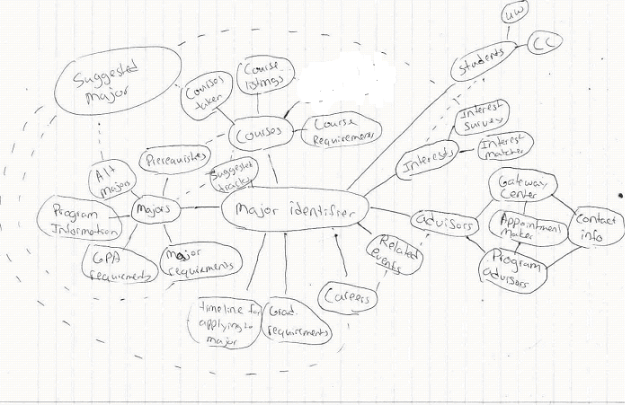

2- Card Sort

User sort 1

Term Id | Term
25 | Students
2 | Community collage students
3 | UW students
26 | Interests
4 | Interest Matcher
12 | Interest Survey
6 | Related events
20 | Suggested majors
8 | Careers
26 | Interests
4 | Interest Matcher
12 | Interest Survey
6 | Related events
20 | Suggested majors
8 | Careers
15 | Majors
16 | Program Information
22 | Suggested tracks
23 | Alternate majors
5 | Timeline for applying to a major
21 | GPA requirements
17 | Major requirements
19 | Graduation requirement
7 | Prerequisites
10 | Courses
13 | Classes taken
14 | Courses requirement
24 | Courses Listing
27 | Advisors
18 | Gateway center advisor
9 | Advisor contact Information
11 | Program advisors
1 | Appointment maker

User sort 2

Term Id | Term (to indent press ctrl-tab)
15 | Majors
5 | Timeline for applying to a major
6 | Related events
23 | Alternate majors
16 | Program information
17 | Major requirements
14 | Course Requirements
21 | GPA Requirements
13 | Classes Taken
7 | Prerequisites
19 | Graduation requirement
25 | Students
2 | Community collage students
3 | UW students
10 | Courses
24 | Course Listing
26 | Interests
22 | Suggested tracks
4 | Interest Matcher
20 | Suggested majors
8 | Careers
12 | Interest survey
27 | Advisors
18 | Gateway center advisor
9 | Advisor contact Information
11 | Program advisors
1 | Appointment maker

