Gathering the information

Interaction
Choose/modify an interaction. Answer these two questions:

What requirements does it address? | Need to explore possible majors taking into account selected past courses.
What will your persona think of it? Will she understand it? Will it be a wow feature? Will she need it? | Maria will think this is useful because she has a potpourri of classes she has taken and cannot decide what she wants to pursue. She knows she has some favorite classes but is not sure what these classes work towards certain majors. It’s a “wow feature” in that it is a new feature available students. However, it is really a need that is not being met by the current functionality of DARS and other UW web tools.

Describe it’s use case below

User entry information need | The user needs to determine what major they wish to pursue, they need information relating their courses to majors that could be of interest.
User entry attitude | The user is slightly confused and possibly anxious about not having a major.
Interaction
  User Action | System Response
  (1) Type in the web address of the Undergraduate advising page | (2) Loading the undergraduate advising page
  (3) Login using UWnetID
  (4) Click enter | (5) Loading all the courses the user took
  (6) Click continue for majors suggestion | (7) Loading page with boxes so user can enter additional interests
  (8) Click submit for majors suggestion | (9) Matching up the information with the database
   | (10) Loading the results: a list of all majors suggested by the system and a short description of each.
  (11) Read the results
  (12) Select a major that you want more information about | (13) Display a short description of the major, requirement to enter the major and the homepage of the department
  (14) Read the information
  (15) Click on the department link of the major | (16) Loading the department homepage
  (17) A smile on the user’s face

Answer the essential interaction design questions for this interaction here:

Essential question | Your answer
How will you indicate where the user is?  - Current Status  - What comes next  - Where the end of the interaction is  - Undo (how to go back) | The user will know where they are through nice large titles on each page. All of the links will be clearly labeled so that the user knows exactly where they are going. The interaction will be over when the user decides that is over. The end of the process can either end with browsing the major information, going to the webpage of the major, or checking requirements. They will also have the opportunity to look up information about other information. The user will also be presented with the option of going back to where they were and will tell them where they are going back to.
How will you indicate want just happened?  - Feedback  - Error recovery | If the action is successful, the page will change and a new title will be present so that the user will know they are in the right place. If there is an error that is user initiated (such as not putting in all the criteria), the system will notify the user and prompt them for the missing information. If there is a system failure, the system will save as much information as possible and will give the user the option of trying again.
How will you give the user the feeling that she gets to do it her way?  - Accounting for divergent goals  - Leveraging the user’s conceptual model  - Defaults | The user has the option to put in as many or as few courses as they would like in order to output a major. After the process is complete, several majors will be outputted in order to not restrict the user to one major. This gives the user the feeling that they still have some freedom in the selection process. The tasks is options will be clearly defined so the user should be able to adjust their conceptual model to the system. There will be no defaults as the system can only work off of user input. There is the possibility of outputting the most popular majors if the user doesn’t have any input for the system.

Metaphors and user experience elements

What metaphors might you use to express this task to the persona? | Because Maria is taking something that she has in order to get something out of it we feel that the metaphor of a cook book is a good one. A cookbook takes things that you already have (or maybe there are things you need to get) to reach an end goal. So, we feel that it is fitting based on this task to use a cookbook as the metaphor.

Illustration 1
Paste the illustration below:

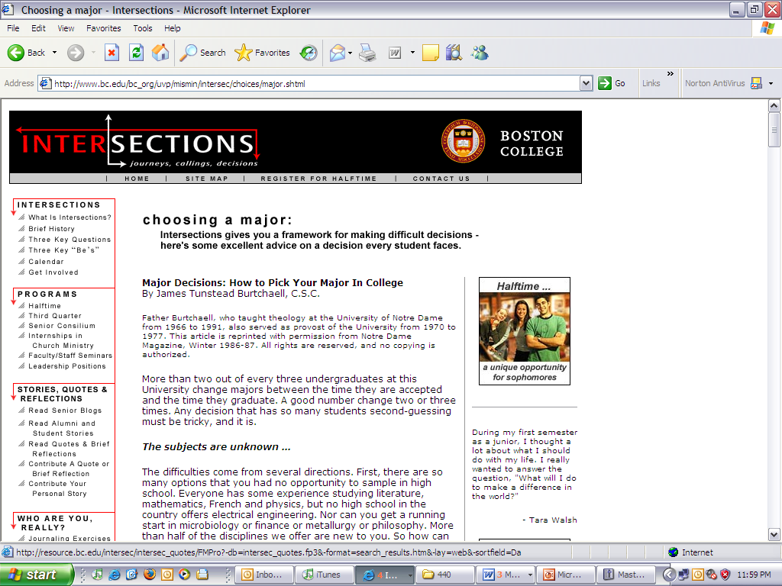

Please answer these questions:

What elements do you want to use from this illustration and why? | We definitely like the logo at the top left of the page. It conveys very much what our system is trying to accomplish, that is help students make decisions at the cross road of their education career.  The breakdown on the left navigation bar is very helpful. It gives a good display of available topics without overwhelming amount of text.
What elements do you not want to use and why? | We would not use the same color schema because it is unrelated to our school color schema. The 3rd navigation bar on the right seems a big unnecessary. We feel testimonials and such would have their place within the construct of the left navigation bar. On top of that we would add a search bar, in case students need direct access to information without browsing.

Subject taxonomy
In the table below, enter the subject taxonomy that relates to the substance of this interaction.

Term Id | Term (to indent press ctrl-tab)
15 | Majors
5 | Timeline for applying to a major
23 | Alternate majors
16 | Program information
17 | Major requirements
21 | GPA Requirements
13 | Classes Taken
7 | Prerequisites
10 | Courses
14 | Course Requirements
24 | Courses Listing
19 | Graduation requirement

Content model
For the content type that this interaction concerns, enter in it’s elements below
Name: Courses

ID | Element name | Required? | Min and max | Constraints | Child of …
1 | Name | Yes | 1 | 8 – 16 chars
2 | Title | Yes | 1
3 | Credits | Yes | 1 | 1 – 15
4 | CreditType | No | 0 - # of types | NW, I&S, VLPA, W, etc.
5 | Description | Yes | 1 | Text Field

Mapping the content model
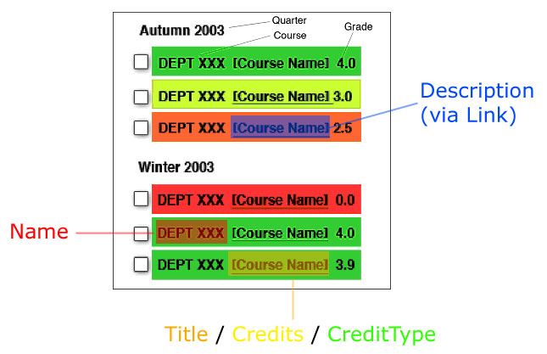
Figure 1: Grade Coloring mockup

Mapping the subject taxonomy

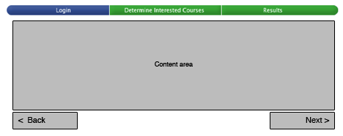

Building the page sequence as a wire frame

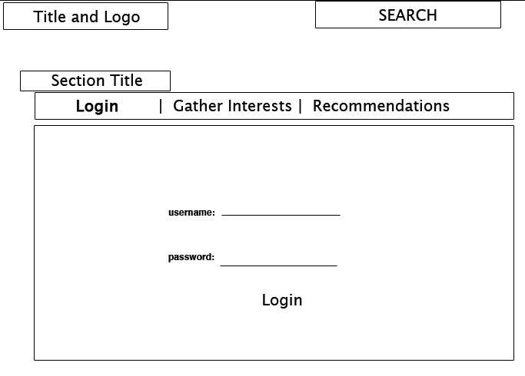
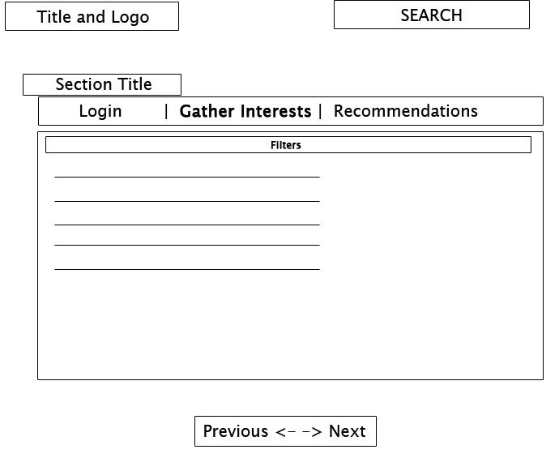
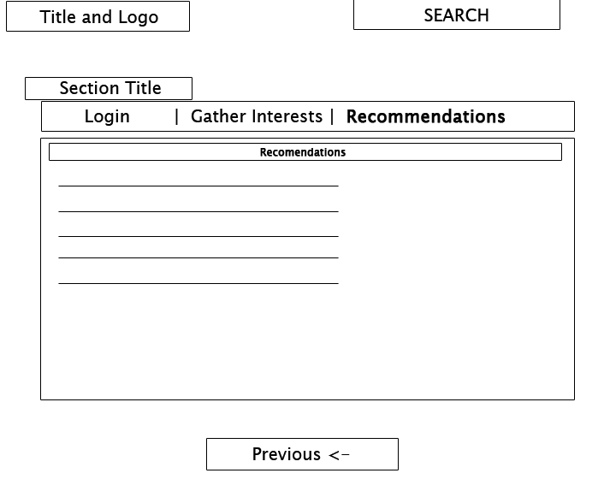

Adding the user experience and metaphors

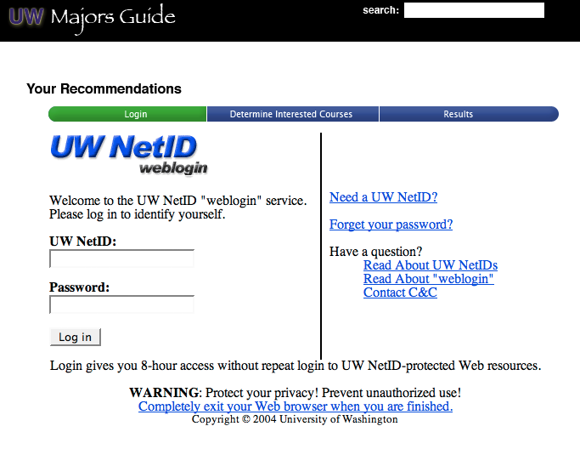
Figure 2: Page 1 - Logging in with UWNetID

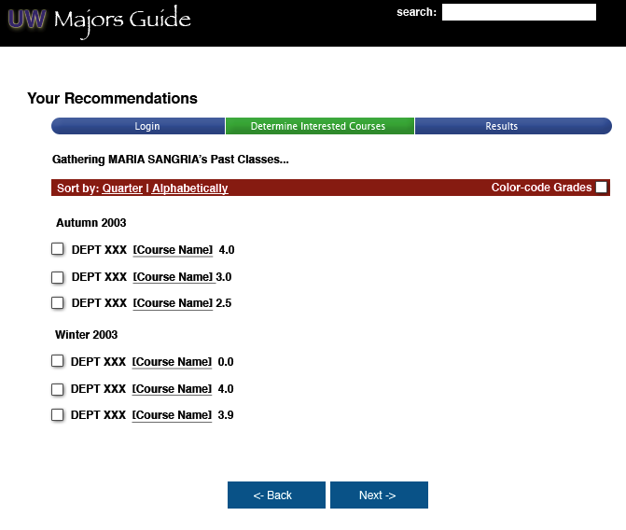
Figure 3: page two, transcript loaded, ready to indicate interests
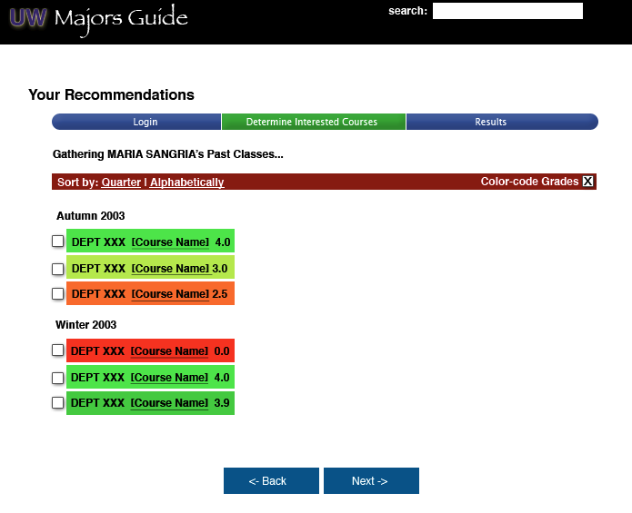
Figure 4: Major Selection Page with colors indicating Grades
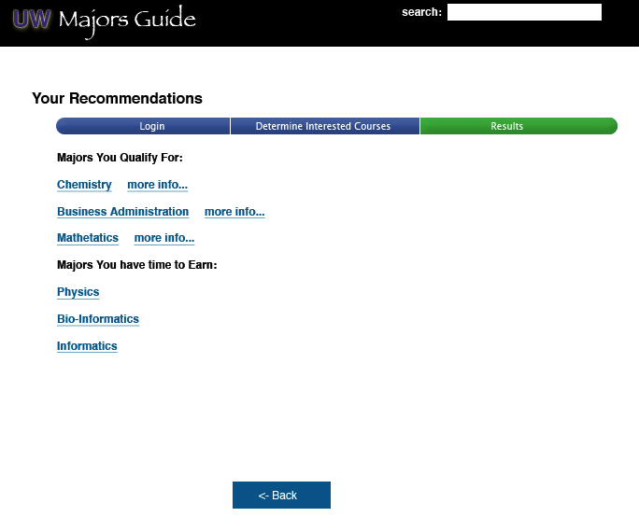
Figure 5: Results page indicating recommended majors

