Gathering the information

Interaction

What requirements does it address? | Need to find information quickly about a requirement or major.
What will your persona think of it? Will she understand it? Will it be a wow feature? Will she need it? | Maria will probably use this every once in a while to easily find requirements, but this is something that she will need along the way in her academic career. This will mainly be used to double check a requirement or two to make sure she’s on top of the process. This is pretty much a required feature in information systems today, so because of that, its not really a wow feature, but Maria won’t even think about it, but that’s kind of the point—“get in, get the information you need, get out.” Because the process is familiar to her and this is just a new way of presenting the information to her, she will be able to understand what is going on right away.

Use Case

User entry information need | Need to quickly find information on a specific major.
User entry attitude | Maria’s in a hurry, doesn’t want to interact a lot, just get in, get out
Interaction
  User Action | System Response
  (1) Comes to site
  (2) Types a Query into the Search Box | (3) Processes Query
   | (4) Returns list of best matched majors
  (5) Browses major to find the correct one
  (6) Presses link for proper major | (7) Loads information for selected major
  (8) Browses presented information to find the information she needs
  (9) Makes a note of the information she needs
  (10) Maria ends happy interaction!

Answer the essential interaction design questions for this interaction here:

Essential question | Your answer
How will you indicate where the user is?  - Current Status  - What comes next  - Where the end of the interaction is  - Undo (how to go back) | We’re going to take a cue from Google here and base a lot of visual cues letting the user know where he or she is in the system. Leaving the query in the box is a huge help to the user. The title at the page will read “Search Results for ‘[QUERY NAME HERE]’” to let the user know their search worked. The button to initiate the search will have text on it that will welcome the user to begin the searching process. Text like “Search” could be used to accomplish this task. If the uses messes up along the way and they want to start over, they will have no problem doing this since we are including the search feature on every page. This way, if they get lost in their interaction or of they messed up they can go back.
How will you indicate want just happened?  - Feedback  - Error recovery | If the search result fails (no results found) they would be given an error message saying that no results were found, and they will be given a listing of all majors, and another search box to make another search if the user wants. If the system has another error that is not necessarily of the user’s doing a system error message will be presented and the user will be informed what that error is and to please be patient with the system as it appears to be having technical difficulties.
How will you give the user the feeling that she gets to do it her way?  - Accounting for divergent goals  - Leveraging the user’s conceptual model  - Defaults | Allowing to search in a list or typing in a query will keep the user in control. No 404’s (page not found errors) or search failed error messages. We will always give an alternative to get the information if something goes wrong. However, there are no defaults in the searching process. If she searches for a blank query we will inform here that she did so and to try again. To accommodate for the user’s conceptual model we will make this process as intuitive as possible. People search for information on the internet frequently and if we make our process similar to what they are familiar with we will better enable this interaction to fit into her conceptual model.

Metaphors and user experience elements

What metaphors might you use to express this task to the persona? | We think the metaphor of a needle in a haystack is a good representation of this task. You are having to sift through all of this information to find that one piece of information (needle) amongst all of this other information (haystack). If the pertinent information is presented to the user they will not have to spend a lot of time digging through the haystack of information to find that needle that they are looking for.

Illustration 1

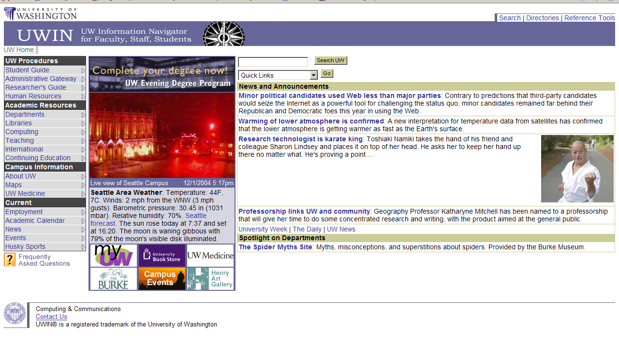

What elements do you want to use from this illustration and why? | We like the layout and the style. The one thing that is nice about all of the university pages is that they mostly have a uniformed style. They have a logo and who they are. So, you get the feeling that when you are at a page put up by the university that you are actually part of the larger system of pages. We also like the navigation and the way the content is laid out. It makes it very easy to find what you are looking for and your eyes easily float across the page.
What elements do you not want to use and why? | We would probably not keep all of the same navigation on our page. Our system will be different that the one presented above, so we will spend some time to revise our navigation to fit our needs. We will also probably drop the bottom footer on the page. It just doesn’t make this page feel very welcoming as a user.

Subject taxonomy

Term Id | Term (to indent press ctrl-tab)
15 | Majors
5 | Timeline for applying to a major
23 | Alternate majors
16 | Program information
17 | Major requirements
21 | GPA Requirements
13 | Classes Taken
7 | Prerequisites
10 | Courses
14 | Course Requirements
24 | Courses Listing
19 | Graduation requirement

Content model (Major)

ID | Element name | Required? | Min and max | Constraints | Child of …
1 | DegreeSection | Yes | 1 – 2 | Undergrad. or Graduate | Schools
2 | Description | Yes | 1 |  | Schools
3 | ContactInfo | Yes | 1 |  | Schools
4 | Degree | Yes | 1 - * | Title of the degree | DegreeSection
5 | Suggestions | Yes | 1 |  | Degree
6 | AdmissionReqs | Yes | 1 - * | List of all requirements | Degree
7 | MajorRequirements | No | 1 - * | List of all requirements | Degree
8 | ContinuationPolicy | No | 1 |  | Degree
9 | StudentOutcomes | No | 1 | List of outcomes | Degree

Mapping the content model
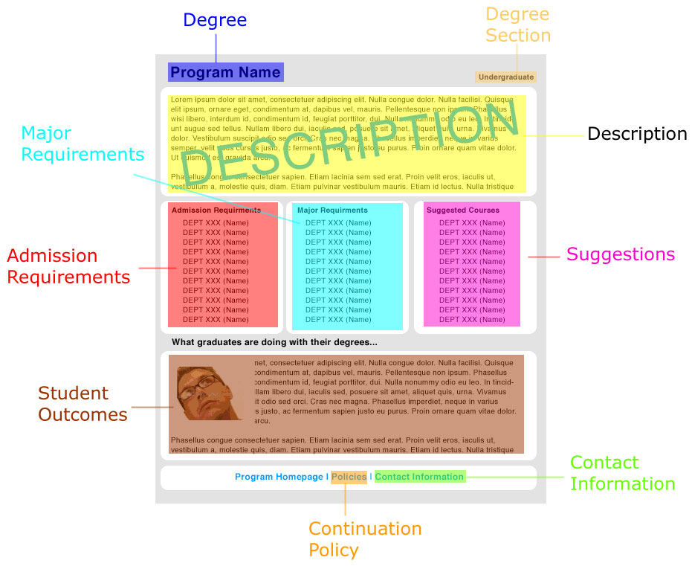

Mapping the subject taxonomy

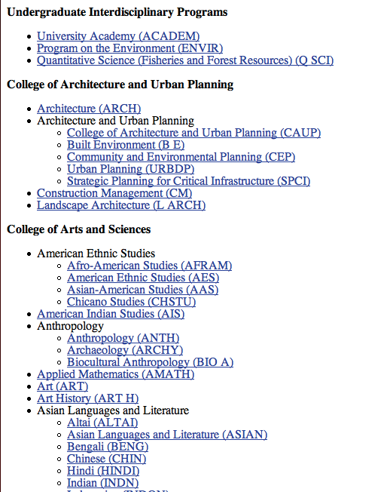

Building the page sequence as a wire frame

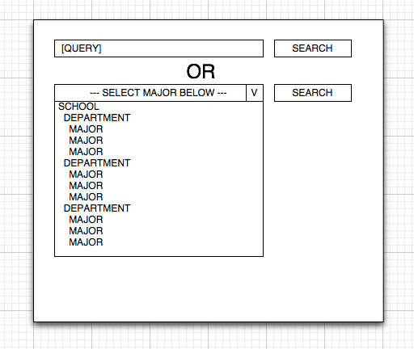

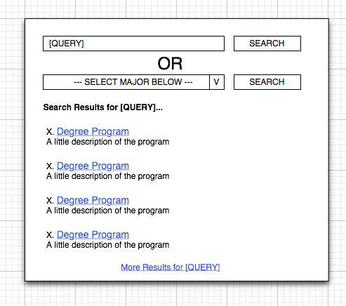
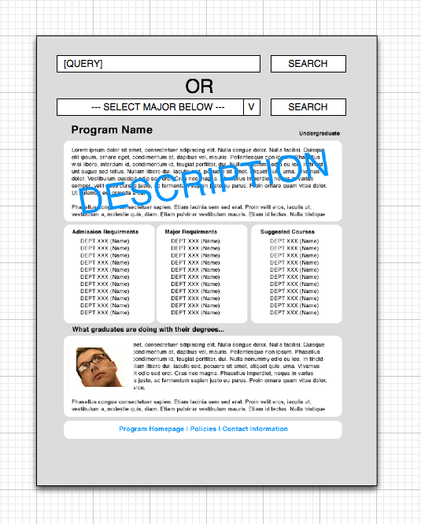

Adding the user experience and metaphors

