Pueblo: Student Project Management System



Team Members

David Horm | (hormd@u.washington.edu)
Ryan Prins | (rprins@u.washington.edu)
Tho To | (tho8@u.washington.edu)
Anthony Trotter | (atrotter@u.washington.edu)

The Information School
University of Washington
Winter Quarter 2005

March 10, 2005

Abstract
Students normally find themselves involved in multiple group projects throughout each quarter and often times they have trouble managing various aspects of these group projects. Schedules collide, communication fails, and groups struggle to finish projects as the due date nears. Students rarely turn to management software to organize their projects due to the fact that current project management software packages are inefficient, overly generalized, and not designed for an academic setting. Moreover, these software packages are often hard to setup, frustrating to use, overly rich in features, and/or lacking functionality. Students waste valuable time figuring out how to use these programs rather than concentrating on the tasks at hand. Our goal was to design an easily customizable, modular student group project management system, built to meet the exclusive needs of students. The system will be easy to setup, easy to manage, and fully extensible, making it more appealing and useful for student group-based projects.

Keywords: Project, Management, Groups, Student
Table of Contents
Abstract i
Table of Contents ii
The Problem 1
Our Goals 1
Audience 1
Needs Assessment 2
Process 2
Results 3
Analysis 6
System Comparison 9
dotProject 9
Jupiter 10
Basecamp 12
Development 14
Process 15
System Architecture 17
Usability Study 24
Conclusion 27
Next Steps 27
What We Learned 27
If We Could Do It Again 27
Appendix 29
Sample Problem Scenarios 30
Requirements Instrument 32
Prioritized Requirements 34
Overview of Database Schema 36
Database Schema by Module 37
Index Page Site Flow 47
File Documentation Outline 48
Module Breakdown 52
Admin Module 53
File Management Module 56
Communication Module 64
Projects Module 68
History Module 78

The Problem

One of the most demanding requirements students encounter here at the University of Washington--in addition to the coursework required--is working as a member of a group. The size of these groups could vary, but due to varying schedules, working habits, and other factors, working in a group situation can be very difficult.

In addition to the group dynamic issues that may arise in a group situation, managing the information that the group needs to succeed is also of concern. Many times files are passed between group members using e-mail. At other times, one member may take the burden and host all of the files himself/herself. Both of these options, while plausible, cause problems; they tend to place the burden on one member of the team to do a majority of the work, result in lost files, overwritten documents, and other problems. In order to help resolve these issues, we aim to design a system that can be used by any group of students that work on projects in an academic setting. Though the system is being developed exclusively for students, it may find use outside of an academic setting as well.

Our Goals
- Design a system to help student groups manage their information.
- Use technologies that are available to them.
- Make it easy to use and maintain.

Audience
- Students in group projects.
- Individuals in group projects (not necessarily in academic setting).

To sum up the problem into one concise statement, we present our triple:

By providing a project management system to students groups, we will be able to help them manage their project information better because it will be located in one place and can be accessed by all users at anytime.

This triple is the guiding force for what follows in this paper. It was what we focused on when moving from our requirements analysis to designing and implementing a prototype, all of the way to usability testing. The process that we used in developing the solution to this problem follows next in this paper.

Needs Assessment

Before jumping into the development phase of our project, it was necessary to acquire the requirements of our system from the users who will be using it. Moreover, we were interested in knowing the most important pieces of a project management system. What problems do groups encounter when creating their projects? Do communication problems exist? How do group members currently accomplish tasks? Questions like these must be answered before we can even begin to code.

Process
To help us answer our questions, we decided to hold two focus groups. We chose focus groups over other types of requirements analysis-- interviews and surveys--due to the fact that holding a focus group allowed the participants to discuss their problems and solutions. Because participants are able to discuss their problems and create their own solutions, we do not need to spend valuable time sifting through surveys and interview transcripts, trying to determine the best compromise between the results. Instead, the participants are allowed to discuss their previous problems, the solutions they came up with, the applications they’ve used in the past, and their likes and dislikes relative to the application. We are then able to ask our participants as a group whether they like or dislike ideas that we may have, as well as what ideas and requirements are most important.

The first focus group would consist of Informatics students from both 1st year Informatics students and the graduating class (2nd year Informatics students). We also thought it would be interesting to hold another focus group to see if there were any differences in the way Informatics students do group work versus other majors. To test this, we elected to hold a focus group consisting of CSE majors.

To prepare for these focus groups, we created a list of questions that concentrated on the problems associated with group projects, and the problems group members have experienced with other pieces of software. The same group of questions would be used at each focus group.

Our focus groups were planned to last about 45 minutes. Notes would be taken by one or two of the design members, and one of the other design members would lead the discussion.

After holding our focus group sessions, the next step involved reading through the notes taken during the focus group sessions and summarizing the requirements from each focus group. The following sections summarize the results we obtained from both the Informatics and CSE focus groups into four parts: Task, Information, Technical, and Presentation Requirements. Following the summary of the results is an analysis of the results.

Results

Informatics Focus Group Requirements
For the Informatics focus group, we were able to gather 10 Informatics students (3 1st year students and 7 2nd year students). The focus group session lasted roughly 45 minutes. The following is a summary of the information, task, presentation, and technical requirements we obtained from our first focus group with 10 Informatics students.

Task/Information Requirements

Member Management
Users stated that the system should either be maintained by one group member (the Project Manager), or all users should have equal privileges. If one group member is designated as Project Manager, and the other members are standard users, the Project Manager should not be allowed to change any of the personal member information (e-mail, IM, etc…). The Project manager, however, has the ability to change project specific information. If all users are Project Managers, they will all have the ability to change the project specific information.

Personal Information
Users shouldn’t be able to change the personal information of another user. Personal data, such as calendars, phone numbers, and instant messaging screen names should only be editable by the owner of that data. The owner of that data may then designate each piece of information as public or private. By default, information other than the user’s first name, last name, and e-mail address will be private information.

It was also stated that users would like their personal information to be reusable. Since this program may potentially be installed on multiple Dante accounts, users want the ability to import their personal information into the software, either by using some proprietary file, or a vCard that they’ve already setup. In addition, users stated that they would like the ability to import their calendar, as well as the group calendar, using a standard calendar format, such as iCalendar format (*.ics). Moreover, they also stated that by default, the details (locations, etc..) of the calendar should only be accessible to the owner of that calendar. Other users will only have access to the most general form of another user’s calendar, that is, they will only be able to see when a user is busy/free to meet. The release of more specific details is optional and is up to the discretion of the owner.

Member Communication
Many users stated that during past projects they’ve setup wikis, Content Management Systems (CMS), list-servs, and ePosts using the UW’s Catalyst System. List-servs tended to be the #1 form of communication; everyone has e-mail, making this form of communication extremely popular. The problem with these systems, however, is that they are not central to the project itself. These applications are only one of many applications that groups have used throughout their group projects. Hence, it is important that a system such as a wiki, forum, or other online list-serv be implemented to facilitate communication between the members of a project.

Task Management
Users stated that in the past, tasks were assigned based on the skill and interest of the member. Moreover, the person assigning these tasks was the group leader (Project Manager). Users also stated that sometimes tasks are assigned at random to avoid having one person do a majority of the work. The system should allow Project Managers to assign tasks, or alternatively, users to volunteer for tasks.

To help the Project Manager(s) assign and keep track of the current tasks, users stated that a calendar showing task assignments and due dates would be highly valuable. In addition, as tasks are assigned/changed, members of the project should be notified of the changes through e-mail, RSS, or both, and the changes should be recorded in the project history (discussed below). However, to cut down on the e-mail clutter, only those assigned to a specific task will be informed of changes, not everyone attached to the entire project. But, if a specific task is dependent on a previous task and their assignment is altered, they will be informed as well.

File Exchange Management
In the past, users have installed web applications such as wikis, created sFTP servers, or designed simple web pages that allow the user to update documents, and let the user know when the document was last changed. Unfortunately, users expressed high dissatisfaction with these systems. For example, transferring data from the wiki to Microsoft Word documents was a tedious and difficult, and at times, Project Managers ended up spending much of their time managing the files themselves. To alleviate this problem, we presented the option of using a check-in/check-out system. All users expressed interest and excitement about this idea. In fact, users stated that the check-in/check-out system for file management was the most important caveat of this project.

It is required that group members be allowed to download the file to look at it whether it is checked out or not. The only person that can upload the latest document, however, is the user that currently has the document checked out. However, if this is a completely new file, any user has the ability to upload a file.

As the user is checking out the document, the user should enter the period of time that he/she will be checking out the document. A default check-out time-limit should be available for each project. While a document is checked out, a check-out reminder should be sent by e-mail to the member that checked out the document. If a group member needs to check out a document that is currently checked out, there should be an option for that member to send an urgent message to the member that currently has the document. Also, in the event that the user is unresponsive or uncooperative a reset can be set on the document in question.

A global option for disabling/enabling the check-in/check-out system should be available to the software administrator. Moreover, this check-in/check-out system should be enabled by default. A better solution would be to use meta tags (e.g. Flickr tags—tags to define uploaded images) for each document, designating whether the check-in/check-out system applies to each document.

Finally, users stated that a certain number of previous documents should be kept for backup purposes, just in case they need to look back on a document to see what’s changed, recover accidental deletions, etc.

Project History
The ability to track project changes should also be available. Changes in tasks, task assignments, due dates, file requests, etc. should all be recorded in the project history. Users also stated that they would like the option to view and search through the project history.

Technical Requirements
Users have stated that any open source solution, especially using PHP and MySQL, would be most useful. One of the users stated that, “As long as it’s not Microsoft centric, I’m happy.” However, some users did request that they have the option to receive appointments in multiple formats using either iCalendar or Microsoft Outlook to display the calendars.

As a bonus, users would also like the ability to change the layout/look of the software itself using either a template system or CSS. Alternatively, a user interface allowing the users to change the colors throughout the application may be useful.

Presentation Requirements
Users stated that their primary presentation concerns revolve around simplicity and professional/visually appealing layout, such as Jupiter (http://jupiter.playgroundblues.com).

CSE Focus Group Requirements
To get a different perspective from student groups outside of the Informatics department, we conducted another focus group session consisting of CSE majors. Five seniors were able to attend the focus group and the meeting lasted about 30 minutes. The questionnaire used for the Informatics focus group were used for the CSE focus group. As we later found, the project styles of the CSE students differed slightly from Informatics, consequently making it difficult to apply some of the questions. The following is a summary of the task, information, technology, and presentation requirements.

Task Requirements

Slicing Up Assignments
When assigning tasks, CSE majors try to slice the project into smaller chunks and then randomly assign those chunks. The majority of their projects involve partner programming, but they can’t simply break it into 2 parts. By breaking the project into many smaller pieces they can help each other on the more difficult piece. Maybe each task should have a completion meter. They won’t know how difficult a task would be until they actually do it. So they would like to adjust their task assignments accordingly.

File Exchange Management
The most important aspect of a project is arguably file exchange. One popular way of collaborating on a project is to use CVS (Concurrent Versions System). However, CVS doesn’t seem to work on all files, such as images. Some of them don’t like CVS in general because of its quirks. They were intrigued by our file check-in/check-out system because it is similar to the alternate email/shared folder method. They had some interesting brainstorming with that topic.

For example, suppose Jill checked out a file for 2 hours. Within those two hours, nobody else would be able to upload a new version except for Jill. After the two hours, our system will send Jill a friendly reminder to check the file back in or to recheck out the file.

Now suppose Jack wants to check out the same file but saw the Jill already checked it out for 2 hours. He wants to work on it now, so he’ll download the version that is also available. He will also request a notification for when the file is checked back in. The CSE majors were thinking people can be notified by email or text message. When the two hours are up, the e-mail sent to Jill will notify her that Jack requested the file for check out.

Please note that this scenario is not much different from what the Informatics focus group came up with.

Information Requirements

Scheduling Meetings
Since CSE majors tend to work in partner programming, it isn’t difficult for them to schedule a time to meet. It usually takes one person to mesh calendars together to arrange possible meeting times. They do feel, however, that the information sent should only contain their free time/availability, rather than their busy time, including classes, leisure time, etc. They’d rather not let their partner know that they can’t work due to the fact that their favorite TV show is on.

Notes
They want to be able to comment on files for a history of changes. They also want to be able to leave random notes about the project in general, somewhat like a blog or forum. In addition, CSE students felt that it would be useful to have messages or alerts pop up whenever they log into the system, notifying them whether members can’t make it to a meeting, etc.

Technology Requirements
The CSE majors didn’t have many technology requirements. They said that as long as the system works, then anything is okay. There was a concern that the project should be kept small because our primary user will be using Dante. They also wanted a quick and easy installation script.

Presentation Requirements
The presentation should be intuitive, simple and easy to use. When asked what they might imagine our website to look like, they mentioned the turn in page for CSE 142. They also noted that there shouldn’t be too many graphics, but there shouldn’t be too little either. The system can’t look boring.

Analysis
After obtaining the above results, it was necessary to compare the two groups to determine the differences (if any) between the CSE focus group and the Informatics focus group. Below we summarize the differences we found between the two groups.

Focus Group Differences
The main differences we found between our focus groups include the following:

- CSE students tended to have smaller group sizes. CSE student group sizes seemed to max out at 3 members per group. Informatics group projects have involved up to 7 members per project.
- Project duration was much smaller for CSE students than for Informatics students. CSE students tended to work on a project for 2-3 weeks, while Informatics students might work on projects that last the entire academic quarter.
- Informatics students tend to work with a wider variety of files. CSE students tend to work exclusively with code and images, while Informatics students work with code, Microsoft Word, Visio, and other documents.
- CSE students tended to use systems such as Concurrent Versioning System (CVS) in the past when doing their projects, while Informatics students tended to use web applications such as wikis, sFTP servers, or even simple web pages written to let the user know when a document was changed.
- Informatics students seemed to want to personalize their system; hence the technology requirement that the system be built around XHTML and CSS. On the other hand, CSE students just want to get their work done, and generally don’t care about tinkering with the look of the system. They care more about whether the system works than the whether or not the ability to change the look of the system is available.
- CSE students mentioned nothing about re-use of personal information, specifically meaning vCard support. Informatics students were concerned that, since they may be involved in many different projects on different servers, they do not want to re-enter their information on each server. It would be easier to upload a vCard that fills in most of the information for you.

Overall, the differences between CSE student groups and Informatics student groups didn’t amount to much. Many of the differences listed above are extremely minimal. For example, the fact that Informatics students desire the ability to change the look of the system while CSE students do not does not mean that the system we create can not support both groups if we implement the requirements for the Informatics students. Rather, the system is still usable by the CSE students, with the added ability to change the look of the system if they wish. In fact, this is the case with most, if not all of the differences above. In general, the only true difference between the Informatics students and the CSE students was the amount of detail in requirements and the number of requirements offered by each focus group; Informatics students tended to be more specific in their requirements and tended to require more than CSE students. In fact, Informatics students may be thought of as “pickier,” or “harder-to-please” than CSE students.

Requirements Final Steps
After obtaining a general list of requirements from the focus groups, it was necessary to look through the list of requirements and prioritize them. This was necessary due to the fact that we were given an allotted period of time to actually design and implement the system. Hence, it was important that we implement the most important requirements before those of less importance.

In addition to prioritizing our list of requirements, it was necessary to ensure that the list of requirements was as detailed as possible. In doing so, we reduce the chance that we miss any requirements while in the design/implementation phase. Consequently, for each general requirement, we provide a description of the requirement, as well as the features that the requirement must contain.

To see a detailed and prioritized list of the requirements obtained from the focus groups please see Appendix: Prioritized Requirements.

It should be noted that member and project management was not priority for our audience; however, because the other requirements depended on this functionality, it was necessary to put this requirement at the very top of our list. After all, one cannot manage files, assign tasks, or communicate with anyone if users and projects do not exist.

File management appeared to be the most important requirement, most likely due to the fact that none of the previous pieces of software used provided the ability to manage files. Wikis, forums obviously do not provide file management, and sFTP servers do not provide a versioning and backup system, making it extremely easy for other group members to overwrite files and lose changes.

Next on the list was task management, also due to the fact that many of the previous systems did not provide an easy way to manage/assign tasks between group members. Wikis, forums, and list-servs allow for communication of tasks, but do not centrally manage tasks, and do not provide a visual display of the late, upcoming, and completed tasks.

Following task management is member communication. It was stated that students currently setup list-servs using the UW’s mailman service to communicate between each other. It was also stated that it would be more useful if the system facilitated communication between members, consequently making the entire project managed through one system, instead of the past technique of using a combination of systems.

The final three requirements include event tracking (history), presentation requirements, and privacy requirements. At this point, the ability to track history for each project was something more of a bonus feature or a “Wow!” feature. Moreover, the ability to subscribe to different history events through an RSS feed was definitely a “Wow!” feature. Because the presentation requirements would be taken into consideration during the creation of each module, we didn’t quite know where to put it on the list, so we stuck it near the end. Please note that while writing our modules, this requirement was constantly at the back of our minds. Finally, because Informatics students are friendly people and share way too much information with each other as it is, we felt that privacy concerns were least important.

Lastly, we created a short list of the technical requirements to remind us of the minimal amount of technology that we should implement.

System Comparison

Before starting to design our system, we wanted to make sure that there was not a similar system out there that could fulfill the requirements that we had in mind. With the help of opensourceCMS.com we were able to test the features of many different types of CMS systems that were focused on groupware. This was a great benefit to us, since it allowed us to demo the systems on their servers and not have to worry about setup and installation. We will present three of the packages that we demoed, what we liked and disliked about them, and why these packages were not suitable for our needs.

dotProject

dotProject was the first system that we demoed. They cater to the needs of a large audience, as stated on their website:

dotProject is a PHP web-based project management framework that includes modules for companies, projects, tasks (with Gantt charts), forums, files, calendar, contacts, tickets/helpdesk, multi-language support, user/module permissions and themes.

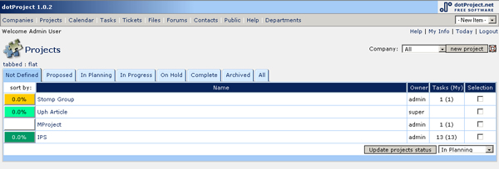
Image 1 - The dotProject "Projects" Page

What we liked
We liked the fact that each component of the project (tasks, calendar, etc...) was in its own module. This was where our idea of modularity stemmed from. The modular design made this software package extensible to users, allowing them to build modules specific to their problem. This system was also easy to install; we actually tested this out using their set of straightforward instructions. Their taxonomy for the various parts of the system was also very straight forward and easy to understand.

What we disliked
As mentioned above, there were only a few useful concepts that we took away from this system. We demoed this system and tried to set up a test project, but it was too cumbersome to complete and required numerous unneeded steps, making it extremely frustrating to use. Also, the sub navigation was confusing to use at times. Furthermore, as an admin of the system, the sub navigation further complicated the process with other hidden options and textual links scattered across the page.

While this system was designed with functionality in mind for the independent modules, it was difficult to justify this as a system that students could use for their course projects. The navigation was difficult to use and adding simple items like a deadline was confusing to the point that we gave up in our attempt to add a deadline.

Why this package was not suitable
From the reasons mentioned in the previous section, this package was not suitable because it was cumbersome to setup a project, the sub navigation was anything but easy to use, and adding simple things like deadlines was more of a hassle than necessary. Because of these reasons, we felt that this package would not be beneficial to use for class projects; a more beneficial tool would assist the project and be easy to use. This package has too large of a learning curve for everyday use, often resulting in frustration.

Jupiter
Jupiter is currently under development, but is open to the public to view and to demo. Due to its “beta” status, we cannot recommend this product. We did, however, use this system to look at how specific features were implemented. Unlike dotProject, this system is designed on a much smaller scale with scaled-back functionality. However, the key functions of project, files, notes, and tasks are used in this system.

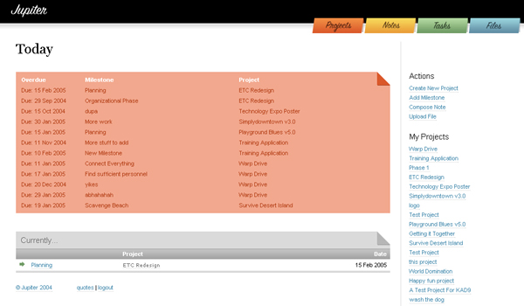
Image 2 - The "Today" Page on Juipter

What we liked
Upon logging into the system, the user is presented with a well designed interface. Note that this was one of the requirements drawn from our focus group analysis (see Needs Assessment). Because of this styling, this site would later be used as an example of what “good” styling looked like for a project management system. The denotation of “good” came from our team, not the focus groups. We also liked Jupiter’s navigation system; it was clearly laid out on the site on every page, the titles were not misleading to the user, the “files” tab lead right to the files section, etc.

We also liked how each page was presented. For example, each of the different function pages contained an overview of items associated with each of the different projects. This made it very easy for the user to look at the page and determine what was required, due, or associated with a particular project. Also, the addition of a side navigation, which provided extended functionality, was a nice addition to the site. The side navigation changed with each different section of the site and provided section specific actions for the user to perform. In addition to the side navigation action items, Jupiter listed the current and completed projects that a user was a member of.

What we disliked
While the system had many desirable features, there were some drawbacks. The first drawback was that this software is not available to the public. As of now, one can only demo the software online. Consequently, this system is not a viable solution for project management. If this project were available for public use, the situation might have been different; we might have been able to build off of this system. However, this is all speculation and this train of thought was abandoned by our team almost instantly.

Even though this system was not difficult to use, the depth of each feature was extremely limited. Our users demanded more features within each of the various facets of the system. Unfortunately, Jupiter was lacking in many of these features, including RSS feeds for updated files, backups of files, a subscribable calendar of deadlines, and so on (see Appendix: Prioritized List of Requirements for more details).

Why this package was not suitable
There are two main reasons that Jupiter is not currently suitable for our audience:

- It is not available for download.
- Each section of the software does not provide enough depth and lacks features/functionality.

Jupiter’s file management system is a perfect example of the second bullet above. The main feature that our users wanted was a robust file management system. While Jupiter’s system did provide file management, it was lacking many of the features required by our users. These features included:

- Revert to a backup file.
- Check-In / Check-Out capabilities
- Ability to download an entire project’s files
- Ability to version files

Our system currently contains Jupiter’s current feature set in addition to the above features.

Basecamp
This package is similar to Jupiter in the fact that it is not available for download. However, it is available for use by the public to manage their projects. It is offered in a free version, with limited features, and also various levels of paid versions. On their main site, where you can create your own project account on one of their hosted servers, you can see why Basecamp might be an ideal solution for project management:

Basecamp is a hosted service so there's no hardware or software installation required. Just log-in, set up a project site (it takes only a few seconds), then go ahead and start posting project updates, contact info, task lists, files or design reviews, or other content. Your clients can then participate by commenting on your messages or creating their own. It's a simple, organized, professional way to communicate project progress to both clients and other team members. And the uses are endless.

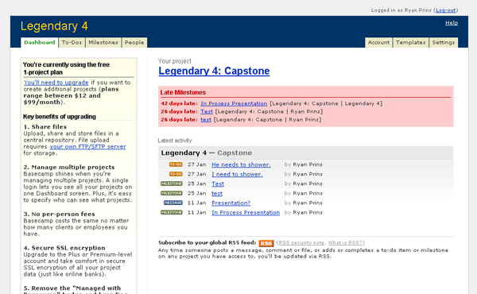
Image 3 - The "Dashboard" in Basecamp

What we liked
When we stumbled across this solution and set it up, we were somewhat amazed at what was bundled with the free version. Setting up the account for a new project was easy and very painless. In no time the project was setup on their hosted server and we were off and running with our new project. Once the project setup was configured to our liking, we then had the ability to add project members. Upon addition, new members were sent an e-mail to join the project with the provided login information. Once the project actually contained members, it was then possible to assign milestones to individuals, create a personal tasks list, or send messages to users on the system with their built in messaging function. These were all features that we really liked.

In addition to the features that came with the free version, the site looked extremely professional. The interface was not stale like dotProject’s and had a nice professional touch, similar to Jupiter. Moreover, the site was standards based using XHTML and CSS to mange the presentation and style of the site. These items were also raised as requirements by our users, which were accordingly brought forward to our design.

Basecamp also had nice little extras, such as a subscribable calendar of Milestones and an RSS feed for all messages, tasks, and milestones that were applied to a specific project. We also planned to bring these items into our design.

What we disliked
There is a lot to like about Basecamp, except for one thing: the user must pay for the software to obtain full functionality. The one feature that we were unable to test using the free version was their file management functionality; this functionality is not available in the free version of Basecamp. Basecamp became even less of an option when we discovered that in order to use the file management feature, the user needed to have an FTP of his/her your own to upload files to. This would not be a problem for our audience since they have space available to them on their Dante accounts. However, one drawback to this is the limit to the amount of files that can be uploaded. Unfortunately, even with the design of our system, this is one limitation that we cannot get around.

Why this is not suitable
Because of the fact that the free version does not have file management, this system is not suitable for our users. File management was the requirement of highest priority for our users. The inability to test the file management functionality on Basecamp makes it extremely hard for us to recommend this system. Moreover, users would have to pay to use the file capabilities and even once they do, they would have to use their own space to house the project files. This is especially a concern since most of our users will be using their Dante accounts, which enforce very small quotas per user. However, because these limitations are on a user by user basis, this is something that will have to be addressed by the user when using either Basecamp or the system that we designed.

Development

The Process
Methodology
Keeping track of changes
Communication tools
System Architecture
The Framework
Overview Versus Project Mode
Security
System Dependencies
Database Schema

Process

Methodology
The method we used during our development stage was Extreme Programming.
Extreme Programming (XP) is an approach to software engineering, created by Kent Beck, Ward Cunningham, and Ron Jeffries. It is currently used for rapid development of high-quality software that provides the highest value for the user in the fastest way possible. XP consists of continuous testing, pair programming, and on-site user involvement. There are a number of other practices involved in XP, but we have only listed the practices relevant to our design process.

The reason why we chose XP as our methodology was because of the size of this particular project and the time constraints we had for developing and implementing the system. Earlier in the project, we realized that in order for our system to be useable, many features and functionality would need to be coded. In addition, we felt that it was wise to avoid wasting time in the design process and start developing right away so that we would constantly have something to test. This allows us to see what works once it has been implemented and redesign it as we see fit. This also meant that we had to have our users readily available to test our system during the implementation process. Luckily, obtaining our test users wasn’t that big of a problem during the course of this project.

Most of the development phase was spent programming individually, but we were all in close contact and were able to exchange ideas and give each other help whenever it was needed. Because of the exclusive nature of our modular system, it was easy to split up the work and write the code for each module on our own time. Each person picked a module to work on and implemented everything that was required for that particular component without having to worry about conflicting with anyone else’s code.

During the development process, we also gathered feedback from users and other team members. This followed the XP strategy of keeping everybody involved; we were constantly obtaining feedback regarding what we were doing right in system and what portions of the system needed improvement. We found that this strategy worked even better than we thought, helping us create an extremely useful, user-oriented system.

Keeping track of changes
We decided to keep an online journal by implementing a blogging system called WordPress. WordPress is a free personal publishing software package built on PHP and MySQL made available to the general public under the GPL license. We felt that this system would be useful for keeping a history of changes and provide a way for each team member to report and make any justifications to their design modifications. One useful feature of WordPress was that it provided an RSS feed. This allowed us to subscribe to the feed using our prefered RSS reader and keep track of the latest entries without having to visit and load the website itself. Another reason why we went with WordPress was because a couple of us were already using it for our personal use. Plus we were all familiar with blogging systems, making it extremely easy for us to get up and running.

Communication tools
We used email as our primary tool of communication whenever we were not working together in the same room (which was pretty rare). Email was essential for sending notifications and reporting updates during our project, aside from keeping the online journal mentioned above. We primarily used email to notify each other of important or global changes to the system.

Instant messaging was also useful during the development process and was used to get quick answers from other team members or to remotely work with the other team members on the project simultaneously. With the help of communication tools such as email and instant messaging, we were able to create a broad awareness among our group and keep everybody updated with the latest changes at all times.

System Architecture

When we first began to design our system, we wanted it be extensible. This was so that users could customize the system to match their specific needs. We did this in two ways:

- We designed the system using languages that are open source and contain online help (PHP/MySQL).
- We also designed the system to be modular. The beauty of the modular design means you only have to use what you want, nothing more, and nothing less.

We began to design the prototype with these two aspects at the forefront of our minds. Though we knew what it was that we wanted to do, the hard part was determining how to accomplish this goal. As was outlined in the Process section of this paper, we worked very intensely as a team in the beginning of this project to make sure that each team member was on the same page when it came to the implementation. From there, we proceeded to build the basic framework for our system.

The Framework

The concept of making something modular is easy on paper, but moving that idea into code required a little more thinking. In order to do this, we spent some time working on a whiteboard to find a method that would work. After discussing various solutions, we finally settled on one solution.

The resulting solution borrowed from object-oriented programming; we chose to create a base class with all of the necessary functions and functionality. Accordingly, we would extend the base class to create each module. The resulting base class was artfully named TurtlePage. This class contained the following methods:

- printBody – Printed the main contents of the page.
- processEvents – Executed before any headers or content was sent to the page.
- printSubMenu – Prints the sub navigation.
- addedProject – Called when a project is added.
- deletedProject – Called when a project is deleted.

To see a diagram describing the page load process, please look at Appendix: Index Page Site Flow. Below, we will describe the functionality of each of these functions.

printBody
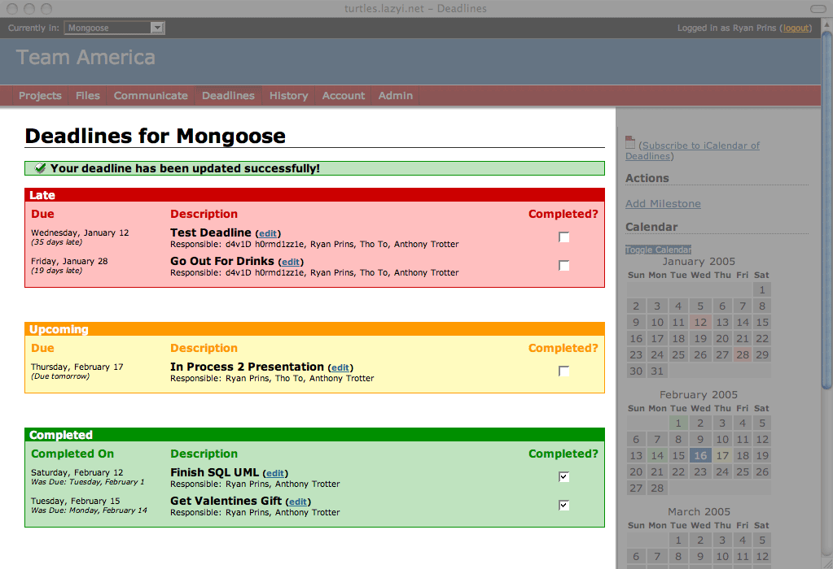
This function printed the main content of the site. The content that this function printed varied from module to module. In the example image to the left, you can see the deadlines page body highlighted.
Image 4 - Content Printed by printBody()

processEvents

While one cannot see what this function does, it provides needed functionality and is vital to the system. This function is called before any other information is sent to the page. This allows us to call SQL commands and update the content of the page before the page is sent back to the user. For example, when a user marks a deadline as complete, processEvents is called and a command is given to update the database that the provided deadline is completed. Accordingly, the page is loaded and the deadline is displayed as completed. By doing this, we are saving a page load for the user because we are running events before the page is even sent to the user. Upon completion of the command, a command for redirection is given and the result page is displayed. Moreover, when the user is presented with the result page, he/she is provided with a message either confirming success or failure on the completed action.

printSubMenu
Image 5 - Content Printed by printSubMenu()

This function prints the sub menu to the right on every page. This menu can change page by page within a module. Each menu provides the user with extra actions that are not available in the header navigation. Menu actions might include the ability to add a deadline, upload a file, look at settings, manage a project, and so on. Generally, the user receives more specific actions when he/she is in a specific project, as opposed to being in overview mode.
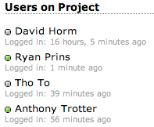
Image 6 - Project User Listing

Currently, the only item that remains static on each menu is the listing of project users. This listing of users is for the specific project the user is in and, accordingly, only appears when a user has chosen a project to work on. It provides names, relative time of last login, and an indicator image to determine the activity of other project members. The indicator image will be green for users that have used the system within the last 20 minutes. Otherwise, the image appears grey.

addedProject

Each module uses this function to initialize any module specific data when a project is added. More specifically, this function is used to prepare the database for any actions that this project might need. This might include adding indexes, creating folders, or any other action necessary to the proper function of the module. The only precondition is that the project ID is passed to this function. Since the programmer will be extending the base class to create his/her module, this function is optional and does not require the module to implement it.

deletedProject

Similar to the addedProject, this function completes processes that need to be completed when a project is removed from the system. This function might perform SQL queries that remove related project information from the database, remove physical files from the system, or even remove user relations from that project. The needed elements for this function are at the discretion of the module programmer.

Overview versus Project Mode

Each module that we designed has functionality for two different types of viewing habits:

- Overview – All projects that user is a member of.
- Project – Specific to a particular project.

We chose to have two modes because we felt that this system might be used by the same person over multiple projects. By offering users the ability to view an overview of all of the project details for each module, they are better able to see what is new, what is completed, and what actions need to be taken. However, this extra functionality comes at a cost.

While adding overview mode was not difficult, it does provide some drawbacks to the user. They will not be provided the ability to see project specific menus or action items for the active modules. For instance, to add a deadline, the user must first enter that specific project and then add the deadline there. This provided us a distinction between the two portions of the site. Overview, as the name states, is simply for viewing the available data in an overview. Generally, functionality is not provided in this mode to alter the project files. However, there is the occasional case where a user might be offered the same functionality on the overview page as he/she would receive on the project page (see File Management Module in Appendix). For the most part, users will need to choose a project before he/she can alter the data for that project.

Security

One of the main concerns with any project where information is managed is security. We have addressed security on various levels in the design of our project.

The first noticeable security measure that we have implemented seems obvious when using the system, that is, the idea of user authentication. It is important to have user authentication for the system in order to maintain permissions over the entire system. This will allow certain users specific rights while other users will be denied rights to specific parts of the software. This almost seems trivial to mention, but it is one of the most important security measures that we have implemented in our system.

Many of our URLs require parameters to be passed to them in order for specific actions to be completed. This makes it much easier to complete actions, but also much easier to spoof or hack. To help prevent such events from occurring, we use the project ID and the user ID to verify each user’s membership to a project before an action is performed on that project. If the user does not have access, an error is printed to the screen and no action is processed. However, if the user has valid permission, the actions will occur as planned, and the user will have no idea that his/her permissions were verified.

In addition to URL spoofing, we implemented e-mail verification for new user creation, requiring a user to use a valid e-mail address in the system. This is important, due to the fact that the system relies on unique users; e-mail is one way to verify that the user is unique. Moreover, in a shared hosting environment (if one user sets up the software for many to use), e-mail adds another layer of prevention from users creating multiple accounts and uploading files, consequently preventing waste of space for all available users.

With these security measures in place, there is still one place where it is difficult to add security; site admin. This user will have access to the entire system, and rightfully so. But, this provides a serious risk to the files on the system. This is something that we cannot prevent in the current version of the system. After all, the person running the software will have access to all of the files and database entries for the entire project. Consequently, it‘s up to the users that use the system to decide whether or not they trust the person hosting the software.

While we have made our best effort to implement security measures, there is always the possibility that security holes exist that we did not catch. Without the system being used heavily by a group of users for an extended period of time, it is difficult to determine if the measures that we implemented are adequate or if we are lacking specific security features in areas that we happened to over look. Due to the lack of time, these issues were not addressed in our usability study. However, if the system is to be used by a larger audience in the future, security concerns will arise and will need to be addressed. Despite our concerns, we feel that we are heading in the right direction with the measures that we have currently implemented.

System Dependencies

Because our user is modular, users have the ability to add and remove modules as needed. Unfortunately, this kind of flexibility can seriously cripple the system if implementation restrictions are not in place. To combat the crippling of the system, we have made the following modules required for operation of the system:

- Projects
- Admin

The Projects module is required due to the fact that the software we’re creating revolves around projects. What good is project administration software without projects? The Admin module is also required, though it is not as essential to the system as the Projects module. It is possible for the administrator of the system to hack the system and remove the Admin module, but the consequences are not worth the effort of disabling it. The administrator would lose convenient features, such as the ability add, remove, activate, and re-order modules. In addition, the administrator would no longer be able to manage all of the users on the system or change system wide variables. Hence, we require that both the Admin and Projects module remain enabled. Moreover, we’ve locked the ability to disable these modules in the Admin module. Unfortunately, having only these two modules active would not provide much functionality to the system. Consequently, the system will come preloaded with the following modules:

- Projects
- Files
- Communicate
- Deadlines
- History
- Account
- Admin

Database Schema
In order for our system to function properly, we needed a database component to house vital project data. We chose to use MySQL as our database management system. This was done for three reasons:

- MySQL is free software
- MySQL is easy to install and has extensive online documentation
- UW’s Computing & Communications has step by step instructions online for students attempting to install MySQL

To best utilize this database, we needed to design and build our schema before moving towards implementation. What follows is a discussion of our database schema design process, and a breakdown (by module) of the schema. The entire overview of our schema, as well as a module by module breakdown, can be found in appendix of this paper.

How We Designed Our Schema
When we initially met to design our schema we first reviewed our list of requirements, went over each requirement, and thought about how they interacted physically. The ability to determine how the various aspects of the project interact made determining their behavior in the database much easier. As a group, we sat in front of a whiteboard, defined all of the tables that we thought we would need, and brainstormed our fields, primary keys, and foreign keys. Following our brainstorm session, we normalized our tables by eliminating redundant fields and defined relationships between the tables.

Using a whiteboard was a large benefit for this task. It allowed for easy changes to the initial mockup and we were able to better define a very robust database schema from the offset. After we were satisfied with the basic schema, we moved to implementing it in our physical MySQL database.

Making the translation from the whiteboard schema to the version that we used in our database was not difficult to complete. We created tables and columns as needed and defined the types as we saw fit. For example, we made the design choice for the database to use MySQL’s built in date and time handling instead of the ones offered by PHP. This meant that we would store a human readable date and time stamp as opposed to the UNIX time stamp, which is stored in seconds from the epoch (1970-01-01 00:00:00).

After the initial database was implemented online, additional tables and columns were added as needed. For example, other modules that we created, such as the Communication and History modules, needed tables of their own that we did not create during our whiteboard session. Consequently, the design of these tables was left up to the module creator.. Though these tables were added at a later point in the project, they did not alter any pre-existing relations or tables to the degree that other module functionality was broken.

As stated earlier, the system will not run without projects, and is useless without a user authentication system. Hence, the tables that are most crucial to our system include the User, Module, Project module tables (Project, ProjectMember, AccessType).

As of this writing, the database schema is in a stable state. However, when adding additional modules, the schema will most likely change again.

Usability Study

The method we used to test the usability of our system was to (a) find representative users, (b) give them tasks to accomplish, and (c) observe without interacting with the user. This method follows Jakob Nielsen’s basic user testing in his Usability 101 column (http://www.useit.com/alertbox/20030825.html).

The tasks that the participants performed were representative of the tasks compiled in the user needs assessment. The tasks may be found in Appendix Z1. We used scenarios rather than a simple list of tasks. Our scenarios are stories that an average Informatics student may run through and are used because they engage the participant more and suspend disbelief. We broke up the scenarios into three different sets that depend on the role of the user:

- New User Somebody that just created a new project
- Project Manager Project manager of an existing project
- Administrator Administrator for the whole system

Engaging the participant more and suspending disbelief are the two main points why user testing collects authentic behaviors (REF http://www.useit.com/alertbox/20050214.html). Keeping the participants engaged in the system causes them to be less distracted by lab settings. We also keep the user less distracted by only observing and not talking with the participant. The students were instructed to talk out loud if they felt necessary, such as when they could not accomplish a task. If the student did speak out loud, we chose not to respond to keep the user as engaged in the system as possible. We kept notes on their actions because “listening to what people say is misleading: you have to watch what they actually do.” (Nielsen)

The representative user for our system consisted of Informatics students. The suggested number of participants in the Usability 101 column is five. However, since we devoted 10% of our efforts towards usability study, we were able to perform four user tests on the New User and Project Manager scenarios. We tested six people on the Administrator scenario. The same script of instructions was read to the participant before taking the test. The script may be found at Appendix Z. The instructions reminded the students that we were testing the system, and not the user. The participants were made up of eight Informatics students: four from the 4th cohort, and four from the 5th cohort. Table 1 shows which scenario that the participant did.
Table 1: Which scenarios were tested
User ID (cohort) | New User | Project Manager | Administrator
1 (4th) |  |  | X
2 (5th) | X | X | X
3 (5th) |  |  | X
4 (5th) |  |  | X
5 (5th) | X | X
6 (4th) | X | X
7 (5th) | X | X
8 (4th) |  |  | X

Results
After the user testing, the participants were asked to fill a survey online. The questions and results are in Appendix Z4. Out of the four that were tested on the New User and Project Manager scenarios, all of them said they would use our system for their project. The users that were tested using only the Administrator scenario said maybe because they didn’t get a chance to use the system as the primary user would.

Table 2: Average Module Intuitiveness Rating
We also wanted to quantify the intuitiveness of each module. The users were asked to rate the intuitiveness on a scale from one to five with one being not intuitive and five being intuitive. In addition, a “Not Applicable” choice was available for rating modules that users didn’t use. Table 2 shows the average intuitiveness rating for certain modules.
Module | Average Rating
Admin | 4.2
Account | 4.7
Deadlines | 4
Files | 4.25
Projects | 4.75

Discussion
The results from the usability testing were not as stellar as we would have hoped. There were minor GUI issues that we noticed. One was with the member management (see Image 42 I the Appendix). When users were asked to remove somebody from their project, all they needed to do was click on the “remove” link. Instead, they clicked on the “PM?” check box, then clicked “remove.” However, when they were asked to make one of the project members a Project Manager, they would look around for a little bit and then understand the affordance of the “PM?” check box.

Another problem was inconsistent GUI design. When making a new project, users used a calendar when picking the start and end date (see Image XX in the Appendix). However, when adding a due date to a deadline, users used a different drop down menu method (see Image XX in the Appendix). This was due to the modular design approach and the differing opinions regarding implementation. The solution would be for a system-wide styling. Though some items weren’t styled for consistency in our project, other items were. For example, we have a system-wide styling for our tables because we used tables in many different places.

We also wanted to test out if users understood what Deadlines meant. The scenario stated that they had a draft due by next week, and they needed to assign that task to some of their members. We specifically used the word “task” in the scenario to see if the user would know that we meant “deadline.” The users were initially lost, but eventually got it once they understood the vocabulary such as in User 2’s case:

“The biggest difficulty I had was adding a task at first. I kept looking for a link that had the word ‘Task’ on it somewhere. When I browsed around ‘Deadlines’ I finally understood that that was where tasks go. After I realized that's what was meant, there weren’t any problems.”

Not all of the usability feedback was bad. Some users saw more potential for the system. User 5 suggested that if one of his group members were “in 5 other group [projects], by common sense I would not assign him as much work compare to someone who's only in 3.” In the end, only two of the eight participants had any general negative feedback, and one of those was out of jest.

Conclusion

Looking back at the design process that we used for the development of our system we can say that we are proud of the work that we accomplished. We’ve met many of our development goals and are proud to announce that our system is in an operational state. Because of this, we have been using it to manage our project files for the past three weeks of the quarter.

In addition to the above, there were many successes, frustrations, and challenges that we encountered along the way. However, with the aid of fellow team members and our peers, help was readily available. To look back and see what we accomplished is very stunning. We exceeded our implementation goals, overcame difficulties easily as a team, and did not let our frustrations get in the way of our overall design process.

Next Steps
Now that we have a functioning prototype, we are looking into continuing development of our system. Currently it is being used by our capstone group as well as a few other groups to manage their projects. Now that we currently have users using our system for their own purposes, we are better able to debug it and provide new features. There are still some things that we would like to implement, tweak, or refine within our system. The ideas are still coming in and we are evaluating on how to handle them. With that being said, we hope to release our software for student use sometime in the future. We feel this could be a very valuable tool for them to use for managing their projects.

What We Learned
With capstone being the culmination of our education in Informatics, many of the concepts and principals that we learned while in the program were applied to the development of our product. We can honestly say that we pulled information from all aspects of the degree to help guide us in the design process. In addition, there were things that we learned along the way that were not taught in class. We gained a better understanding of technologies, methodologies, and managmenet skills, including PHP/MySQL, interface design, and how to manage our time most effectively to meet our goals.

Working in a group of four on such a project as the one that we completed involves a large amount of organization and dedication by all users in the group. This is one thing that we were constantly reminded of during the entire process. We learned to help each other with problems and to be there when a second opinion was needed.

If We Could Do It Again
If we had the chance to do the process over again, there would definitely be aspects of the project that we would like to change.

While our project did not contain many extremely difficult challenges that left us completely stumped, there were definitely items that proved to be annoying bumps in the road to project completion. These bumps ranged from an inconsistent UI to creating a standard API that we, as designers, could utilize for our modules. Redundant code still currently exists, but this is expected in such early development of the project.

In order to overcome some of these issues, in the future it would be nice to define all of the larger issues up front, such as UI design, the API, and all schemas. We were very close to achieving a uniform definition for these items, but if we were to do this again, or even had more time, it would have been more beneficial to have all three of these aspects defined before our project development fully commenced.

Appendix

Sample Problem Scenarios
Requirements Instrument
Prioritized Requirements
Overview of Database Schema
Database Schema by Module
Index Page Site Flow
File Documentation Outline

Sample Problem Scenarios

Document Passing
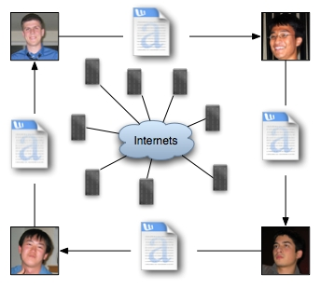

In this scenario a document is passed among team members. Documents are passed in a linear fashion. They can be sent to one person or many. In the diagram above, they are being sent to many people. This can be problematic because users may not be aware of what other users are doing to the document.

Pass All Documents to One User
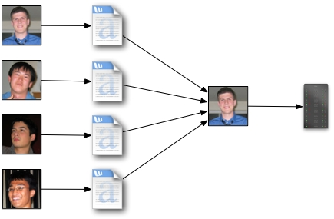

In this situation all documents are passed to one individual. This person manages the version control and makes a repository of files available for the users. In this scenario, the bottleneck is at the individual that is managing the files.

Requirements Instrument

Design
- 8 People total
  - 3 - 5th Cohort
  - 5 - 4th Cohort
- Round Table Discussion
- Thursday, January 6th at 12:30pm
- 45min to an hour
- Record Discussion (Audio)
  - Ask for permission before hand

Questions
- What kind of group projects have you had in the past?
- How did you assign tasks to group members?
- Did you run into any problems with group members completing those tasks in a timely manner?
- How did you determine compatible meeting times for group members?
- Have you setup any software packages for group communication?
  - If so, what packages did you install?
  - Do you find setting up an e-mail list server too much work?
  - Catalyst tools?
- How have you managed documents between group members in the past?
  - Catalyst tools? (ePost?)
  - E-mail?
  - Other?
- Have you setup any software packages for managing documents?
  - If so, what packages did you install?
    - What did you like/dislike?
- What kinds of contact information do you exchange?
  - IM
  - Phone
  - E-mail
- Would you find…
  - A calendar with task assignments and due dates useful?
  - Member management useful?
  - A check-in/check-out system for document management useful?
    - Would you prefer that this were a feature that may be enabled/disabled?
- Technical Requirements?
  - We are leaning towards using technologies that are openly available at UW.
  - We want you to be able to install this on your Dante account.
- Presentation Requirements?
  - Polished interface? Or not?
  - Software that you have used which have interfaces that you like?
- Anything else you would like to add?

End Goal
To be able to get as complete a set of requirements as possible for the time that we have allotted. From this, we will create out list of requirements that we will take forward to the design/implementation phase.

Prioritized Requirements

- Member/Project Management
  - Description: The ability to manage all members of the system, as well as those that are applied to a specific project.
  - Features:
    - Username/password
      - A 32 character maximum on both fields
      - Password must be hashed
    - Privilege levels
      - Standard User – The Standard User has the ability to create a project and add users to that project. When a user creates a project, he is given Project Manager status for that project and also has the ability to give other members of the project Project Manager status. If a user is not the Project manager, he/she is limited to non-management activities, or other settings that the Project Manager may enable/disable.
      - Project Manager – The Project Manager has the ability to manage projects, add/remove members to/from projects, change project options, etc.
      - Administrator – The Administrator has the ability to change application specific data, load/enable new modules, edit/delete/create users, send notification e-mail to specified groups, ban IP addresses, and view application statistics.
    - Assigning to Projects
      - Users can be assigned to projects by the Project Manager.
    - Creating Projects
      - All users can start new projects and add users to these projects.
    - Member contact information
      - E-mail
      - Instant Messaging Clients (AOL, MSN, Yahoo)
- File Management
  - Description: The ability to upload, download, check-in, check-out files for a specific project.
  - Features:
    - Upload files
    - Check in/out system
      - Only person who checked out the file can upload the latest version
      - A file can be checked out for a limited amount of time
    - Label and comment files with meta tags
    - Complete collection of project files can be downloaded via zip/gzip
- Task Management
  - Description: The ability to add tasks to a specific project.
  - Features:
    - Tasks have arbitrary definition and hierarchy
    - Calendar
      - Users will be able to view their tasks, due dates, etc. within a calendar.
    - Project manager assigns tasks
    - Member can volunteer for tasks
- Member Communication
  - Description: The ability to facilitate communication between team members.
  - Features:
    - Email
    - Forum
    - PMs
- Project History
  - Description: The history for the entire project. All changes, additions, deletions, etc… for the entire project.
  - Features:
    - Recent changes
    - Task assignments
- Professional/Visually Appealing
  - Description: It needs to look sharp and be visually appealing.
  - Features:
    - Simplistic default layout
    - Table-less design (use CSS and XHTML)
    - Templates (CSS)
- Privacy
  - Description: The ability to manage private information for each user on a user by user basis.
  - Features:
    - Only owners can edit their own personal information
    - All personal info defaulted to private except for name and email
    - Options to make information public/private

Technical Requirements

- PHP
- MySQL
- XHTML
- CSS
- Modular
- RSS
- Exportable to iCal and Outlook

Overview of Database Schema

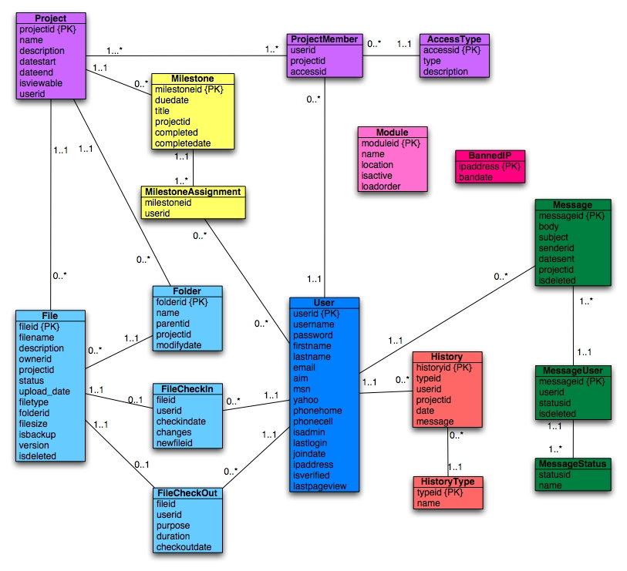
Image 7 - Complete Database UML

Database Schema by Module

In what follows, each module will be broken down to better understand their schema. We will show you the tables that are dependent for each particular module to function properly. Following each database schema diagram, a table will be provided to outline the specifics of each field in the table(s) for that module.
Account
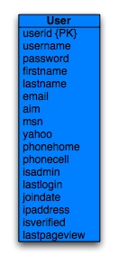
Image 8 – Account Module Database Schema
Account
Field Name | Type | Description
userid {PK} | int(11) | A unique number that identifies each user.
username | varchar(32) | The user’s login name.
password | varchar(32) | The user’s password. Stored as a hash value.
firstname | varchar(50) | The user’s first name.
lastname | varchar(50) | The user’s last name.
email | varchar(100) | The user’s validated e-mail address.
aim | varchar(50) | The user’s AOL IM address. (OPTIONAL)
msn | varchar(50) | The user’s MSN IM address. (OPTIONAL)
yahoo | varchar(50) | The user’s Yahoo! IM addresss. (OPTIONAL)
phonehome | varchar(10) | The user’s home phone number. (OPTIONAL)
phonecell | varchar(10) | The user’s cell phone number. (OPTIONAL)
isadmin | tinyint(1) | A Boolean to identify this user as a site admin.
lastlogin | Datetime | The date and time the user last logged in.
joindate | datetime | The date and time the user joined.
ipaddress | varchar(40) | The user’s last known IP address.
isverified | tinyint(1) | A Boolean to identify the account as verified.
lastpageview | datetime | The date and time the user last viewed a page.

Communicate
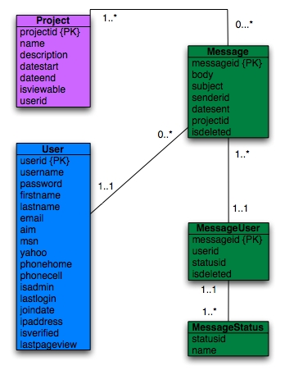
Image 9 – Communicate Module Database Schema

Message
Field Name | Type | Description
messageid {PK} | int(11) | A unique number that identifies each message.
body | text | The body content of the message.
subject | varchar(255) | The subject of the message
senderid {FK} | int(11) | The user ID of the person sending the message.
datesent | datetime | The date the message was sent.
projected {FK} | int(11) | The project ID of which the message is attributed.
isdeleted | tinyint(1) | A Boolean to denote the message as deleted or not.

MessageUser
Field Name | Type | Description
messageid {FK} | int(11) | The message ID.
Userid {FK} | int(11) | The user ID associated with current message.
Statusid {FK} | int(11) | The status ID for this message for this user.
isdeleted | tinyint(1) | A Boolean to denote the message as deleted or not.

MessageStatus
Field Name | Type | Description
statusid {PK} | int(11) | A unique number that identifies each message status.
name | varchar(100) | The various status messages for a message

Deadlines

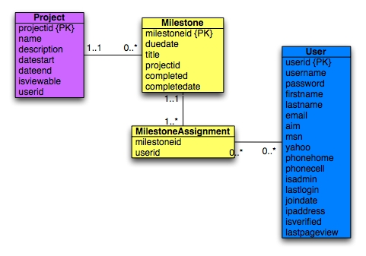
Image 10 - Deadlines Module Database Schema
Milestone
Field Name | Type | Description
milestoneid {PK} | int(2) | A unique number that identifies each deadline.
duedate | datetime | The date the deadline is due.
title | blob | The title of the deadline.
projectid {FK} | int(2) | The project ID this deadline is associated with.
completed | tinyint(1) | A Boolean to determine if the deadline is complete.
completeddate | datetime(1) | The date the deadline was completed.

MilestoneAssignment
Field Name | Type | Description
milestoneid {FK} | int(2) | The deadline ID the user is assigned to.
Userid {FK} | int(2) | The user ID that is assigned the specific deadline.

Files

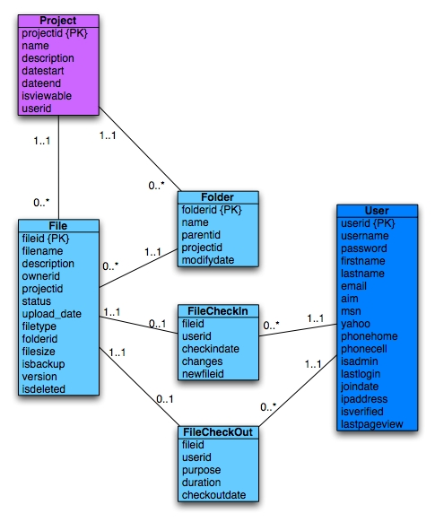
Image 11 – Files Module Database Schema

Files
Field Name | Type | Description
fileid {PK} | int(11) | A unique number that identifies each file.
filename | varchar(100) | The name of the file.
description | Blob | The description of the file
ownerid {FK} | int(11) | The user ID on who owns the file.
projected {FK} | projectid(11) | The project ID that the file is associated to.
status | int(2) | A Boolean to verify if the file is checked in or out.
upload_date | datetime | The date the file was uploaded.
filetype | varchar(100) | The MIME type of the file.
folderid {FK} | int(11) | The folder ID that the file resides in.
filesize | varchar(50) | The size of the file in kilobytes.
isbackup | tinyint(1) | A Boolean to verify if the file is a backup or not.
version | decimal(3,2) | The version number of the file (e.g. x.yy).
isdeleted | tinyint(1) | A Boolean to verify if the file is deleted or not.

Folder
Field Name | Type | Description
folderid {PK} | int(11) | A unique number that identifies each folder.
name | varchar(100) | The folder’s name.
parentid | int(11) | The parent ID for this folder.
projectid {FK} | projectid(11) | The project ID that this file is associated to.
modifydate | datetime | The date which this folder was modified.

FileCheckIn
Field Name | Type | Description
fileid {FK} | int(11) | The file ID which is being checked in.
userid {FK} | int(11) | The user ID that is checking in the file.
checkindate | datetime | The date and time the file was checked in.
changes | Text | The user defined field on what was changed.
newfileid | int(11) | The new ID associated with this file.

FileCheckOut
Field Name | Type | Description
fileid {FK} | int(11) | The file ID for the file being checked out.
userid {FK} | int(11) | The user ID of the user checking out the file.
purpose | text | The reason for checking out the file.
duration | datetime | The duration that the file will be checked out.
checkoutdate | datetime | The date the file was checked out.

History
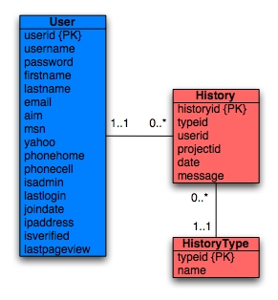
Image 12 - History Module Database Schema

History
Field Name | Type | Description
historyid {PK} | int(11) | A unique ID for each history event.
typeid {FK} | int(11) | The ID used to determine the history type.
userid {FK} | int(11) | The user ID for the user that completed the history action.
projected {FK} | int(11) | The project ID that the history event is applied to.
date | datetime | The date the history event was completed.
message | text | A message about the history event.

HistoryType
Field Name | Type | Description
typeid {PK} | int(11) | A unique number that identifies each history type.
name | varchar(100) | The name of the history type.

Project
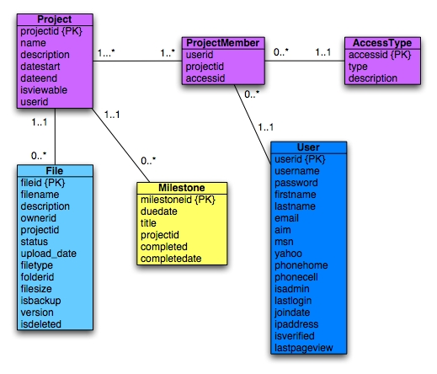
Image 13 - Project Module Database Schema

Project
Field Name | Type | Description
projectid {PK} | int(11) | A unique number that identifies each project.
name | varchar(100) | The name of the project.
description | blob | The description of the project.
datestart | datetime | The start date of the project.
dateend | datetime | The end date of the project.
isviewable | tinyint(1) | A Boolean to determine if this is shown the public projects list.
Userid {FK} | userid(11) | The user ID of the user that created the project

ProjectMember
Field Name | Type | Description
userid {FK} | int(11) | The user ID of the user assigned to the project.
projected {FK} | int(11) | The ID of the project this user is assigned to.
accessed {FK} | int(11) | The ID of the type of access the user has on this project.

AccessType
Field Name | Type | Description
accessid {PK} | int(11) | A unique number that identifies each access type.
type | blob | The title for the access type.
description | blob | A description for the access type.

Other

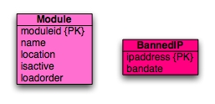
Image 14 - Other Modules Database Schema

Module
Field Name | Type | Description
moduleid {PK} | int(11) | A unique number that identifies each module.
name | varchar(200) | The unique name of the module.
location | varchar(255) | The location on the server for the module files.
isactive | tinyint(1) | A Boolean to determine if the module is active or not.
loadorder | tinyint(s) | Used to determine the order which the modules are ordered on the navigation bar.

BannedIP
Field Name | Type | Description
ipadderess {PK} | int(11) | The unique IP that is banned.
bandate | datetime | The date the IP was banned.

Index Page Site Flow

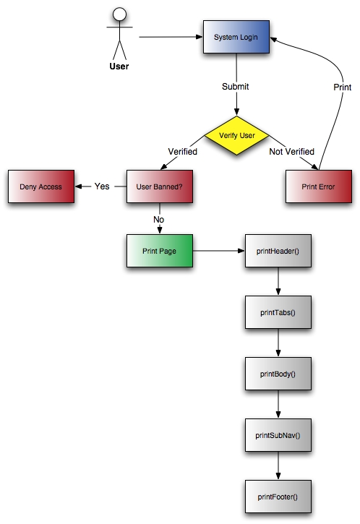

File Documentation Outline

Package TurtleSession Procedural Elements
TurtleSession.php

Package TurtleSession Classes
Class TurtleSession
Constructor TurtleSession
Method endSession
Method setSession

Package Turtles Procedural Elements
functions.php
Function addHistoryItem
Function getAccessId
Function getProjectOwner
Function isAdmin
Function isBanned
Function loadModules
Function printError
Function printFooter
Function printHeader
Function printSingleTab
Function printSuccess
Function printTabs
Function timeDiff
Function updateModules
getfile.php
Function getCurrentPath
Function printFooter2
Function printHeader2
Function readfile_chunked
Function setCurrentProject
Function verifyAccess
List.php
Function print_public_projects
Function print_user_projects
Overview.php
Function getPending
Function printPanel

Package Turtles Classes
Class OnProject
Var $projectid
Constructor OnProject
Method printProjectUsers
Method processEvents
Class ProjectChooser
Var $isStyled
Var $printLabel
Var $userid
Constructor ProjectChooser
Method printChooser
Method processEvents

Package TurtlePage Procedural Elements
TurtlePage.php

Package TurtlePage Classes
Class Account
Constructor Account
Method getPhoneNumber
Method getProjectUsers
Method hasRequiredFields
Method makeSQLPhone
Method printBody
Method printForm
Method printSubMenu
Method processEvents
Method verifyPassword
Class Admin
Constructor Admin
Method printBody
Method printSubMenu
Method processEvents
Method verifyAccess
Class Communication
Constructor Communication
Method addedProject
Method deletedProject
Method getMessageIcon
Method printBody
Method printSubMenu
Method processEvents
Method verifyAccess
Class FileManagement
Constructor FileManagement
Method addedProject
Method deletedProject
Method deleteFolderDatabase
Method deleteFolderPhysical
Method getCurrentPath
Method getIcon
Method printBody
Method printCrumbs
Method printSubMenu
Method processEvents
Method readfile_chunked
Method setCurrentProject
Method verifyAccess
Class History
Constructor History
Method addedProject
Method addHistoryItem
Method deletedProject
Method printBody
Method printSubMenu
Method processEvents
Method verifyAccess
Class Home
Constructor Home
Method printBody
Method printSubMenu
Method processEvents
Class LunchPicker
Constructor LunchPicker
Method printBody
Class Milestones
Constructor Milestones
Method containsValidElements
Method dateDiff
Method getAssignedUsers
Method getCal
Method getProjectsByUserID
Method getProjectUsers
Method getProjectUsersByID
Method isSelected
Method makeChecked
Method printAssignedUsers
Method printBody
Method printDeadlineDisplay
Method printEditTable
Method printErrorHeader
Method printMsg
Method printSubMenu
Method processEvents
Class Projects
Constructor Projects
Method addedProject
Method deletedProject
Method printBody
Method printSubMenu
Method processEvents
Class TurtlePage
Var $friendlyName
Var $moduleName
Var $requiresAdmin
Constructor TurtlePage
Method addedProject
Method deletedProject
Method getModuleName
Method printBody
Method printSubMenu
Method processEvents

Module Breakdown

Admin Module
File Management Module
Communication Module
Projects Module
History Module

Admin Module

We wanted our system to be available for students to download and install on their Dante web server provided by UW. We also thought up of the situation when a system administrator installs it on the department server for students in the school. In either case, there needs to be an Admin interface that gives the installers administration options over the rest of the users. The below image shows the index page for the Admin module:

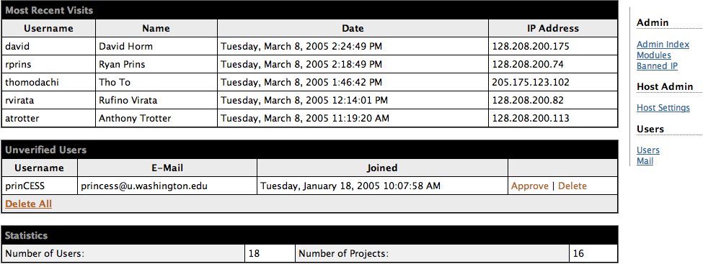
Image 15: Admin Index view
The first thing that the Admin sees is a list of most recently visited users. This is provided to show the admin how often the system is being used. There is also a list of “unverified users” which are users that signed up and didn’t verify their email account. Administrators have the ability to approve or delete unverified users. The final piece of information on the main index page is the statistics of how many users are signed on, and how many projects there are.

Administrators also have the power to install different modules. The following image shows the interface that administrators use to interact with the modules:

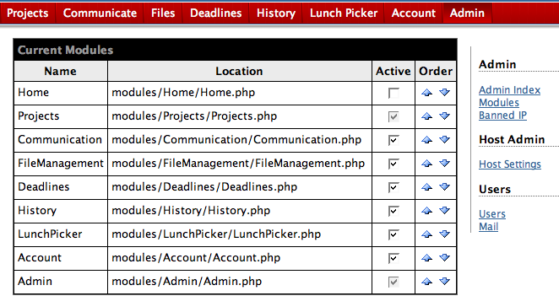
Image 16: Admin Module view
Installing a module is as easy as dropping a folder into the modules folder, and then coming into this interface to activate it. Each module will create a tab in the navigation which may be reordered.

Going down the Admin navigation, the administrator also has the power to ban users by their IP. The Host Settings shows what version of MySQL and PHP that the server runs on. It is also where the admin can change the title of the whole site, and change the template. Ideally it would be nice for different project managers to install their own modules and templates as they see fit. But due to the time constraint of capstone, we implemented so that the Admin manages all of that. Possibly future implementations would allow project managers to pick and choose their own modules, but the Admins would still need to install the module as a way of approving its usage.

Administrators can do user management that is different than project managers. The following image shows that interface:
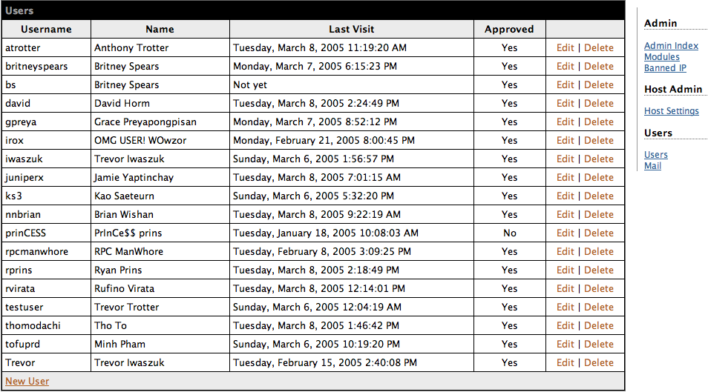
Image 17: Admin User Management Interface
There is simple information here: their username, name, time last visited and whether or not they are approved. The admin may go in and edit their information, such as their name, in case users are using inappropriate names. Admin may also delete users for whatever reason (maybe they haven’t logged on in a certain amount of time).

The Admin also has a Mail menu option to email all of the users or admins on the system. The following image displays this functionality:

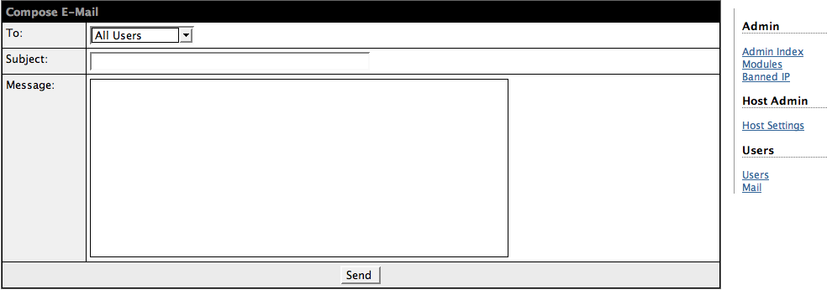
Image 18: Admin Mail Option
This may be used for when the admin wants to stop hosting the system, then he or she may email all the users of that fact, and instruct them to back up all of their files. Or maybe an administrator installed a new module and wanted to email all of the administrators about the new features. Whatever the case is, this is a feature that will save the administrator a lot of time.

File Management Module
This module is used for managing any files that a group may need to deal with. The file management module allows the user to upload new files, delete uploaded files, create folders, and delete these folders. Moreover, this module also provides the user with a versioning system similar to a CVS. In addition to a versioning system, the module provides a check-in/check-out system, as well as a backup system; whenever a user checks-out a file and then checks the file back in, a backup of the older file is made. Users then have the ability to revert to backup files, just in case something horrible happens to the most recent version of the file. The file management module includes many other features, which will be described in more detail in the following module breakdown. Below, we will break down the various functionalities that this module has to offer.

All Projects File Overview Page
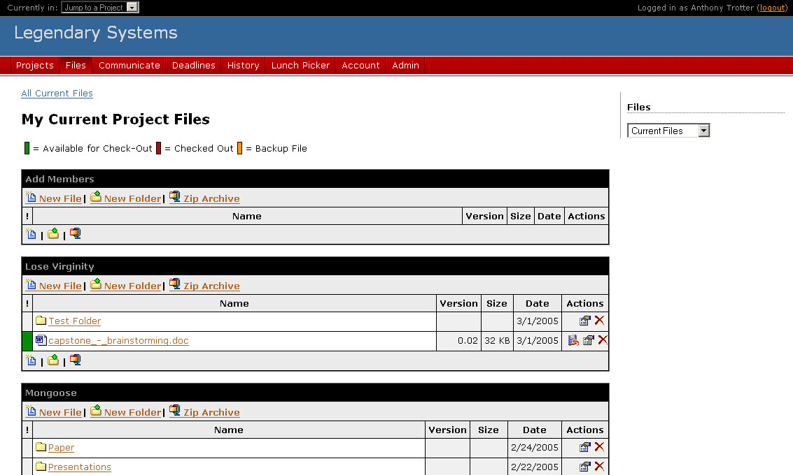
Image 19 - Viewing Files for All Projects
Image 8 above demonstrates that the user is able to view the files in the root directory of each project that he/she is a member of when a project is not chosen. We felt that a user that hasn’t chosen a project to work on yet will want to view the root directories of each project. From there, the user can choose the project he/she wishes to work on. As usual, the user can also choose his/her project from the drop down menu at the top left of the page. We also designed this page so that, in the event that a user starts to work on any of his/her files, the current project becomes the project that he/she decided to manipulate files in.

The file overview page also allows the user to change his/her view of the files. There are three different views that apply to all file browsing pages in the file management module: Current Files, Backup Files, and All Files. These views can be changed by using the drop down menu at the top of the side-bar. The Current Files view shows only the most recent versions of each file. The Backup Files view shows all backup files, but leaves out the most current versions of those files. The All Files view is the union of both the Current Files view and the Backup Files view. Also note that once a user has chosen a view, that view stays with him/her for all module tasks until he/she leaves the module page, or chooses a different view.

The All Projects File Overview Page also offers the user the same list of file actions offered in the Single Project File Overview Page, which will be discussed next.

Single Project File Overview Page
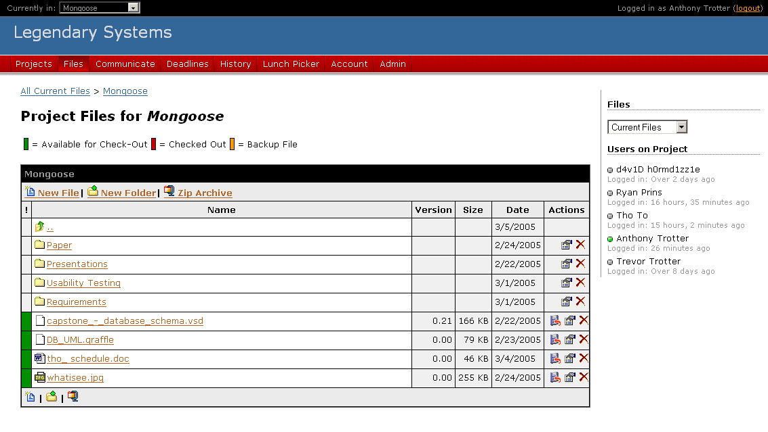
Image 20 - Viewing Project Files for Single Project
Once a user has selected an active project, only the current project will be shown. Notice, however, that the user has the ability to go back to the All Projects File Overview Page by using the crumbs at the top of the page. The functionality of this page is exactly the same as that of the All Projects File Overview Page. The only difference is that the fact that one page shows files for all projects, while the other shows files for a single project.

However, we will cover the further details of the other actions a user can perform on this page. First, notice the color key at the top of this page. These colors correspond to the colors that are shown in the status column (the first column on the left). The “Status” column provides the user with information regarding the status/type of the file. Files are colored in the following fashion:

- Green – Files colored green are current files that have not been checked out—they are available for checkout.
- Red – Files colored red are current files that are checked out, and cannot be checked out by another user until the file has been checked back in.
- Orange – Files colored orange are backup files, which cannot be checked-out/checked-in.

Secondly, notice that the layout of the file view attempts to mimic that of the Windows Explorer and an FTP client. Folders are shown first in alphabetical order and then files are shown, also in alphabetical order. The three columns that Windows Explorer does not contain include the “Status” column, the “Version” column, and the “Actions” column. The “Status” column was explained in the previous paragraph. The “Version” shows the user what version the file is currently at. Finally, the “Actions” column provides the user with certain quick actions, depending on whether the item is a file or folder. Folders and files have a “Properties” action and a “Delete” action. Files also have a “Download” action, allowing the user to quickly download the file.

The last few actions a user can perform at this screen include the “New File,” “New Folder,” and “Zip Archive” buttons at the top and bottom of the table. Users can upload a new file by clicking on the “New File” button. When uploading a file, the user will not be allowed to upload files that match the name of a file that already exists. To create a new folder, the user need only click on the “New Folder” button. The user can download all files (including backup files) in the current folder structure by clicking on the “Zip Archive” button. The resulting file is a tarball-gzip file (*.tar.gz). Unfortunately, this will only work on systems running Linux. However, since our target audience consists of Informatics students, they’ll most likely be running their systems on Dante, which supports the tar and gzip commands.

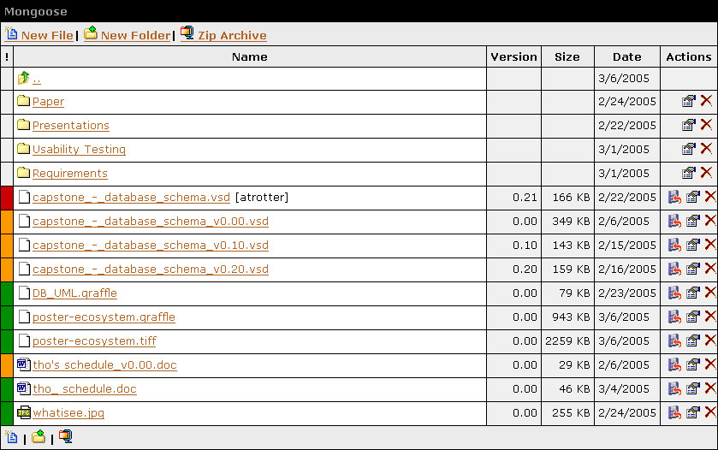
Image 21 - Viewing All Files for Project Mongoose

File Information Page
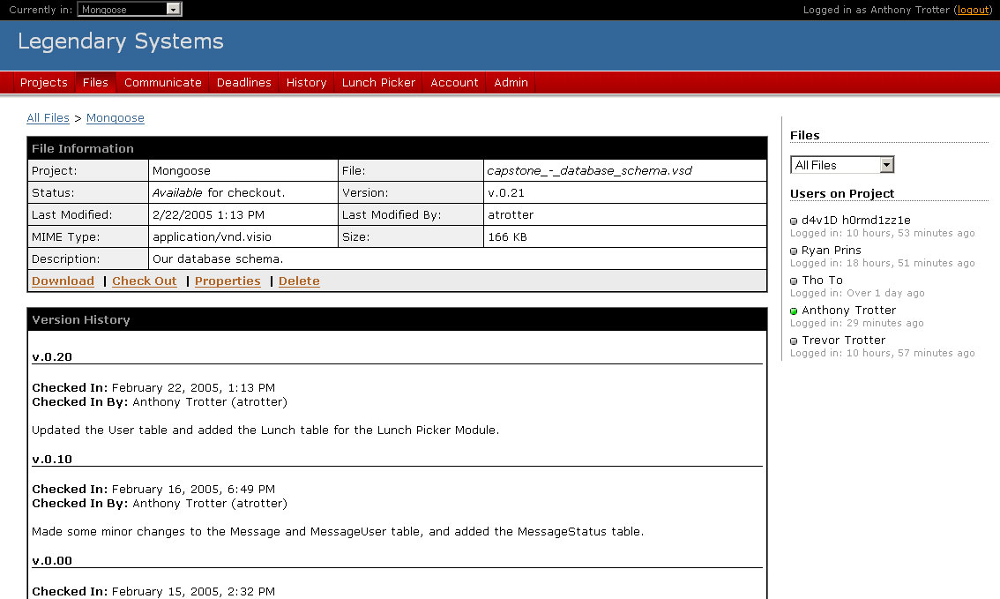
Image 22 - File Information Page for capstone_-_database_schema.vsd
We decided to give each file a detailed file information page. This page displays the various file properties (editable in the “Properties” section), as well as the file history. Image 22 above demonstrates the layout of this page. Various information about the file, including the version of the file, the date last modified, who it was modified by, and even it’s checkout status are found on this page. This page also displays the history of the file in descending version order, making it extremely easy for the user to see who made changes to the file, as well as what change(s) that person made.

The user is also provided with a list of actions at the bottom of the “File Information” box. As on the file overview pages, the user is provided with “Download,” “Properties,” and “Delete” actions. However, the file information page offers a few different actions than the file overview page; it handles the check-in and check-out actions, as well as reverting to a backup file.

Depending on the status of the file (current, checked-out, or backup), the options displayed to the user will vary. If the file status is current and checked-in, the user will receive a “Check Out” link in the “File Information” box. If the file status is checked-out, the user that checked-out the file will be offered two links: “Check In” and “Cancel Check Out.” We chose to add the “Cancel Check Out” action, since there is always the possibility that users will check out a file by accident. If the file is checked-out, but the user viewing the information page is not the one that checked it out, they will receive a “Request File” link, which allows the user to send a quick file request e-mail to the person that checked out the file. Finally, if the file is a backup file, the user will receive a “Revert” link, allowing the user to revert to the chosen backup file if desired.

Editing File Properties
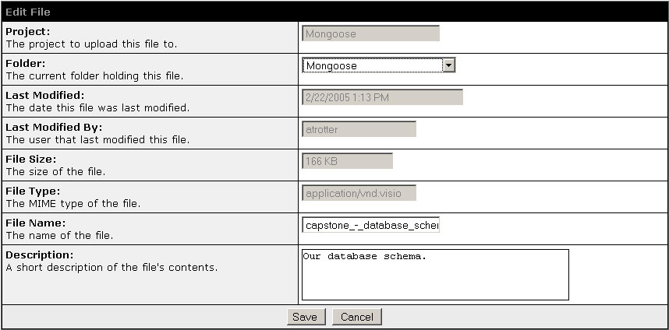
Image 23 - Editing File Properties for capstone_-_database_schema.vsd
Image 5 demonstrates the Edit File page. This page allows the user to edit a limited amount of data about the file, including the file name and file description. Also notice that this page allows the user to change the folder that the file is located in. Due to the limitations of the web (and our limited knowledge of Javascript), we have no drag-and-drop interface similar to that of the Windows Explorer. Hence, we decided that we’d provide a drop down list of folders currently available in the project to the user.

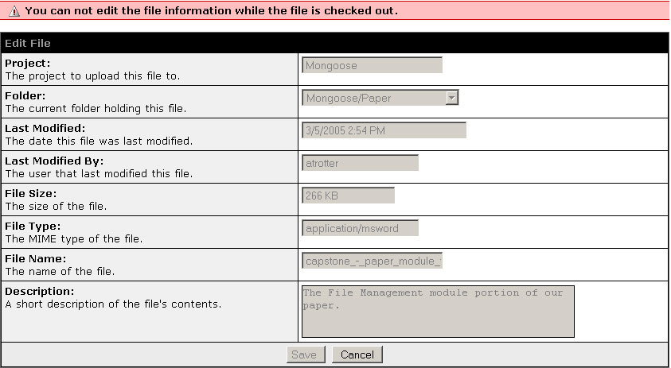
Image 24 - Editing File Properties for a Checked Out File
There are a couple of special rules to be mentioned about the Edit File page. First, the only type of file that a user can edit is a current file that is not checked out. If the file is checked out, or if the file is a backup file, the user will receive a window like that in Image 6 with the appropriate feedback. We chose to do this to minimize confusion and problems. Because each backup file is attached to the current file, and because each backup file follows a naming schema that builds off of the current file, it made sense that the only file that a user can edit should be the current file. Second, if a user decides to change the folder that a file belongs to, all backup files move with the current file to the new directory. Again, we chose to do this because the backup files are extremely connected to the current file.

Checking Out a File
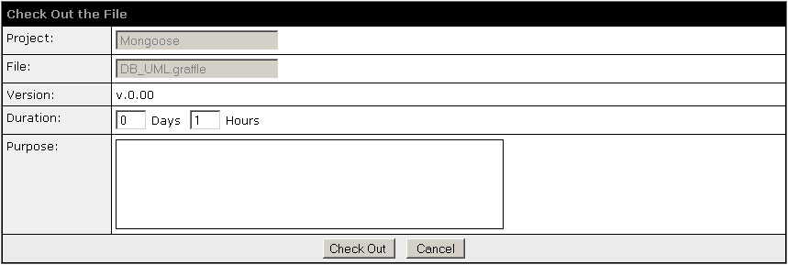
Image 25 - Checking Out the DB_UML.graffle File
Once a user has chosen to check out a file, they’re given the screen in Image 7 above. This form allows the user to request the file for a particular duration and purpose. Once the user has filled out the appropriate information and clicked the “Check Out” button, the module will bring up a download window, shown in the picture to the right. This download window will automatically start the user’s download. However, if for some reason the download does not start, we also provide the user with a “Download” link, just in case. We also provide feedback for the user, letting him/her know that this window is for the download, and that once the download is finished, he/she can close this window.
Image 26 - Download Popup Window

Once a user checks out a file, the File Overview Page is updated as well. Image 3 above shows that the user “atrotter” checked out the file capstone_-_database_schema.vsd. Note that the indicator is plain text and provides no link. This is what the user that checked out the file will see—user “atrotter” is currently logged on and looking at the File Overview Page. If the user is not the one that checked out the file, the name is also linked, providing quick access to the “Request File” page.

Checking In a File
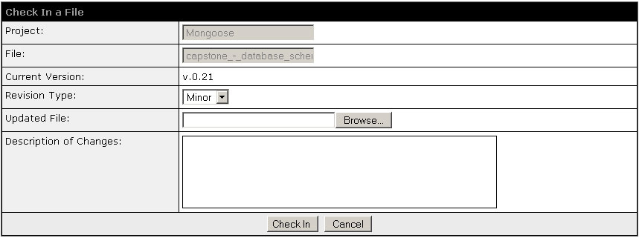
Image 27 - Checking In File capstone_-_database_schema.vsd
Once the user has chosen to check in the file, he/she is brought to the screen shown in Image 27 above. Here, the user is asked to upload the updated file, increment its version number, and provide a short description of the changes he/she made to the file. The user has three options for the revision type: Minor, Point, and Major. Minor will increment the revision type by 0.01. Point will increment the version to the nearest tenth decimal place, and Major will increment the version to the next whole number. We chose to give the user three types of revision, attempting to reach some kind of versioning scheme, like that of the MySQL database server.

Once the file is checked in, the history of the file is updated with the description of changes, the version is incremented, a backup of the old version is created, and the status of the latest version is set to current (not checked out).

Feedback and Integrity Checking
As with the other modules, most actions will provide the user feedback, informing him/her whether the action performed was successful or not. Many of the feedback messages look like those in Image 28 and Image 29 below.

Image 28 – Example of a Successful Action (Positive Feedback)
Image 29 - Example of an Unsuccessful Action (Negative Feedback)
To help minimize the post backs and server side data integrity checking, we also do some client side checking using Javascript. In this case, the user will receive feedback in the form of an alert box, as shown in Image 30.
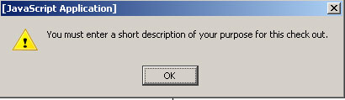
Image 30 - Client Side Data Integrity Checking with Javascript

Communication Module
This module was created for facilitating communication between members within group projects. While conducting the focus group and gathering our requirements, our users expressed the need for a way to be able to communicate within our system. However, they said that it wasn’t that great of an importance to implement this feature and so we placed it low on our priority list. Since we anticipated that members in the group projects will usually turn to email as their primary method of message exchange, we designed this module just there as another means of communication and to allow group members to send private messages to each other. We thought that this was a less obtrusive way of sending un-important email messages other group members, which can be an annoyance when they already have an overly filled email inbox. Instead, a user can just send a private message to another team member and the other team member could choose whether or not to check it whenever they log into the system or completely ignore it.

The communication module was designed to act like a private message system that you usually find in forums. You can find a lot of similarities with our communicate module compared to a messaging system of a forum.

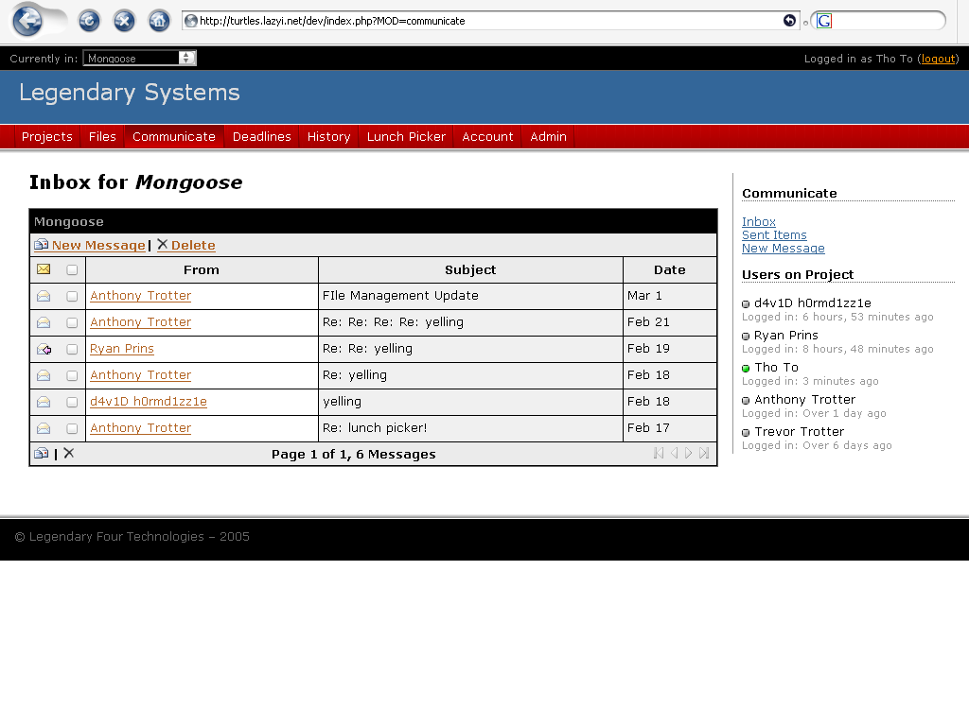
Image 31 - Communication Module

As you can see in Image 1 above, this module displays a very basic layout you commonly find on all of our modules. The main content is in the middle and the sub-navigation resides on the right side. The default page that loads up shows the inbox of the messages you received for the project that you are currently working on. In this case, the picture above is showing the inbox of messages received within the “Mongoose” project.

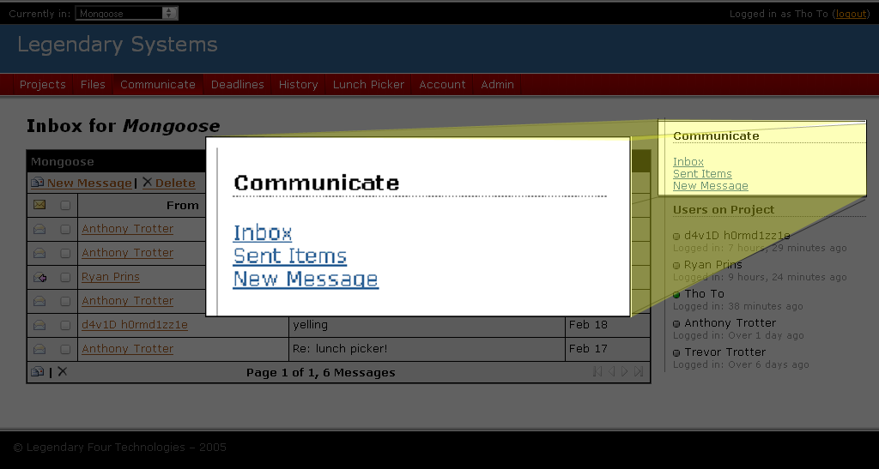
Image 32 - Sub Menu

The sub navigation contains three links. They are all pretty much self-explanatory.

Image 33 - Inbox Contents

The contents of the inbox consist of the sender of the message, the subject line and the date sent. The icons on the far left shows the status of each message whether they are unread, read, or has already been replied to. There are also checkboxes next to each message that allows multiple deletions of messages.

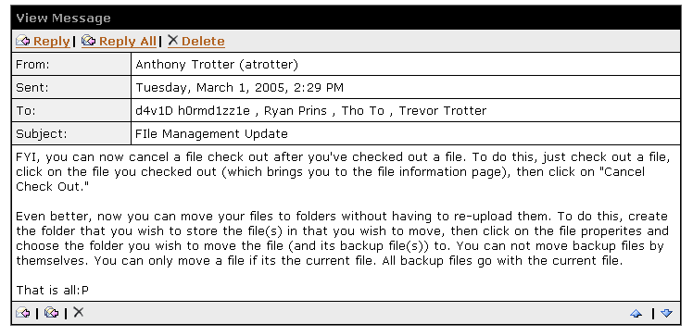
Image 34 - Sample Message

A sample of a message that a user receives would look like the one in Image 4. The message shows the typical details and fields that everybody is normally accustomed to and again they are pretty much self-explanatory. The content of the message is displayed shortly after message details. As you can see in the screenshot there are several functions that allows you to reply to the sender of the message, reply to all sender and receivers, or delete the message. You can also find at the bottom right corner a way to navigate to the next or previous messages in your inbox.

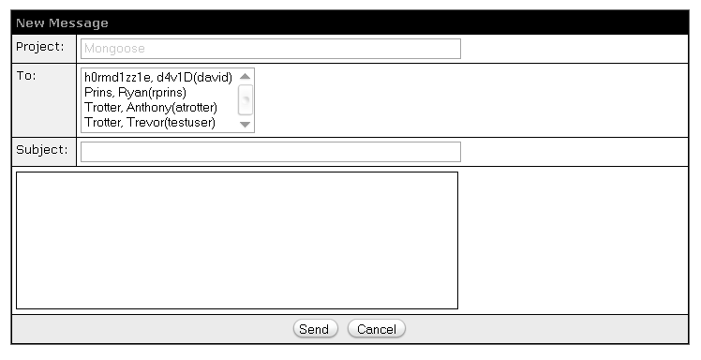
Image 35 - Composing a New Message

Sending a message is relatively simple. All you have to do is pick the receiver(s) of the message from the pre-generated list of users who are currently on your project, then write in a subject line and type in your message. Once that is completed, you just hit send and the message is sent to the inbox of the recipient(s).

Projects Module
The projects module holds several dependencies from other modules. As mentioned before, this module had to be implemented first and foremost in order for the rest of the system to work. It is obvious that a project needs to be created before you should be able to do anything else like add members, set deadlines, or upload files. So even though there isn’t a whole lot of features implement for the projects module, it was an important piece of our system.

Your Projects Page

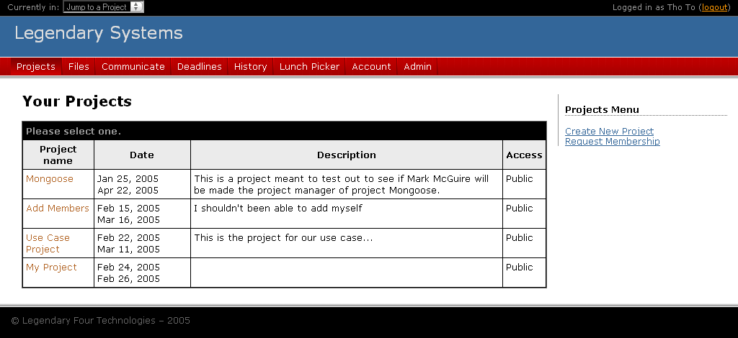
Image 36 - Your Projects Page
When a user first logs into the system, they will be directed to the first module, which was set to be the Projects module when the system is first installed. However the modules can be reordered if you are the admin of the system (see Admin module section). In the picture above, you can see a sample of what a user would see if they were already involved in several projects. Each project displays a name with a hyperlink to the project’s overview page. You can see the starting and ending dates, the full description, and the access level of the project, which will be explained later.

On the side menu, there is a “Create New Project” option and a “Request Membership” option. The “Create New Project” option will take the user to a form where they can enter in all of the necessary information for their project and become the PM of that particular project. “Request Membership” option will take you to a page where you can request membership to any public projects available.

Creating a New Project
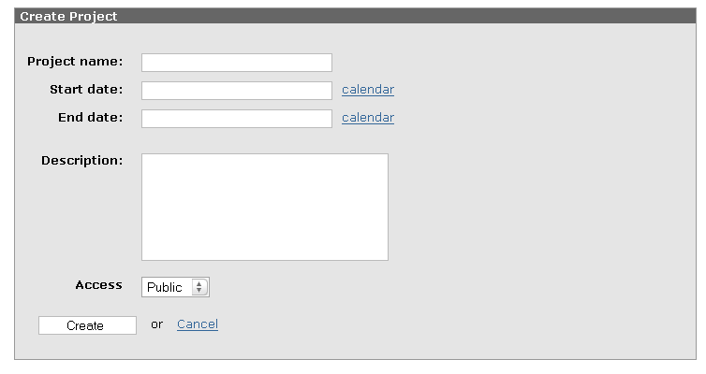
Image 37 - Creating a New Project Form
Here is a simple form that allows the user to create their own project. The calendar link will allow the user to pick their dates from a small popup calendar if they do not want to enter it manually. The access level of the project can be either public or private. If you do not want to other users on the system to see or request membership to your project, then you can make it private. The rest of the fields are pretty much self-explanatory

Requesting Membership
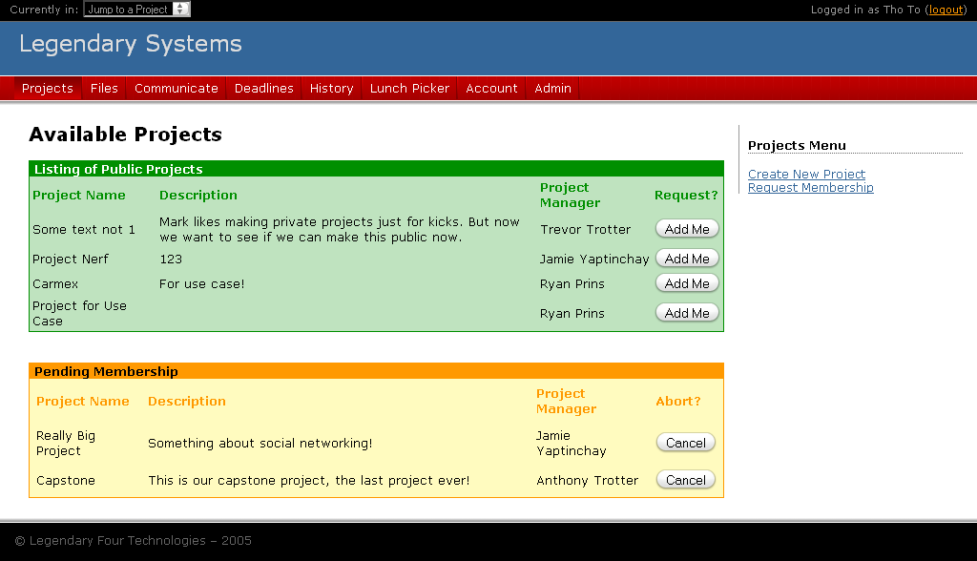
Image 38 - Requesting Membership Page
If Project Managers decide to make their projects public, then any users are free to request membership to that project. By going to the request membership page, a user is able to see a listing of public projects and request to be added to that project. The project managers will be notified of pending users and the user requesting the membership will see in the yellow pane which project they are currently pending for. The reason why we added this requesting membership feature to our system was because we understand that sometimes, the person leading the project could forget to add one of their members and we want a way for the user to remind the project manager to add them.

Extra Menu Options for PM’s
Image 39 - Project Manager Menu

Image 4 - PM Menu

Once a user creates a project on the system, they are assigned as the PM of that project. If they start to work on that project they will see a special menu on the side only available for PM’s. Here they can edit or remove the current project or manage the members of the project.

By going to “Edit/Remove Project” they will be taken to another page with a form where they can change any specific information relating to the project or completely remove the project from the system. You can see a sample screenshot below.

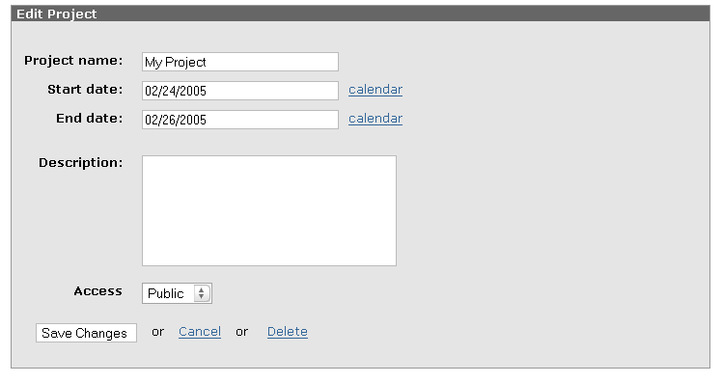
Image 40 - Edit Project Form

Member Management

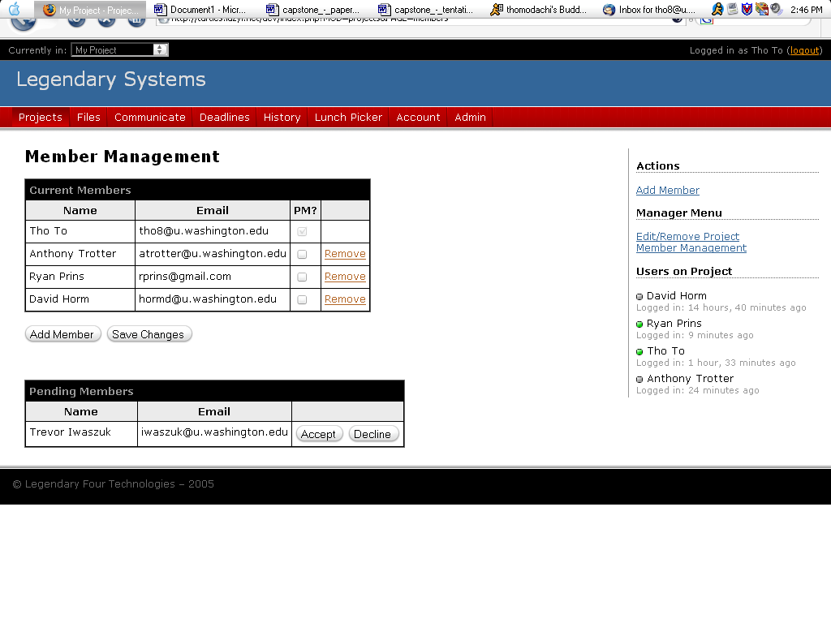
Image 41 - Member Management Page

The member management page allows the PM’s to add new members, add pending members who are requesting membership to the project, or remove existing members. Below are close up shots of the current members table and pending members table.

Image 42 - Current Members and Pending Members

Adding Members

When a PM decides to add members to the project and clicks on the Add Member button, they will be taken to this page:

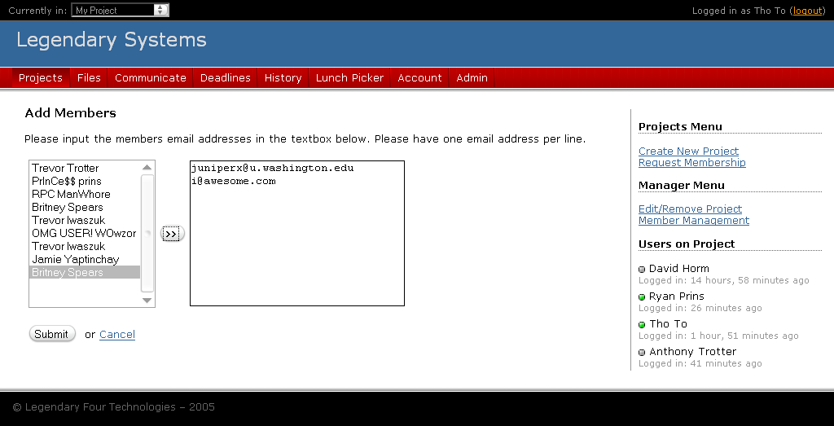
Image 43 - Add Members Screen

Here, the system will list all of the users who are in the database who are currently not on the project. To add members, the PM just clicks on each person’s name or select multiple people from the list and click on the arrow button to add them to the textbox on the right. The PM can choose to manually add member’s to the textbox by typing their emails in separated by line breaks. Having a textbox allows a lot of flexibility of removing users if they accidentally added the wrong user to the box, they just have to be careful of the some formatting issues by making sure there is only one email per line. All is left of the process is clicking on submit and the system will verify each members’ email by checking to see if the email entered matches an existing user’s account on the system. If there is a match, the user will be added to the project automatically and if not, then an error message will appear notifying that the particular user is not registered in the system.

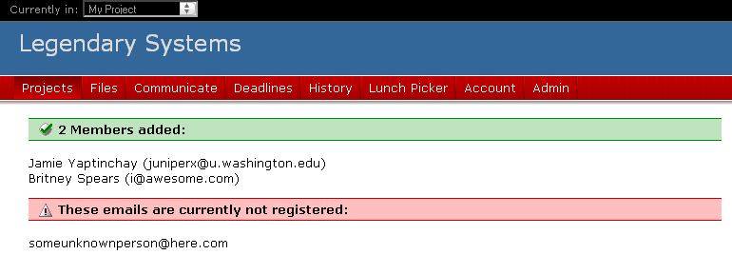
Image 44 - Sample System Success and Error Messages
Deadlines Module
This module is used for managing deadlines for a specific project. The deadlines module allows users to add, edit, and delete deadlines. In addition, they are able to mark deadlines as complete when they are finished as a team. This module also comes with two features that manipulate the data found in each deadline. We offer each user an iCalendar file that they can use to subscribe to the deadlines for the project. These calendars are project specific and each project has a different calendar. In addition, users will see on the sub navigation a three month calendar outlining, by color, the statuses of the various upcoming deadlines. As an added feature, when the user is looking at an overview of their deadlines, over all projects, a simple hover over the calendar will highlight the specific deadline for them to view. Below, we will break down the various functionalities that this module offers.

Deadline Overview Page

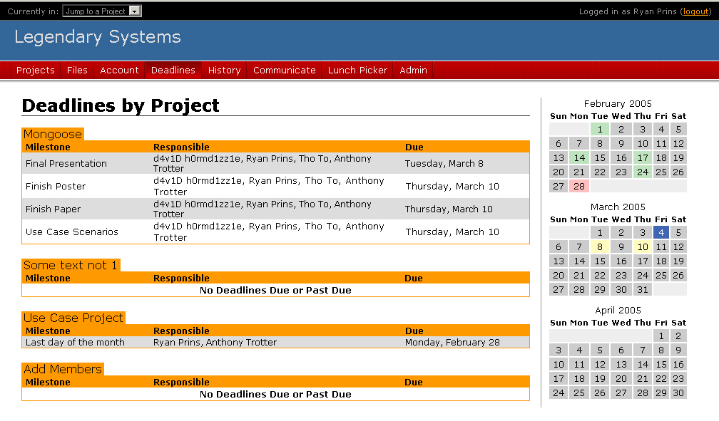
Image 45 - Viewing All Project Deadlines
In the above image the user is able to view all of their deadlines over all of the projects that they are a part of. On the right side of the screen, the three month calendar is provided to give the user an outlook into the future of their deadlines. One decision that we made when designing this page was how many and of what type of deadlines we wanted to display. We felt that it was not important to display deadlines marked as complete, but to only offer the user the ability to see deadlines which are marked as late or upcoming. By doing this, we are able to not fill the screen with projects that have uninformative information on completed deadlines. Also, it can be hard to see in the listing what deadline is what so we offered the user two options to view their deadlines:

- Mouse over on the calendar to highlight deadlines for that date.
- Alternating row colors

With the addition of these two visual cues on the page, it is much easier to view multiple deadlines.

Deadlines for a Project

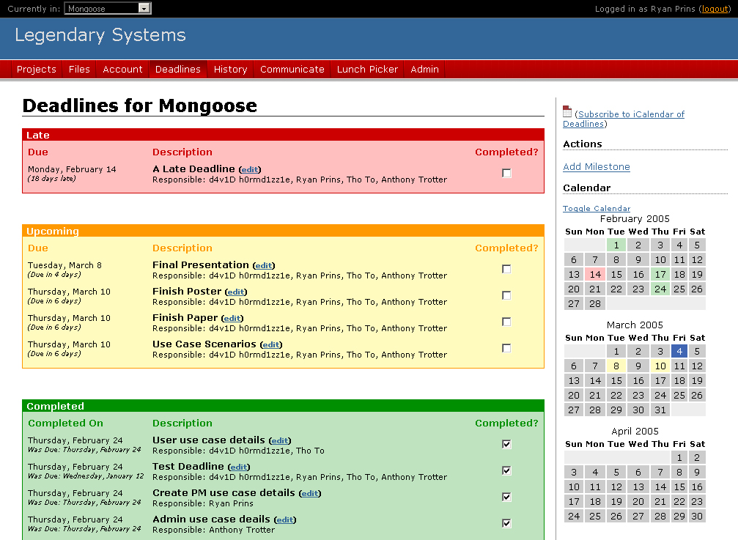
Image 46 - Deadlines for Project Mongoose

Once a user is selects a specific project’s deadlines to view, they are taken to the above page, which shows a detail view of all of the deadlines for that project. We decided to use the metaphor of a stoplight in respect to colors for how deadlines were handled. The color designations are as follows:

- Green – Completed Deadline
- Yellow – Upcoming Deadline
- Red – Late Deadline

By using this metaphor, it is easy to see, at a glance, what is late, due, or completed.

Also, on this page users can see what date the deadline is due, who is responsible for it, and, if completed, what date it was completed on.

Deadlines Sub Navigation

In addition to being able to view the deadlines for the specific project, the user was also provided a sub navigation menu that offers them three things:
Image 47 - Deadlines Sub Navigation (Within a Project)

- Subscribable iCalendar of Deadlines
- Ability to add deadline
- A 3 month calendar of deadlines, with the option to hide

The iCalendar that users can subscribe to is just another way that users can stay in touch with the project without having to log in to check the system on a daily basis. This allows them to look on their calendaring program when deadlines are due. This is a nice feature to be able to use, however there are security risks.

Since the iCalendar format does not have a way to authenticate users for a specific calendar, each calendar has the potential to be viewed by any user that has the URL for that calendar. In order to combat spoofing of URLs we implemented a basic hashing algorithm to try to make the URL more difficult to spoof. This means that each user of the same project has a different URL for the same project calendar. This is done for the sake of security. So, for example, one of these URLs could look like:

ical.php?CAL=7ae5c7bbb1bf0eacd5263016380aa44e22ee2647&PID=3

The CAL parameter is the calendar that the user wishes to access and the PID is the project that the calendar is for. Both pieces of this URL are needed for the calendar to work correctly. The CAL hash is created using the MD5 hash. This is a combination of the user’s user number and a SALT, which is added for variance and to prevent any sort of generic spoofing. But, in order for this to work properly, both parts (CAL and PID) are needed and must be correct. If incorrect parameters are passed to the calendar file, an empty calendar will be returned.

Users are also able to add a deadline for this particular project. This functionality will be covered later in this section.

In addition to the previously mentioned items, the user is also displayed with a three month calendar of all the deadlines for the specific project. This differs from the deadlines overview page which displays deadlines for all of the projects. Also, this calendar does not offer the same hover over feature that the overview calendar does due to the way the page was implemented. We opted to make the stoplight metaphor more prevalent on this section of the module and we feel that the hovering functionality was not needed. One extra feature about the calendar is the ability to hide it from view. This feature is enabled by clicking the “Toggle Calendar” link right above the calendar. This is enabled by the use of JavaScript and the setting is not stored over sessions. So, each time the user comes to visit the page, the calendar will be displayed. As a next step, it could be added as a feature to have the calendar always be hidden, if the user so chooses.

Adding a Deadline

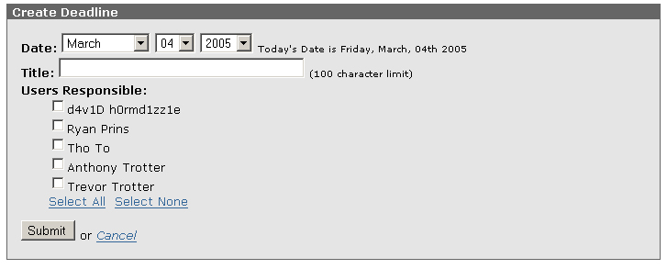
Image 48 - Add Deadline Form
The above image is what the user is presented when they want to add a deadline. The form is very straight forward and easy to fill out.

Each deadline is composed of thee things:

- A due date
- A title
- Responsible users

The due date is completed by the use of drop down boxes. When the form is initially loaded, the form displays the current day’s date. Also, the current day’s date is spelled out just to the right of the form in case the user is unaware that the date in the dropdown boxes is not the current day’s date. In order to make sure that the date being processed is an actual date, the use of the PHP function checkdate was used to verify the date existed. However, in the event that the user does input an incorrect date, or an empty title field, an error will be displayed to the user. These error messages are displayed above the form and look like:
Image 49 - Invalid Date Error Message
Then the form is presented again to the user with all of the other information left in tact, but with today’s date displayed again since an invalid date was provided. Also, there are positive feedback messages as well when a user completes a task that completes successfully. For example:

Image 50 - Successfully Added Deadline Message

Editing a Deadline
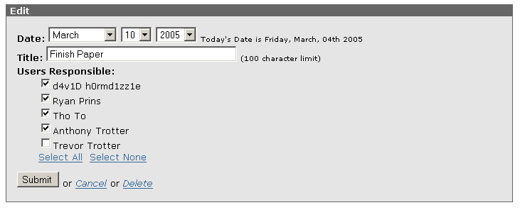
Image 51 - Edit Deadline Form
You will notice that this form is very similar to the add deadline form. The only changes to the form are that all of the fields are filled in for the specific deadline and there is also the option to delete the deadline at the bottom of the form. Other than these additions, the form functions exactly the same as the form previously described.

History Module
The history module serves as the main avenue for all modules to post history events into one location. This module is mainly a presentation module containing data from other modules that calls on the global function, addHistoryItem. This function allows all modules to inform the history module that an event has occurred. Then, the history module can sort these out by the user who completed the history event or by the event that completed itself.

To view the different history events, a user can log into the system or they can subscribe to an RSS feed that contains all of the various history events for a specific project. Below, we will describe how a history event is added, as well as how the user can view these events.

Adding a History Event
In order for this module to serve its purpose, history events need to notify the history module that something has happened. In order to do this, each module, if they wish to participate, can add a call to the addHistoryItem function to add an event. A sample call to this function is as follows:

addHistoryItem($_SESSION['userid'], $_SESSION['projectid'], "Deadline <em>" . $milestone_title . "</em> was added.", "Deadline Add");

This example history item occurs in the Deadlines module when a deadline is added. The first parameter is the user that created the action, the second parameter is the project this history action is for, the third parameter is the message for the history item, and the list item is the type of history event. An example of a message that would show up in the history module is as follows:

Image 52 - Example History Item

Now, while the date is not added to the history item when it is added, it is added to the database when the history item is inserted to the database.

Also, there is no predefined set of history event titles (e.g. Deadline Add). Each module can create as many or as few as they wish. Every time a new title is found by the
addHistoryItem function, a new title is added to the database. However, if a title repeats, it is not added again, but rather, it is just reused.

Viewing History Events
As mentioned above, each user has two options for viewing history events. They can view the events online or they can subscribe to an RSS feed for the history events that they choose. When the user views the history events online, they are presented a screen that lists all of the history events for the specific filter selected.

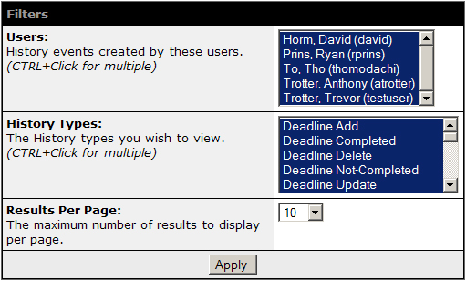
Image 53 - History Module Filters

As can been seen in the above image, the user has three main options to choose from. They can see the history items for a specific user, a specific history type, and they can also choose how many history items to display on the page. By default, all users and history types are selected and only the 10 most recent history events are listed on the page.

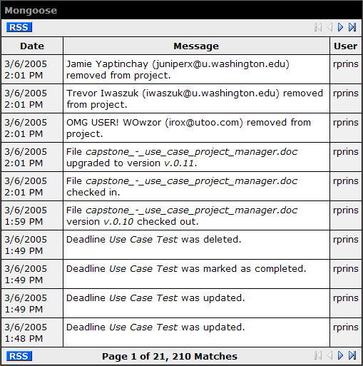
Image 54 - Example Listing of History Events

In addition to looking online for the history events, a user can subscribe to an RSS feed that provides the same information. This is an addition that, if used, will provide users with up to the minute listings of history events that have been committed for a specific project. They could, for example, watch the RSS feed for when a specific file is checked in or if new deadlines are added that they should we aware of. The information presented in the RSS feed is exactly the same as is provide online, however, the format differs due to our need to accommodate RSS readers as opposed to web browsers. Using Bloglines as our example news reader, an example RSS history event looks as follows:

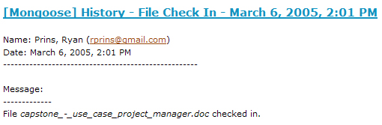
Image 55 - Example RSS History Item As Seen in Bloglines

While RSS is an emerging technology, there are some concerns when it comes to security. Since we opted to not require the user to log into the system to view the RSS feed, other security measures needed to be put into place so that the feed cannot be spoofed by a member who is not in the project. As with the Deadlines module and the subscribable calendar of deadline, all of the security measures mean nothing if the user specific URL is passed on to a differing user. That being said, each user receives their own specific URL to subscribe to the RSS feed. This URL looks like:

http://turtles.lazyi.net/dev/rsshistory.php?pid=3&u=4,7,3,2,11&h=316,312,310,311,313,302,306,305,303,317,304,307,308,309,320,318,321,315,319,314&wtf=bfb8f5f23a98b0840d4a44290068bef6b6028329

There are 4 main parameters to the URL:

- pid – The project ID that this RSS feed is for (e.g. 3)
- u – The user ID for this RSS feed (e.g. 4)
- h – The history events that you wish to be subscribed to (e.g. 316, 312, … , 314)
- wtf – The hash to verify the user’s identity

If any of the above are not correct, especially the hash, the RSS feed will return empty. Also, the hash is a combination of the users ID and the project ID that they are requesting. So, the hash is dependent on these two numbers as well as a SALT that is used to add variance and to also help prevent spoofing.

History Searching
In addition to the browsing outlined previously, users are also able to search for history items. They can search by user, type, date, and project. This enables the user to look back at the history events while at the same time not needing to browse through hundreds of history events. This feature comes in particularly handy when looking for specific events that have been completed on a particular day by a particular user.

Security
While we have outlined the security measures for the RSS feed, there are also smaller security measures in place in this module to prevent users from seeing information that they are not privileged to see.

When browsing or searching for history events, users are only allowed to see users related to projects that they are members of. This security measure was added when designing this module to prevent users from other projects viewing the history for other projects that they are not a part of. However, this also made more sense the longer we used the project, because history events tend to build quickly and then become very difficult to browse due to the quantity of events.

http://www.opensourcecms.com/
http://www.dotproject.net
http://www.dotproject.net/modules.php?op=modload&name=News&file=article&sid=5
http://jupiter.playgroundblues.com
See http://www.basecamphq.com/ for more information.
http://wordpress.org
http://www.gnu.org/copyleft/gpl.html
For Instructions: http://www.washington.edu/computing/web/publishing/mysql-install.html
It should be noted that while we have foreign keys in our models, they were not implemented on the system due to lack of support using the MyISAM table type with MySQL 4.1.8.
For documentation on this function check: http://us2.php.net/manual/en/function.checkdate.php
http://www.bloglines.com

