Results
From the procedures described above, the following results were ascertained. The results listed below come from two separate days of war walking. The first night was to “test the waters” per se so that on the second night we would be ale to work in an area that had the highest concentration.

Day 1
As was mentioned above, the first night was spent finding a neighborhood/area that had a high concentration of access points to obtain good data from. We ventured to eight (8) different locations; each location is marked if we were war walking or war driving.

- Yarun Loun’s Couch (War Walking)
- 22nd Ave and 47th Ave to 11th Ave and 47th Ave (War Driving)
- 47th Ave and 15th Ave to UW Health Sciences (War Driving)
- SR520 to I-5 to Union St. to 6th Ave to Denny to 5th Ave (War Driving)
- 11th Ave and 47th Ave to 45th and University Way (War Walking)
- International District to UW (War Driving)
- 22nd Ave and 47th to UW to Terry Hall (War Driving)
- International District (War Driving)

The following statistics were obtained from this evening:

Total Access Points Found: 710
Total Unique Access Points: 314

Access Points by Locations:

Location | # Access Points
Yarun Luon’s Couch | 37
47th Ave and 15th Ave to UW Health Sciences | 25
22nd Ave and 47th Ave to 11th Ave and 47th Ave | 67
SR520 to I-5 to Union St. to 6th Ave to Denny to 5th Ave | 88
11th Ave and 47th Ave to 45th and University Way | 138
International District to UW | 108
22nd Ave and 47th to UW to Terry Hall | 219
International District | 28

From the 314 unique networks we found, we were able to pull some descriptive statistics about the hardware and setup of each access point. We compiled data about the data rates, network types, and what channel they were broadcasting on.

Access Point Data Rate
Information about the data rate that the access points were transmitting on can be seen in Graph 1. The data can also be seen in Table 1. All of the data rates are in KBps.

Graph 1: Data Rate of Unique Networks

KBPS | 0 | 10 | 20 | 110 | 220 | 360 | 540 | Total
DataRate | 79 | 1 | 3 | 165 | 14 | 7 | 45 | 314
% Total | 25.16% | 0.32% | 0.96% | 52.55% | 4.46% | 2.23% | 14.33% | 100.00%
Table 1: Data Rate of Unique Networks

Network Type
In Graph 2 the network type is compared. There were only two types of networks found, Ad-Hoc and BSS. The data is presented in Table 2.

 | ad-hoc | BSS | Total
Network Type | 16 | 298 | 314
% Total | 5.10% | 94.90% | 100.00%
Table 2: Network Type

Network Channel Selection
In Graph 3 the channel that the networks used is being displayed. The data mainly revolved around three points: 1, 6, and 11. The reasons for this will be discussed later in the analysis stage of this paper.

Graph 3: Network Channel Usage

Day 2

Based on the results above, we decided that the University District would be the best area for our analysis. We chose this based on the preliminary count of access points and also because of the close proximity to where we live. The path traveled during this second day of war walking can be seen in Map 1.

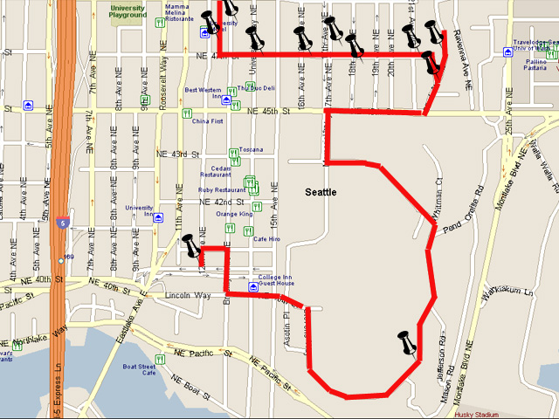
Nine locations in University Distirct were tested. These nine locations were:

- 1819 NE 17th
- 4550 Sortun Count
- 4600 22nd
- 4710 17th NE
- Alley at 11th and 47th
- Phi Delta Theta (17th and 21st)
- Safeway Parking Lot (50th and Brooklyn)
- University Presbyterian Church (47th and 15th)
Map 1: Map of war walking area

From these locations the following types of data was collected about each network:

- MAC Address
- SSID
- Manufacturer

Secure versus Unsecured Networks

We are saying that a network is unsecured if there is no authentication (WEP or WPA) on the network. We also realize that some networks have the ability to hide the SSID for an added layer of security. These networks were not found during our war walking and are not included in this report. The graph of secured versus unsecured networks can be seen in Graph 4. The data for this graph is listed in Table 3.

 | Yes | No | Total
# Secure | 28 | 46 | 74
% Secure | 37.84% | 62.16% | 100.00%
Table 3: Secure versus Unsecured Networks
Graph 4: Secure versus Unsecured Networks

Pinging Google.com

If a network was found to be unsecured, we attempted to obtain an IP Address to prove that we had connectivity. The procedures for this are listed above in the section titled “Procedures”. If we were able to obtain an IP address we would then ping google.com to verify that the connection was actively connected to the Internet. The results of this are presented below in Graph 5 and Table 4.

The data that is represented in this graph is over all networks (secure and unsecured). All secure networks are automatically included in the “No” category as well as the unsecured networks that could not be used to ping google.com. If pinging google.com was a success that network was included in the “Yes” category. The data for this graph is as follows:
Graph 5: Ability to ping google.com (all networks)

 | Yes | No | Total
Pinged Google (entire Sample)? | 31 | 43 | 74
% | 41.89% | 58.11% | 100.00%
Table 4: Ability to ping google.com (all networks)

In Graph 6 the data being presented is only from the networks that were found to be unsecured. Those networks in the “No” category could not be used to ping google.com. The networks in the “Yes” category leased us an IP Address and were used to get a successful ping request to google.com. The data for this graph is seen in Table 5.
Graph 6: Ability to ping google.com (unsecured only)

 | Yes | No | Total
Pinged Google (# of Unsecure)? | 31 | 15 | 46
% | 67.39% | 32.61% | 100.00%
Table 5: Ability to ping google.com (unsecured only)

Security by Location

As was outlined above we visited nine (9) locations on our second day of war walking. Below is the data that outlines the number of networks that were secure, unsecured, and if we were able to connect to them. Graph 7 displays the data by locations and Table 6 contains the data.

Graph 7: Security by Location

 | 1819 NE 47th | 4550 Sortun Court | 4600 22nd | 4640 22nd | 4710 17th NE | Alley at 11th and 47th | Phi Delta Theta (47th and 21st) | Safeway Parking Lot, 50th and Brooklyn | University Presbyterian Church
Secure | 3 | 3 | 2 | 3 | 3 | 4 | 1 | 5 | 4
Unsecure | 5 | 1 | 8 | 7 | 7 | 11 | 3 | 1 | 3
Connected? | 3 | 0 | 6 | 6 | 4 | 7 | 1 | 1 | 2
Table 6: Security by Location

Also, on average, at each location there were roughly three (3) secure networks and five (5) unsecured networks. We were also able to connect to roughly three (3) networks per location. From the data above the location “Alley at 11th and 47th” had the most unsecured networks and also the highest count of connected networks.

Router Manufacturer
Of the data that we were able to collect, the manufacturer of each router was compiled because the information was available to us from the raw data. We took the initiative to compile this data because there might be some correlation found later in our analysis. Graph 8 depicts router manufacturer popularity of the sample access points that we collected data from.

Graph 8: Router Manufacturer Popularity

