Methods
In the following sections, we describe the tools and procedures used throughout the War Driving project.

Tools
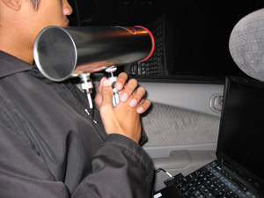
To maximize the number of networks we were able to connect to, we used many of the tools that war drivers and war walkers have in their arsenal. Though the intent of many war drivers is to hack into another user’s network and cause havoc (i.e. browsing and corrupting files, or sending spam using the user’s bandwidth), this was not our intent. Consequently, we left out many of the other tools that war drivers use, including Kismet, a tool designed to crack WEP.

We used the following list of tools throughout this project to collect our data:
- 2 Windows XP laptops, one equipped with 2 wireless network devices, the other equipped with one
- 1 Cantenna (http://www.cantenna.com)
- Net Stumbler
- 1 digital camera
- 1 rice rocket
- 1 backpack
- 1 INFO 498 War Walking Assignment Sheet

To capture networks, determine whether they were secure or un-secure, and to make our data collection as easy as possible, we used 2 laptops equipped with Windows XP SP2. The first laptop was equipped with 2 wireless network devices and would be used to gather wireless network data using Net Stumbler. The second laptop was used to analyze and aggregate the data collected on the first laptop. In order to analyze the data on the fly, we used the second wireless device on the first laptop to create an ad-hoc network between the two laptops to allow the two to exchange data.

Net Stumbler was chosen due to the fact that it exhaustively searches the wireless airspace for access points and their identifiers, or SSIDs, along with their GPS-derived locations. We did not have a GPS device and consequently were not able to pinpoint the locations of wireless networks. However, pinpointing the locations of these networks was not one of our project goals. Hence, we did not use a GPS device.

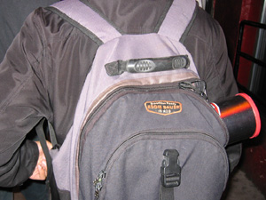
The first laptop was equipped with a wireless card that attached to the Cantenna, an external high-gain antenna used to boost the signal of the wireless access points, allowing us to connect to and detect more wireless access points.

To record our stakeout locations and to acquire pictures to demonstrate the use of our equipment (see the picture at the left), we brought along a Canon S410 digital camera.

Because we were doing a combination of war driving and war walking, we used a Honda Civic (the rice rocket) to drive through our chosen locations, and a backpack to conceal the Cantenna while walking.

Finally, because war driving itself looks suspicious and might attract campus police, or the Seattle P.D., we included one INFO 498 War Walking Assignment Sheet in our arsenal of tools. This tool, however, may prove to be just as useful to hackers as it was to us, as we will describe later on within this paper.

